**Teacher’s Guide – Bond Pricing and Amortization**

Bond Pricing

In cell B9, calculate the coupon payment as the face value multiplied by the coupon rate of interest divided by the frequency (1 for annual, 2 for semi-annual, 4 for quarterly, 12 for monthly). The formula in cell B9 is =B3*B4/B5

To calculate the price of the bond, use the PV function in Excel. Click on cell B11, click Formulas, then Financial, then PV. Enter the following:

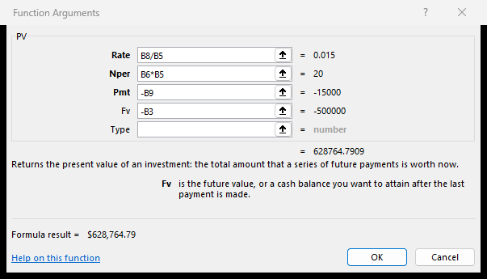

The rate is the market rate divided by the frequency. The Nper is the number of years multiplied by the frequency. The Pmt is the coupon payment, and the FV is the face value of the bond. Negative signs are used so that the answer is a positive number.

To calculate the premium or discount, take the price of the bond and subtract the face value. If the answer is positive, the bond is issued at a premium. If negative, the bond is issued at a discount.

Bond amortization

The beginning carrying value for period 1 is the issue price of the bond. In cell F16, the ending carrying value for period 0, enter the formula =B11.

The ending carrying value of one period is the same as the beginning carrying value of the next period. In cell B17, enter the formula =F16.

Use the principal * rate * time formula to calculate the interest. In cell C17, enter the formula =B17*$b$8/$B$5 (the dollar signs are necessary).

The coupon payment is calculated in cell B9. In cell D17, enter the formula =$B$9 (the dollar signs are necessary).

The amortization is the difference between the coupon payment and the interest. In cell E17, enter the formula =D17-C17.

The ending carrying value is the beginning carrying value plus the amortization (for a discount) or minus the amortization (for a premium). In cell F17, enter the formula =B17-E17.

Select the range B17:F17 (NOT row 0, row 1 of the amortization chart). Double click or drag the fill handle to fill the formulas down to period 20. If you are correct, the ending carrying value should be equal to the face value.