**Teacher’s guide – Car Payment Calculator**

In cell B8, to calculate the amount financed take the cost of the car and subtract the down payment

The formula in cell B8 is =B3-B4

In cell B10, to calculate the monthly payment, click Formulas, then Financial, then PMT

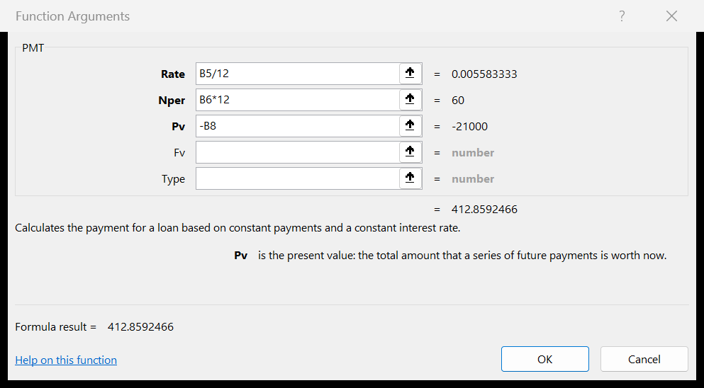

In cell B11, to calculate the total interest paid over the loan take the sum total of the payments (what you pay back) and subtract the amount financed (the amount borrowed). The formula in cell B11 is =B10*12*B6-B8.

You can now have the students change any of the numbers (cost of car, down payment, interest rate, or number or years) and the monthly payment and the total interest will be correct. Make sure they do not delete or change any of the formulas in B8, B10, and B11.