**Using Subtotals and Pivot Tables to Analyze Accounts Receivable**

Open the Excel file AR Subtotals and Pivot Tables.xls. Click the Subtotals worksheet tab if necessary.

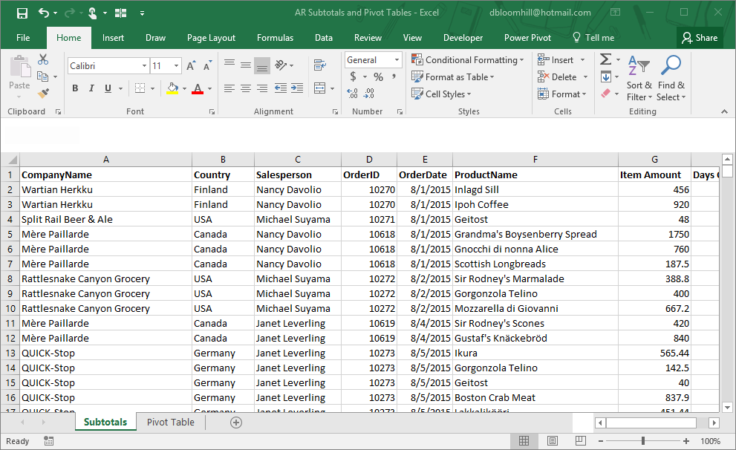

This file is downloaded from a computer – it represents all open accounts receivable. You have been asked to provide totals by company, country, salesperson and to age the report.

**Using the TODAY function to calculate days overdue**

Click cell H2. Type the formula =today()-E2 and hit enter. Today is a dynamic function which will recalculate each time the worksheet is opened.

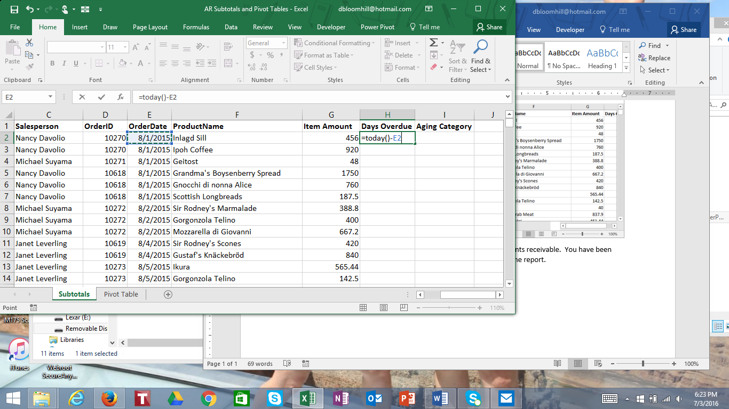

The answer will be formatted as a date (excel remembers dates as serial numbers so that you can do calculations with dates). Click cell H2, click the Home tab, and in the Number group click the down arrow and choose Genera format (or any number format will work as well).

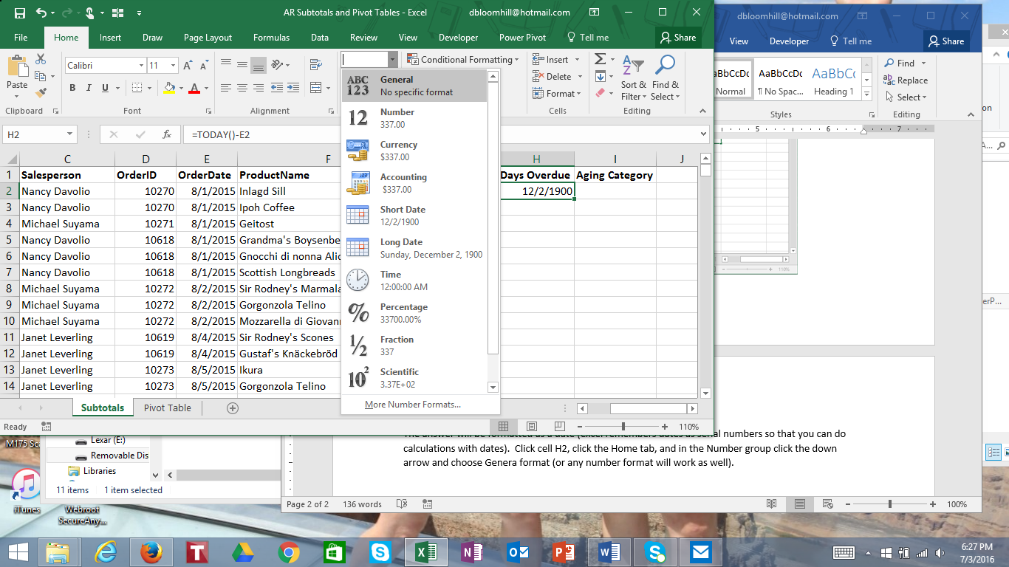

Double click the fill handle (or drag the fill handle down) to calculate the days overdue for all of the unpaid orders.

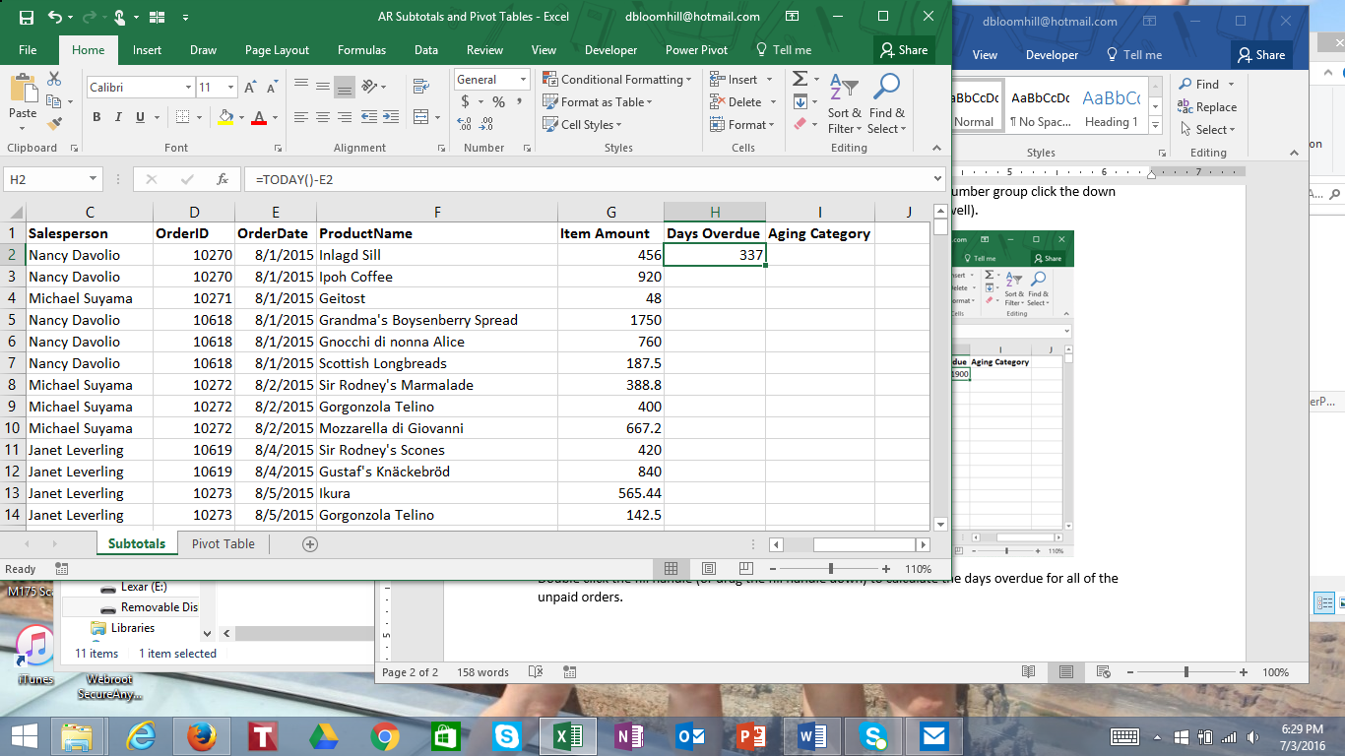

The fill handle

To age and provide subtotals by aging category, we will need to use a nested if statement (in Excel 2016 you can use IFS which I will also demonstrate).

If the days overdue is less than or equal to 0, the category is “not yet due.”

If the days overdue is 1 to 30, the category is “30 days or less overdue.”

If the days overdue is 31 to 60, the category is “Between 30 and 60 days overdue.”

If the days overdue is 61 to 90, the category is “Between 60 and 90 days overdue.”

If the days overdue is more than 90, the category is “More than 90 days overdue.”

The format of the if statement is:

=if(condition to test, do if condition is true, do if condition is false)

You can nest the if statements by putting an if statement in either the do if condition is true or do if condition is false statement.

To age the worksheet, type the following formula into cell I2

=if(H2<=0,”Not yet due”,if(and(H2>0,H2<=30),”30 days or less overdue”,if(and(H2>30,H2<=60),”Between 30 and 60 days overdue”,if(and(H2>60,H2<=90),”Between 60 and 90 days overdue”,”More than 90 days overdue))))

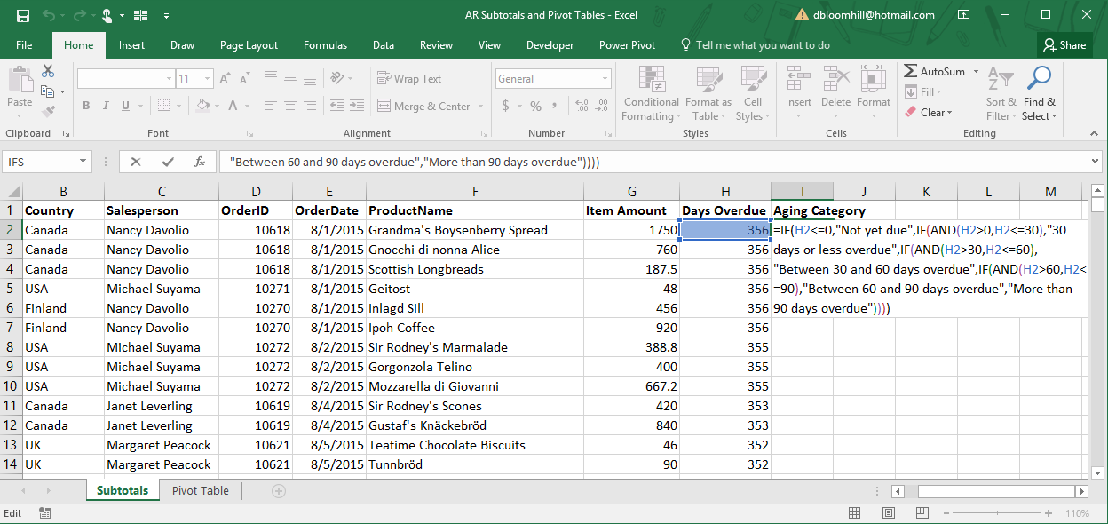

Double click the fill handle to copy the formula down column I.

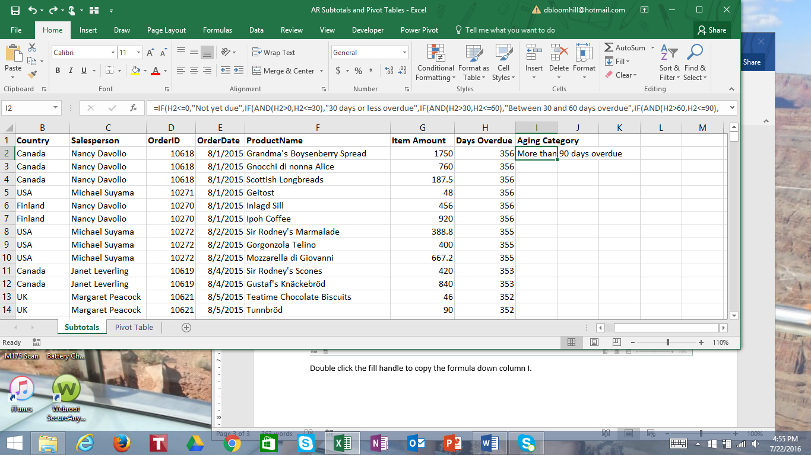

The fill handle

To insert subtotals by customer and then by date

Click cell A2. Click the Data tab, then the Sort button in the Sort & Filter group.

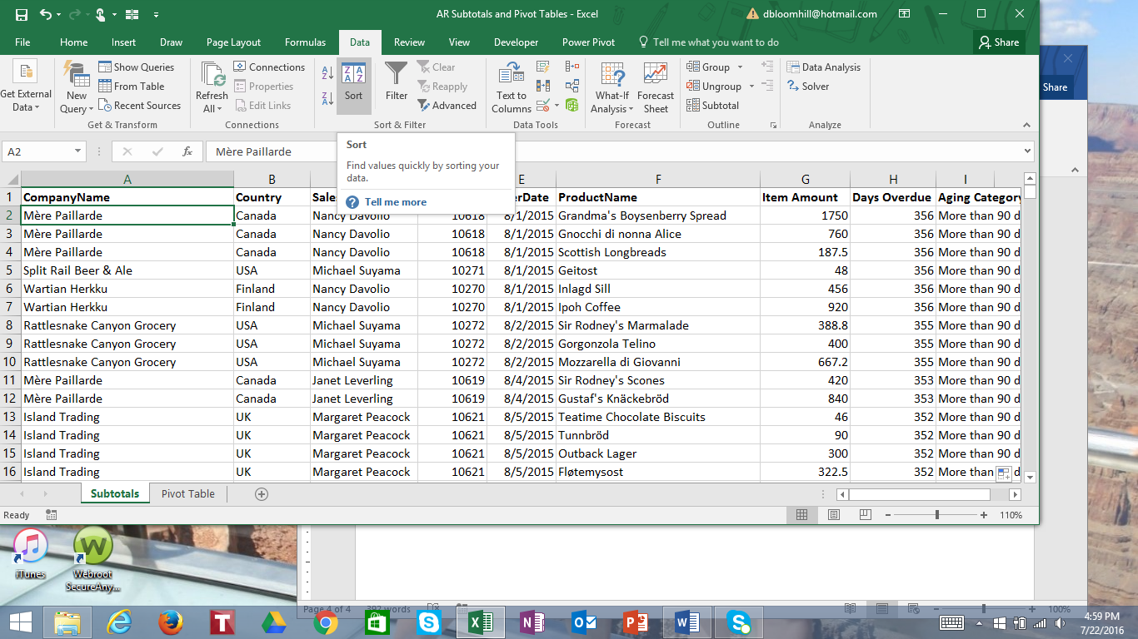

In Excel 2016, you can use the IFS function for nested if statements:

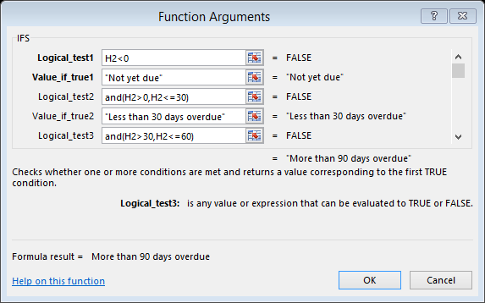

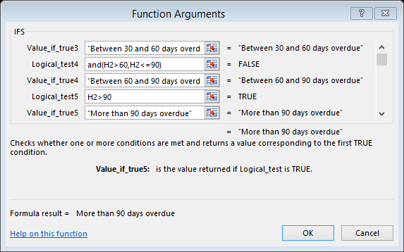

In the Sort dialog box, click Add Level. Sort first by company name, then by aging category. Click OK.

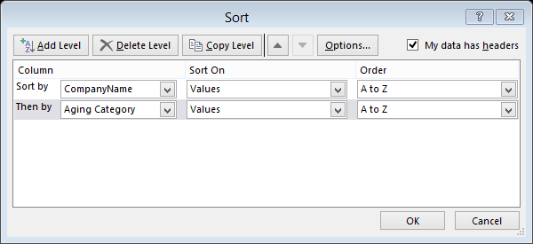

Make sure the active cell is any cell in the table. Click the Data tab. In the Outline group, click Subtotal.

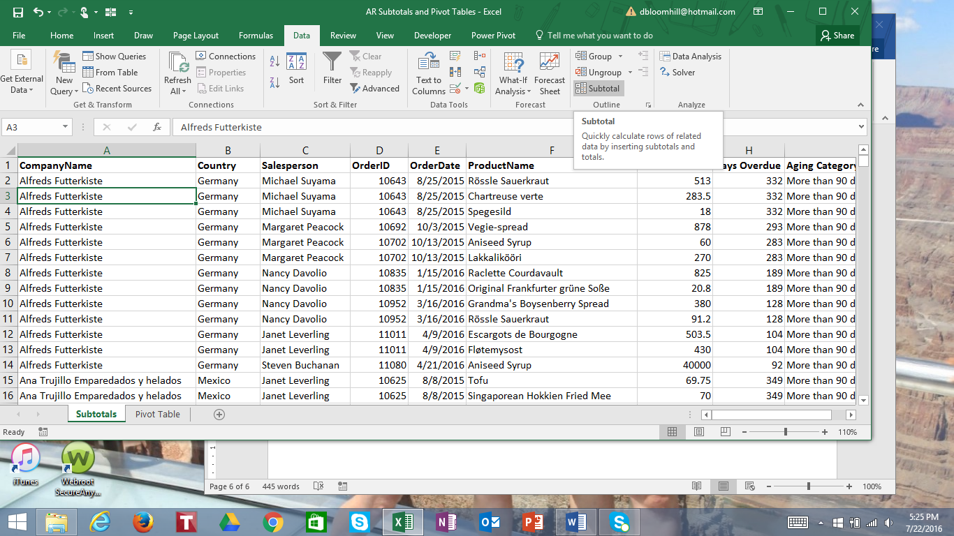

In the Subtotal dialog box, change At each change in to read Company Name, use function Sum, and add the subtotal to item amount. Make sure Summary below data is checked.

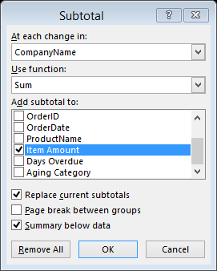

Making sure that the active cell is in the list, click Subtotal again in the Data tab. This time, At each change in should read Aging category, function is sum, add subtotal to item amount, but make sure that replace current subtotals is NOT checked.

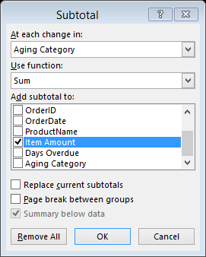

Now you can get subtotals for each company, and subtotals for each company by aging category.

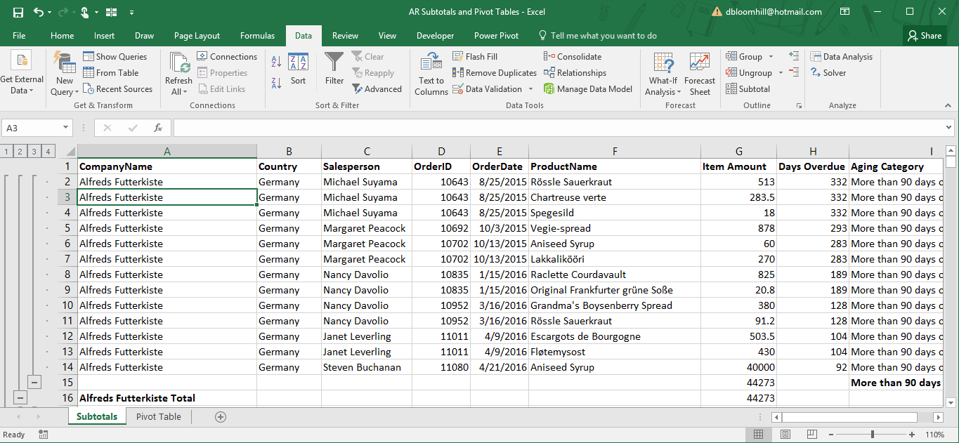

Use the outlining tools on the left to display different levels of data, Click the 3 to see totals for company and aging category.

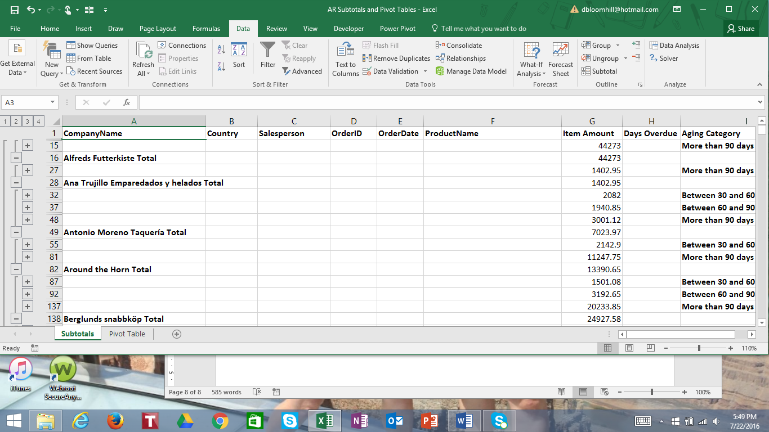

By clicking Subtotals, you can remove all current subtotals and analyze the data by aging category, salesperson, item or any data point you choose.

**Using Pivot Tables**

Click the Pivot Table worksheet tab. Click any cell in the list. Click Insert, then Pivot table.

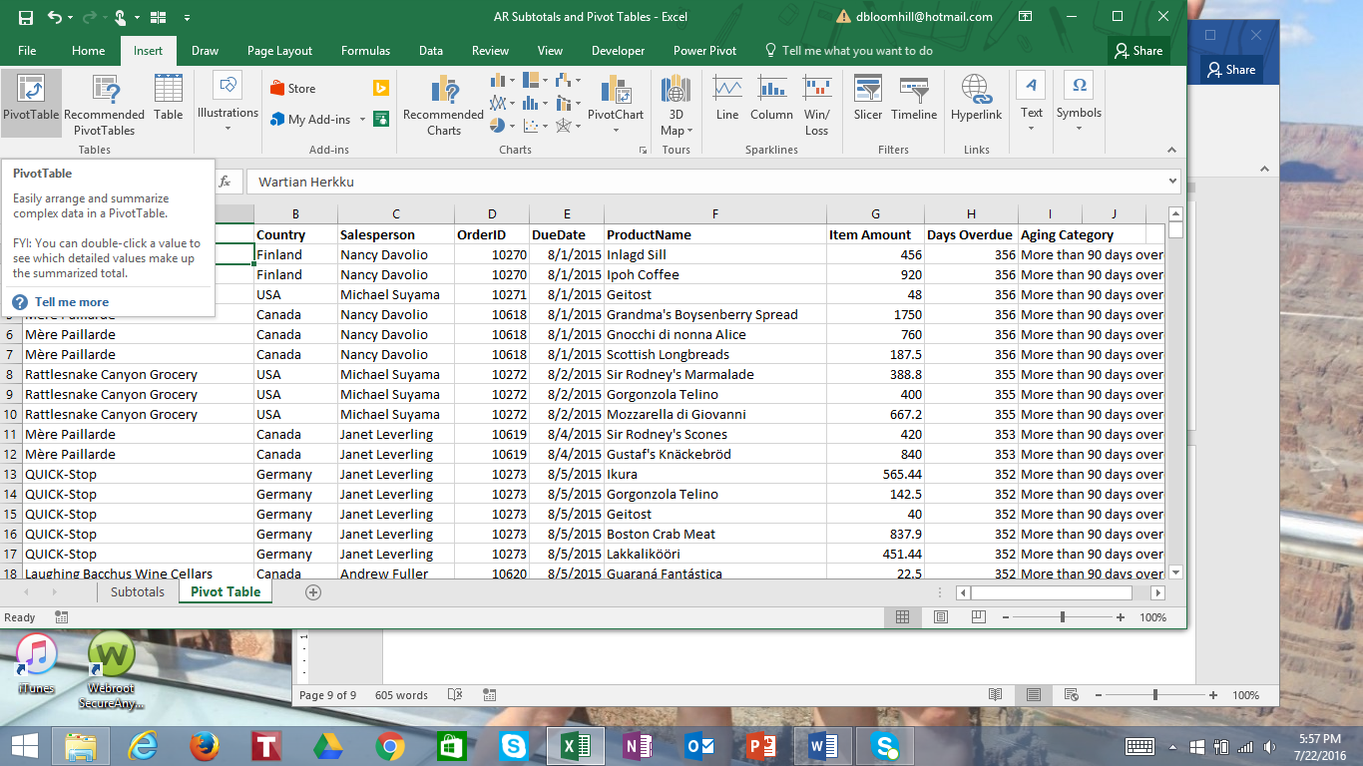

Accept the defaults for the table range and new worksheet for the pivot table. Click OK.

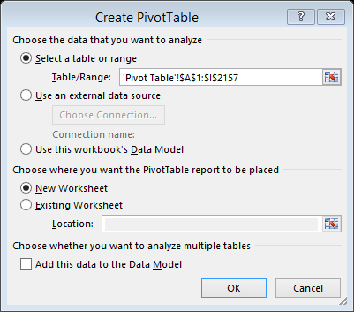

This is what the pivot table builder looks like.

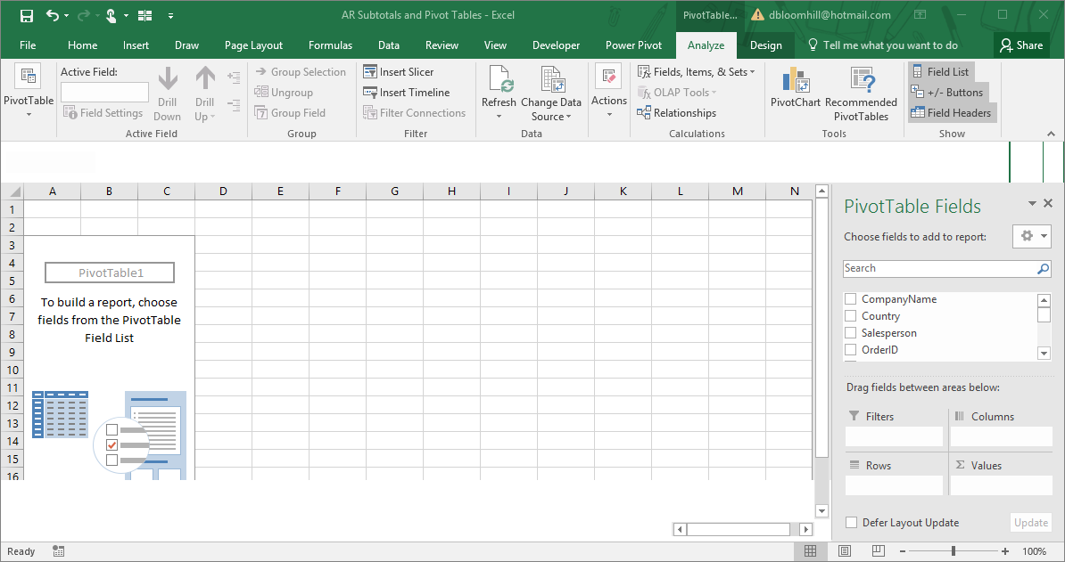

Drag CompanyName to the Row area, Aging Category to the Column area, and Item Amount to the Values area.

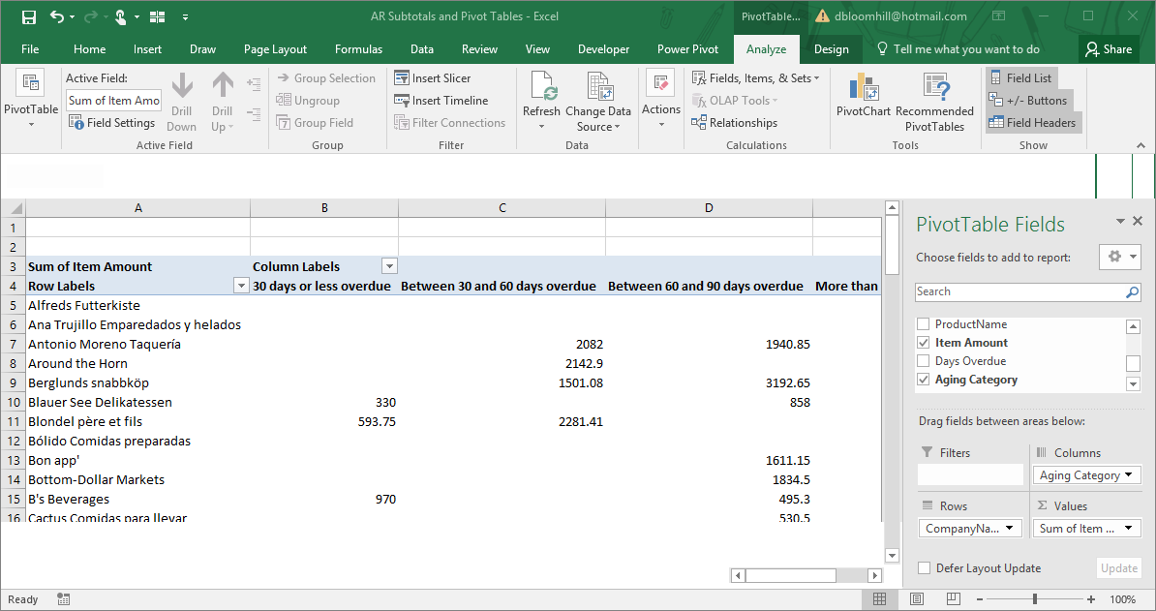

Drag the field Aging Category to the Rows area below CompanyName.

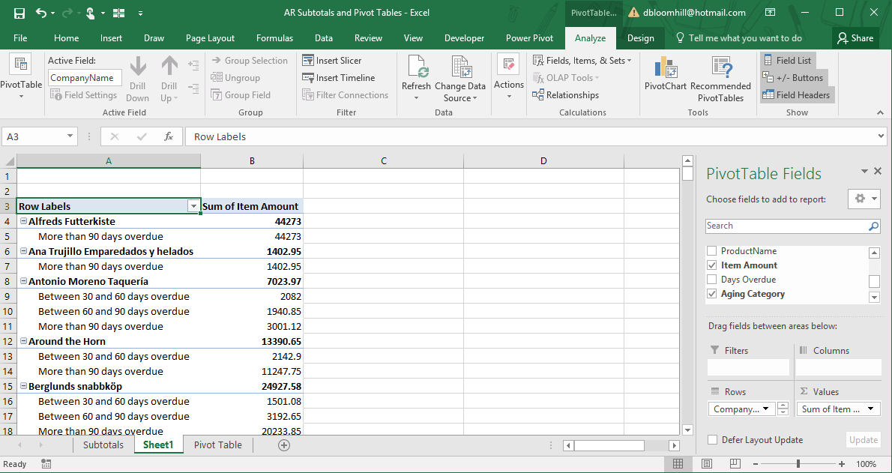

In the Rows area, drag Aging Category so that it is before CompanyName.

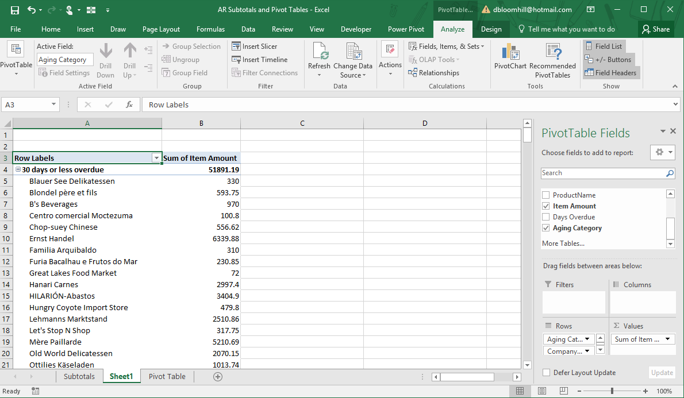

Notice the filters at the top of the columns, the outlining tools and specific toolbar to help you analyze your pivot table.