Table Functions and CVP Analysis

Open the file CVP Worksheets. Let’s use Cost-Volume-Profit (CVP) Analysis to demonstrate the use of tables. Suppose you are planning a fundraising event. Variable costs include food, drink and decorations and are estimated to be $35 a person. Fixed costs include the hall rental and the band and are estimated to be $3,500 for the evening. A ticket price of $105 is proposed.

Holder cells have been set up for the ticket price, unit variable cost and total fixed cost. With this information, we can calculate the breakeven quantity, the breakeven sales dollars, and the ticket sales necessary for a target profit of $5,250.

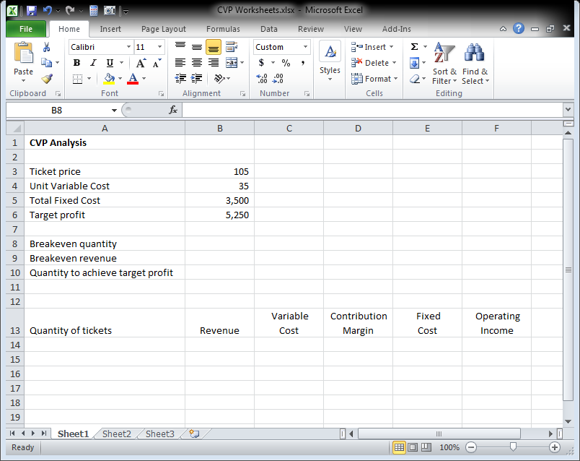

The breakeven quantity is the total fixed cost divided by the contribution margin. The contribution margin is the selling price minus the unit variable cost. Click cell B8 and type the formula
=B5/(B3-B4). Hit enter.

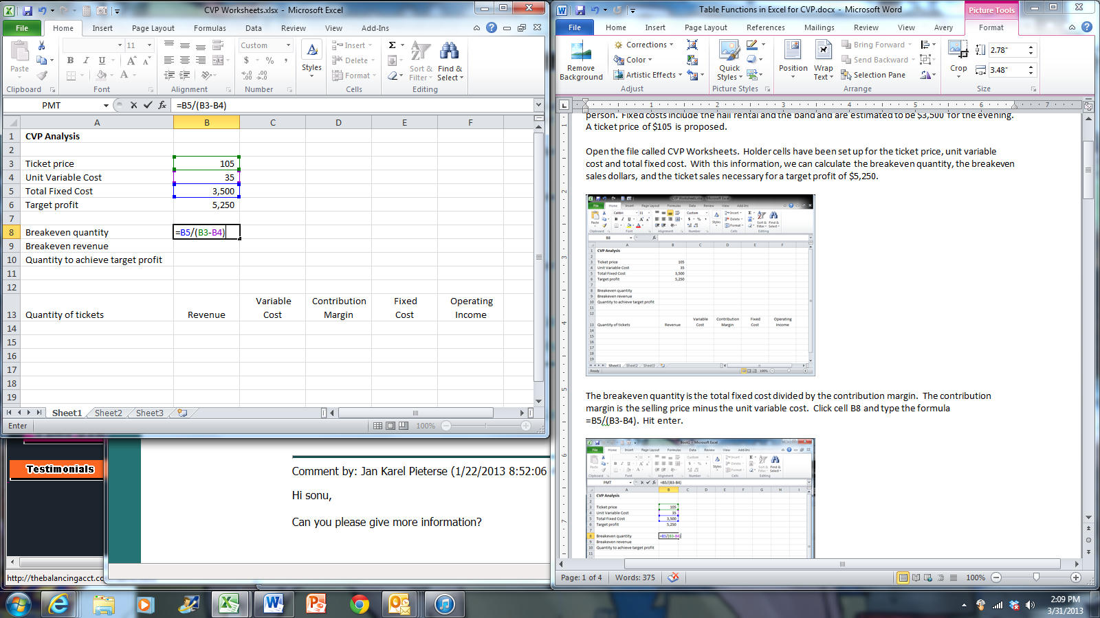

Click cell B9. The breakeven revenue is the breakeven quantity multiplied by the ticket price. In cell B9, type the formula =B8*B3. Hit enter.

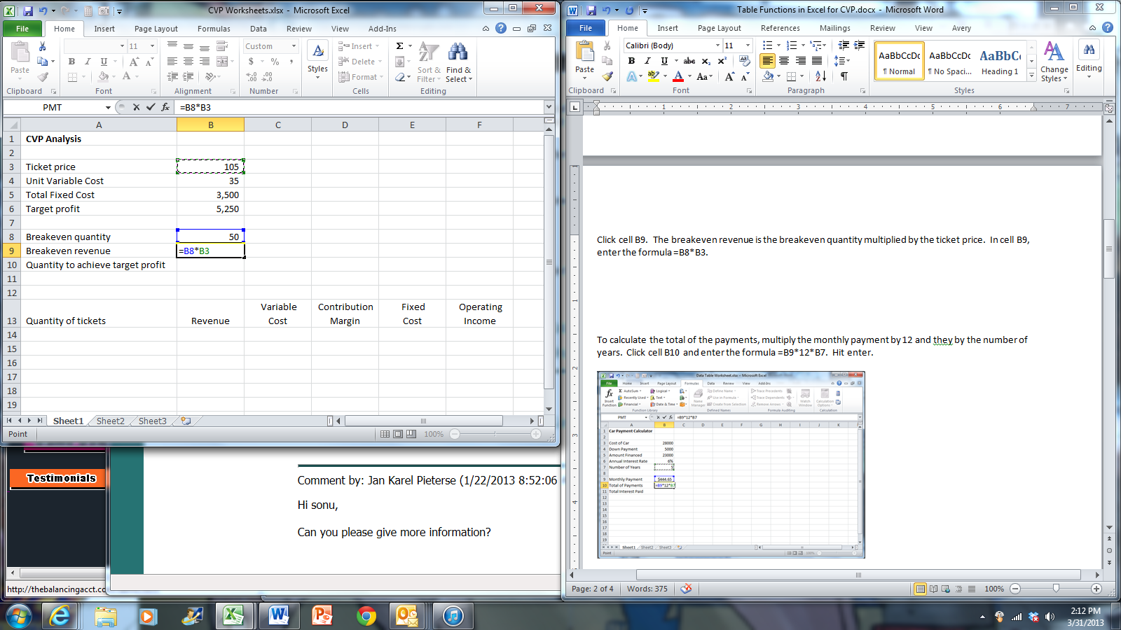

The formula for number of units to achieve target profit is (target profit + fixed costs) divided by the unit contribution margin. In cell B10, type the formula =(B6+B5)/(B3-B4). Hit enter.

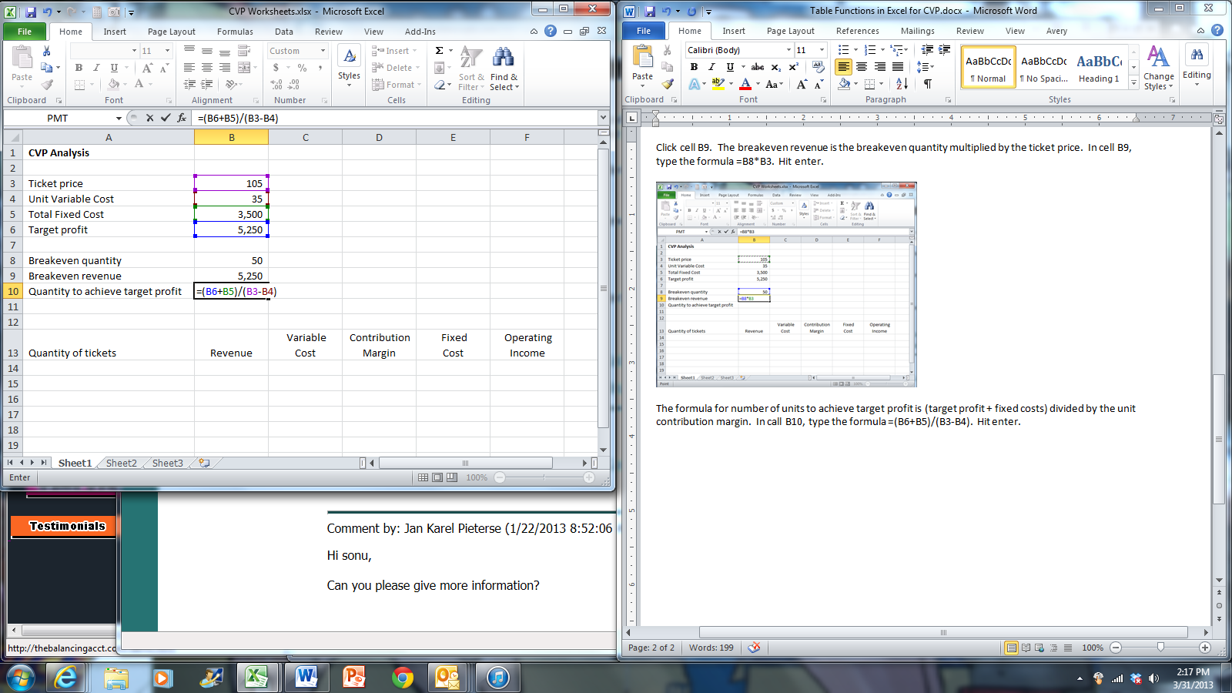

Format as Table

Formatting cells as a table gives a lot of advantages, not just formatting. One of those advantages is the automatic filling of formulas. We will use Format as Table to construct a table of revenues, costs and profit given different quantities.

Type 10 in cell A14. Type 20 in cell A15. Select cells A14 and A15 and use the fill handle to fill the numbers from 10 to 100 in column A.

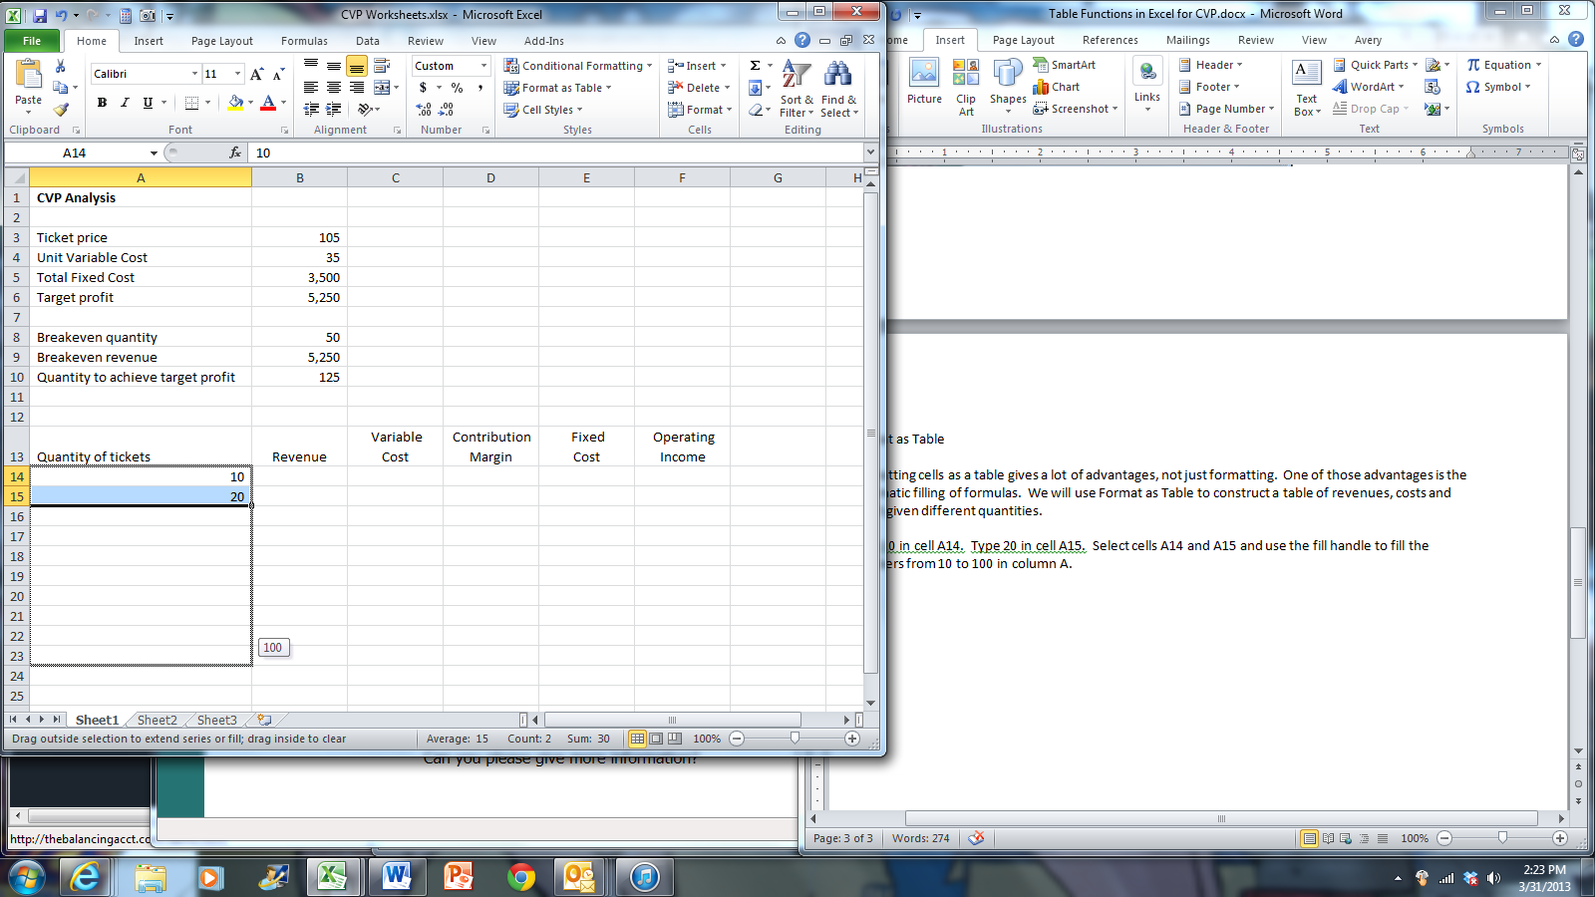
Drag the fill handle down. The fill handle is in the bottom right hand corner of the selection

Select the range A13:F23. Click the Home tab if necessary, and in the Styles group click Format as Table.

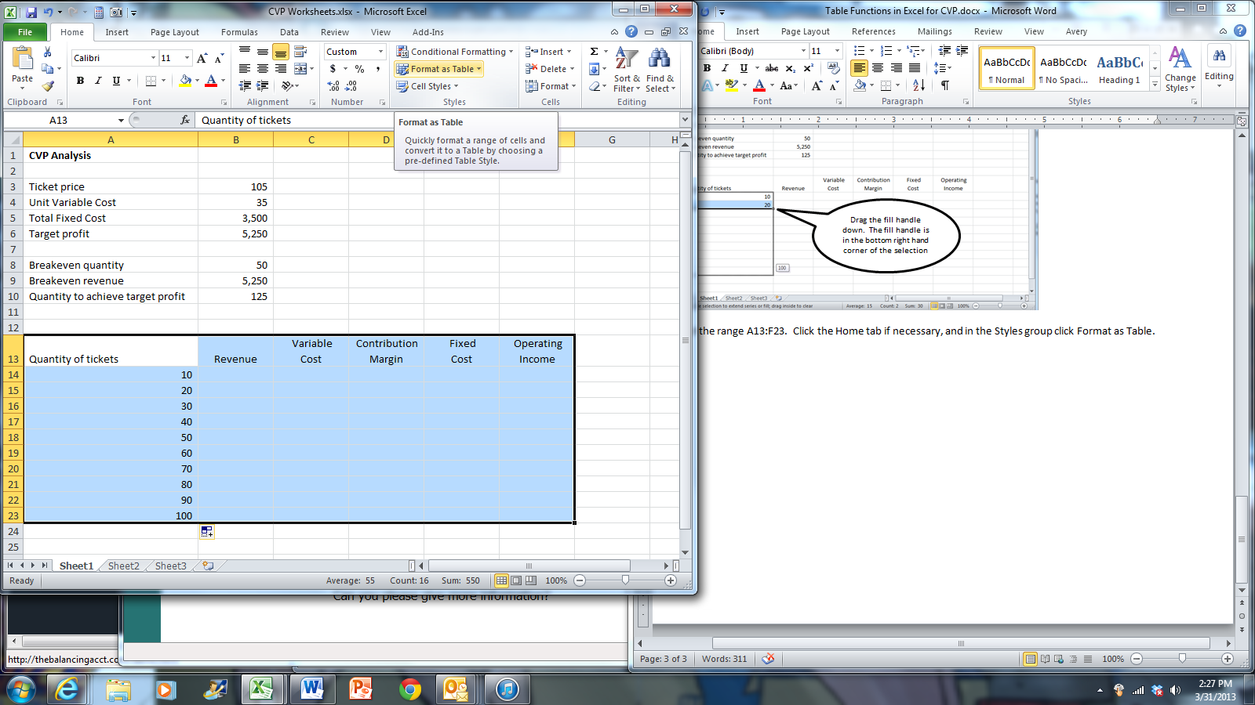
Choose Table Style Light 1 in the upper right hand corner.

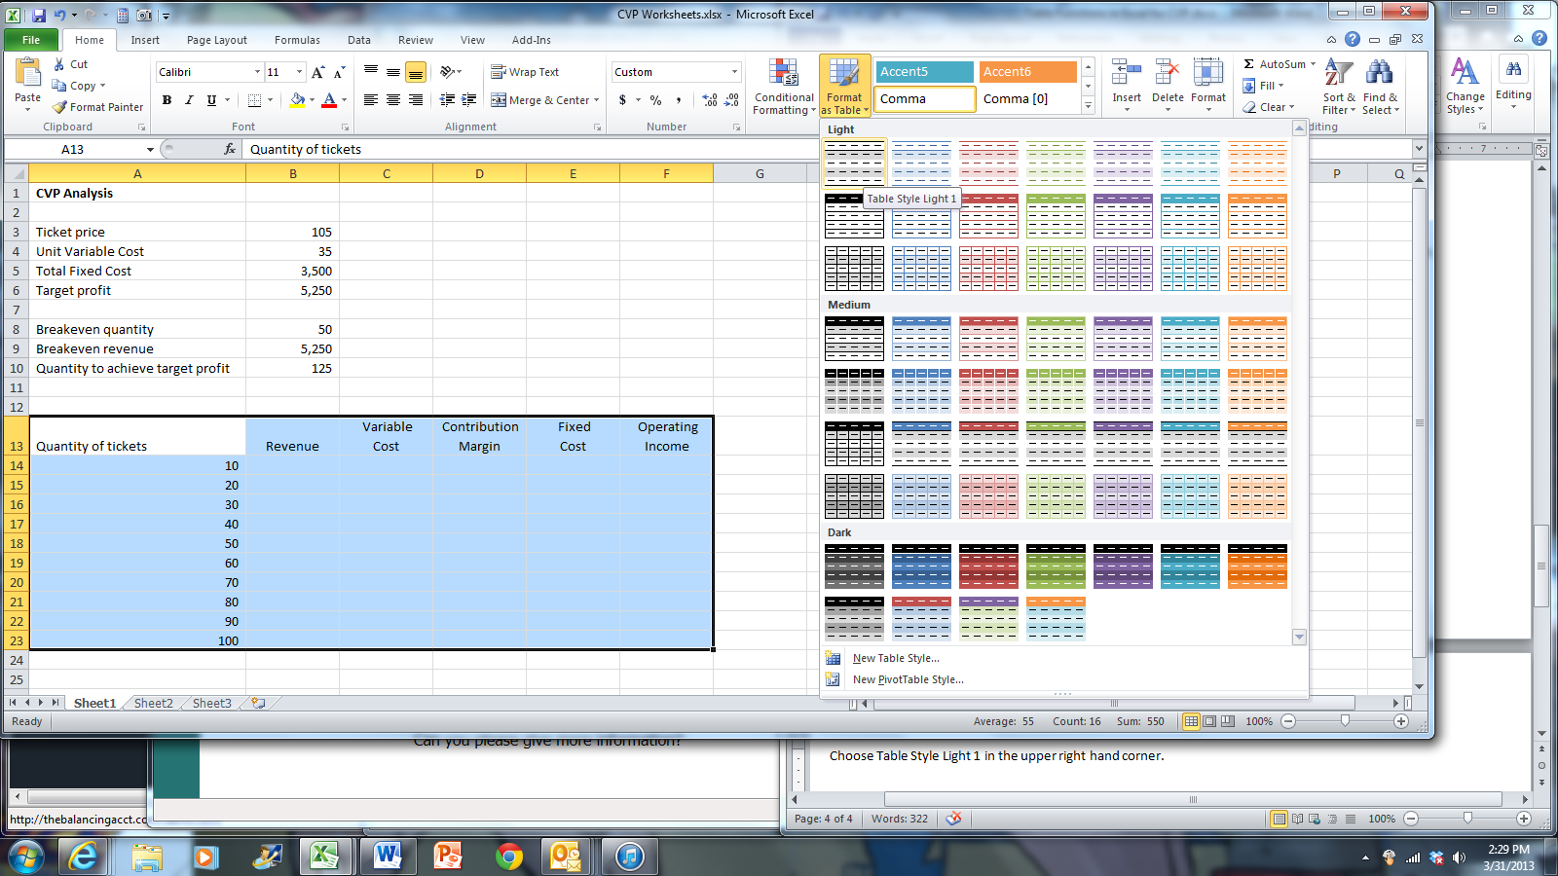

When the Format As Table dialog box appears, accept the defaults for the location and table headers. Click OK.

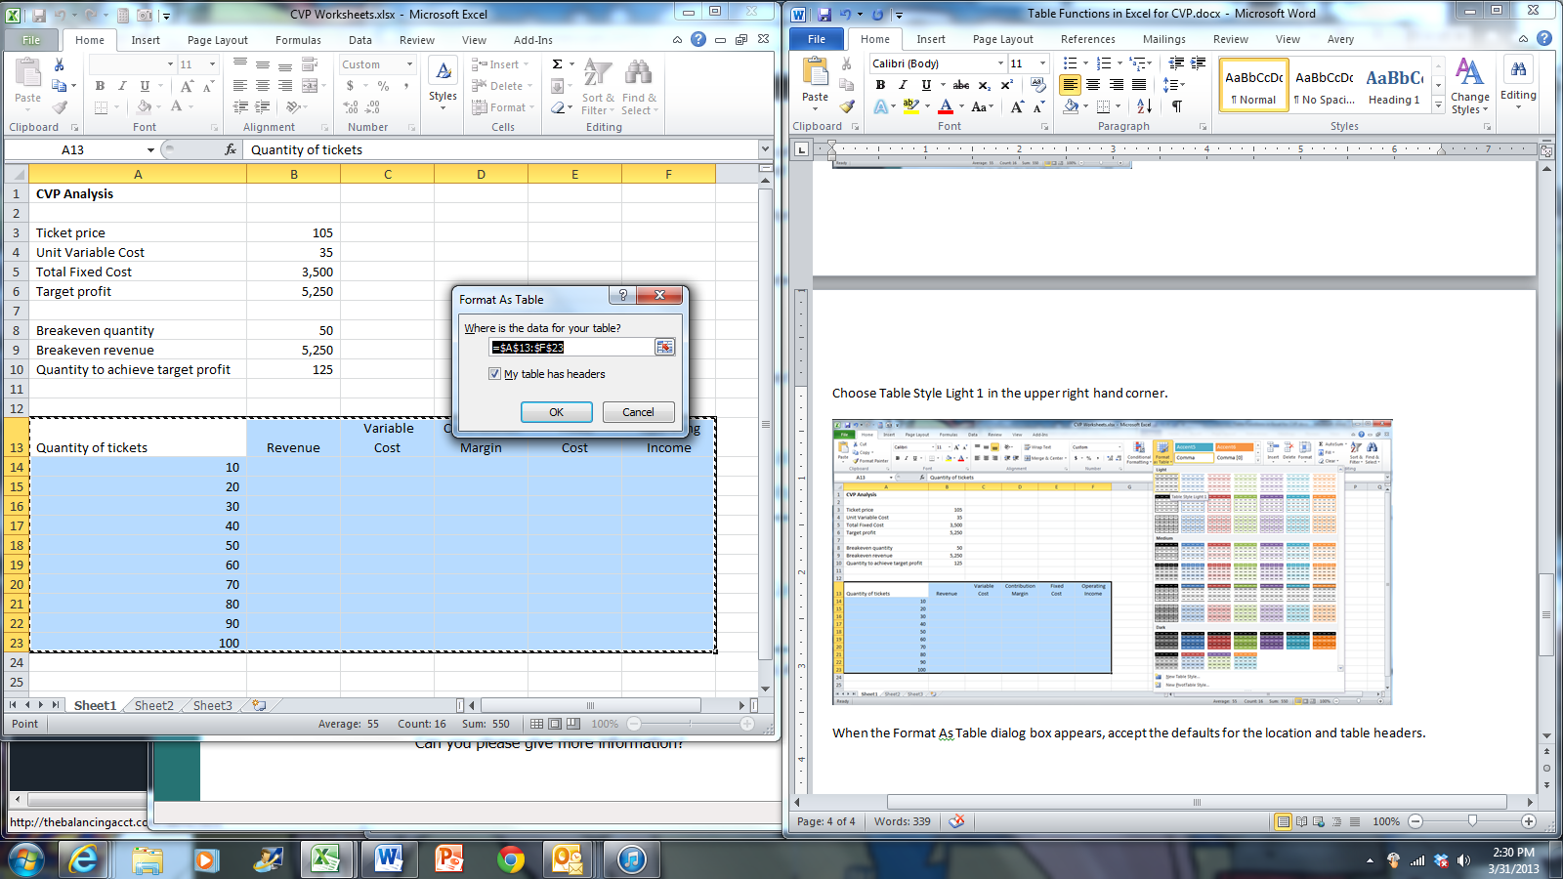
One of the major benefits of table formatting is the automatic filling of formulas. To calculate total revenue for each quantity, click cell B14, type =A14*$B$3 (you can use the F4 key to change the second cell reference to an absolute cell reference).

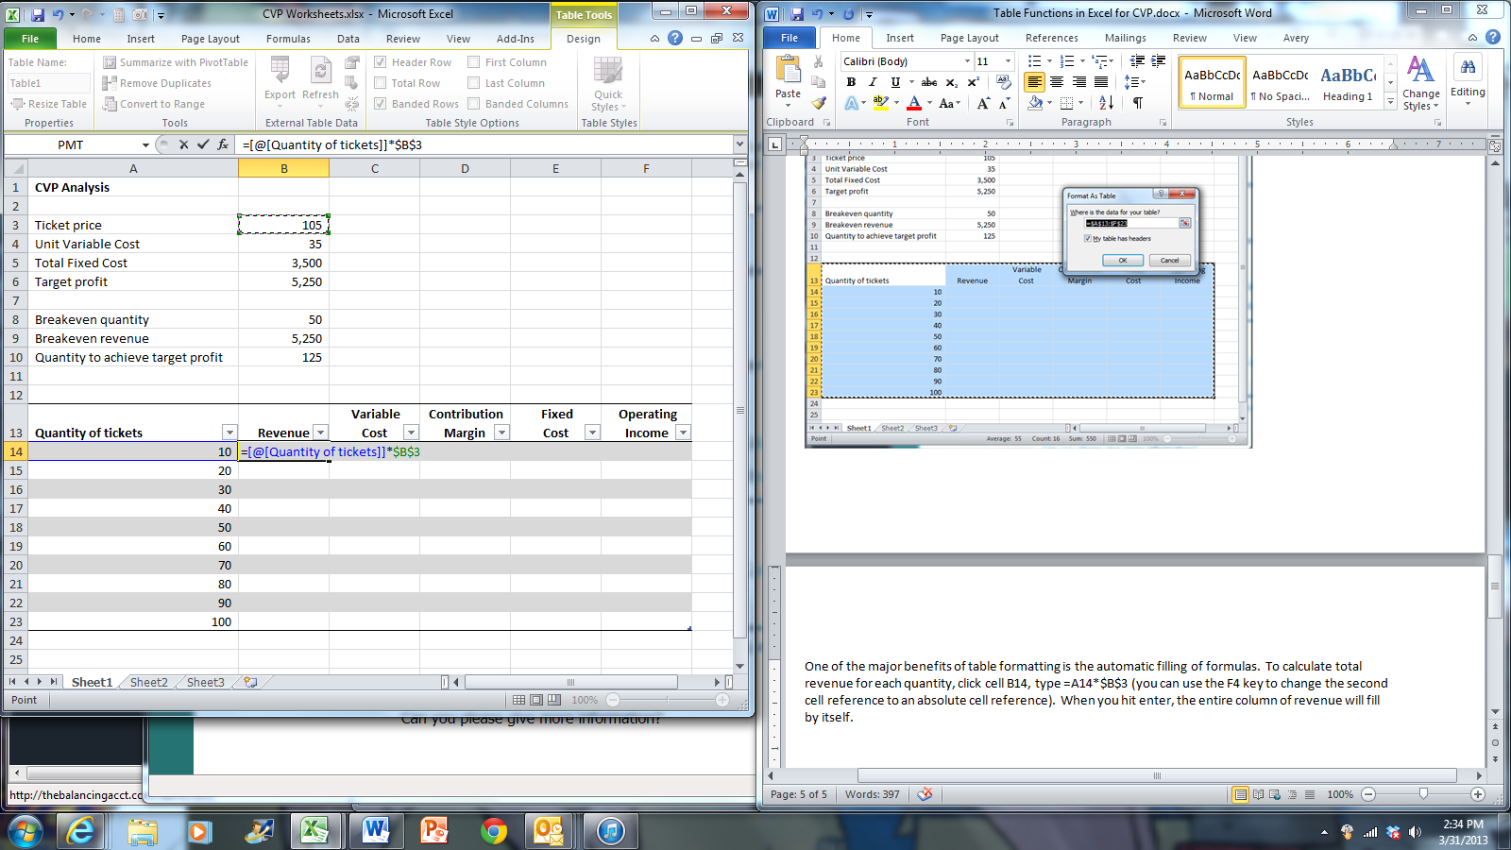

Hit enter and watch the revenue formula automatically fill column B.

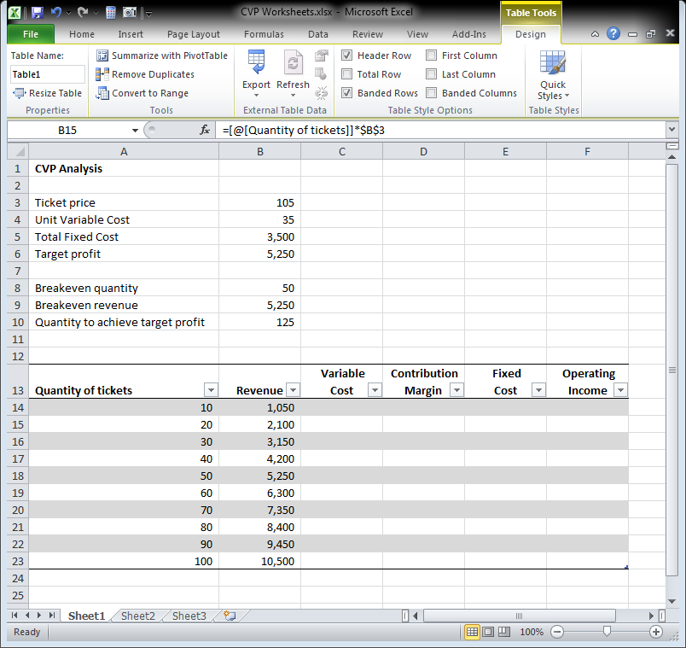

To calculate the variable cost, click cell C14, type =A14*$B$4 and hit enter.

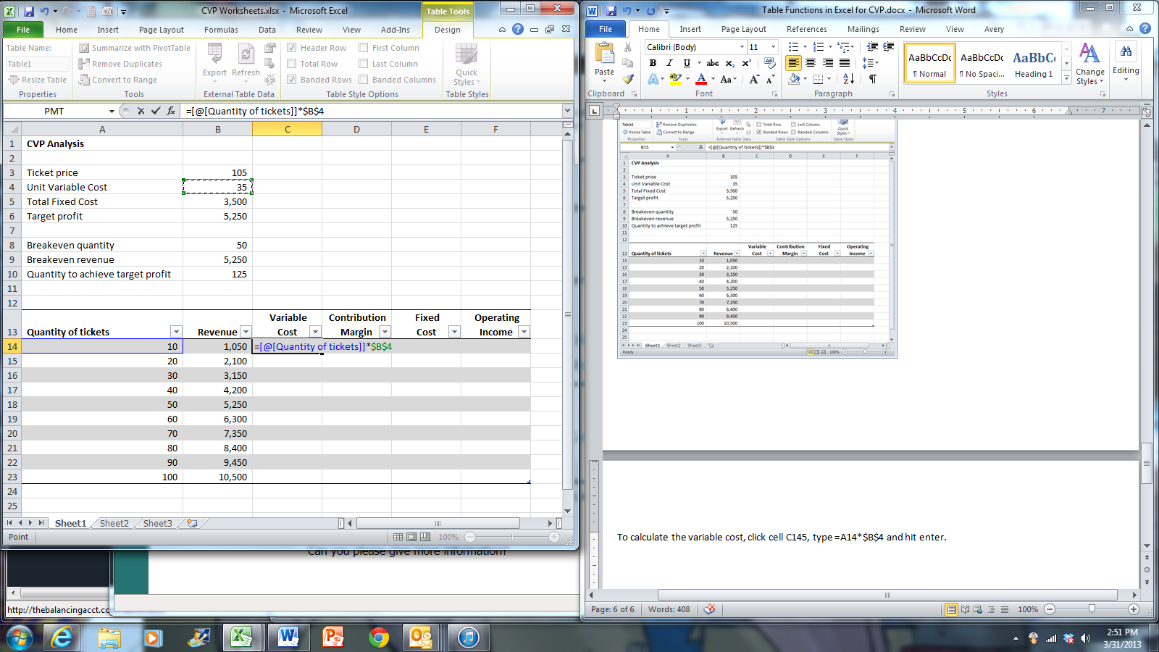

To calculate the contribution margin, click cell D14 and type the formula =B14-C14 and hit enter.

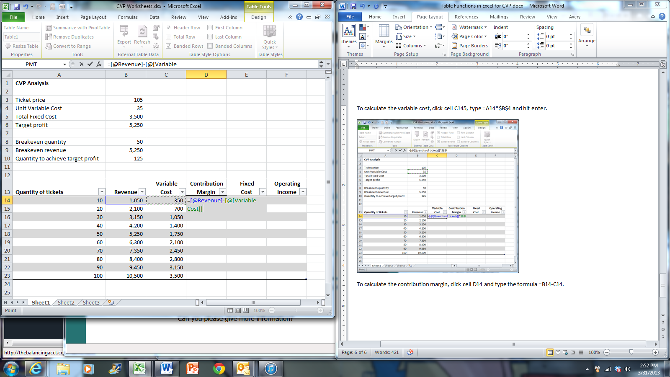

For the fixed cost, click cell E14 and type =$B$5 and hit enter.

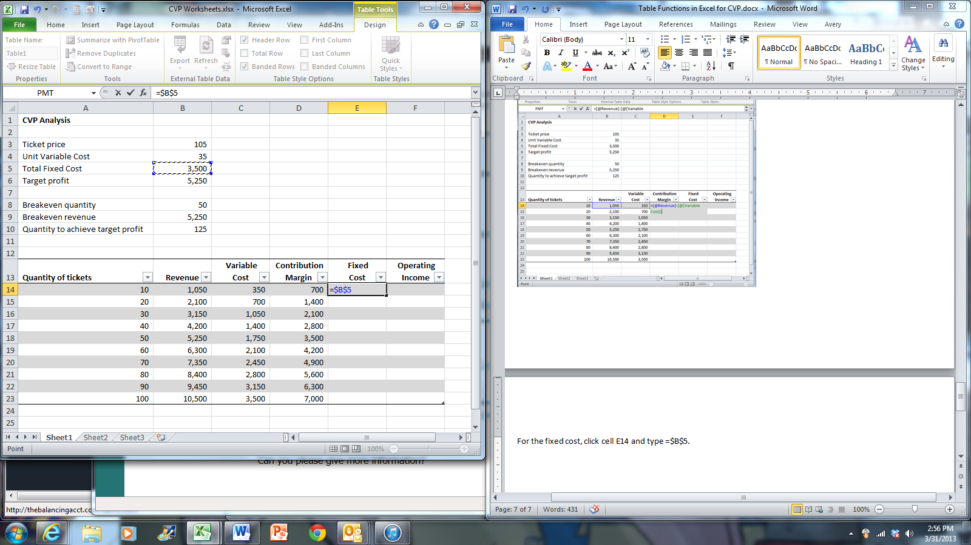

To calculate the operating income, click cell F14 and type =D14-E14. Hit enter.

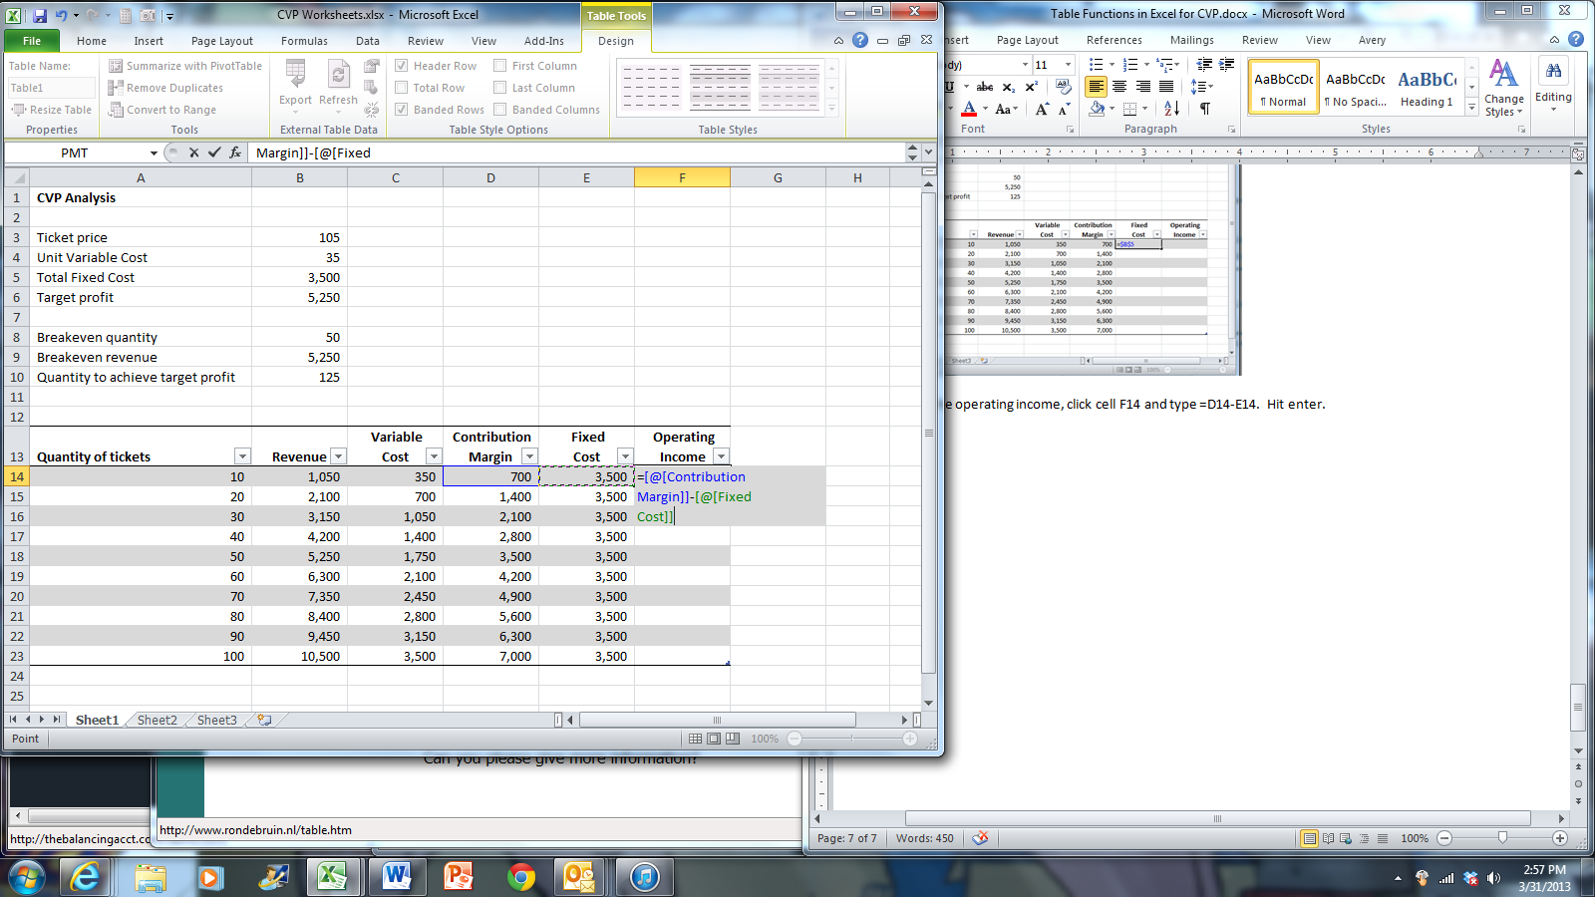

The resulting worksheet should look like this.

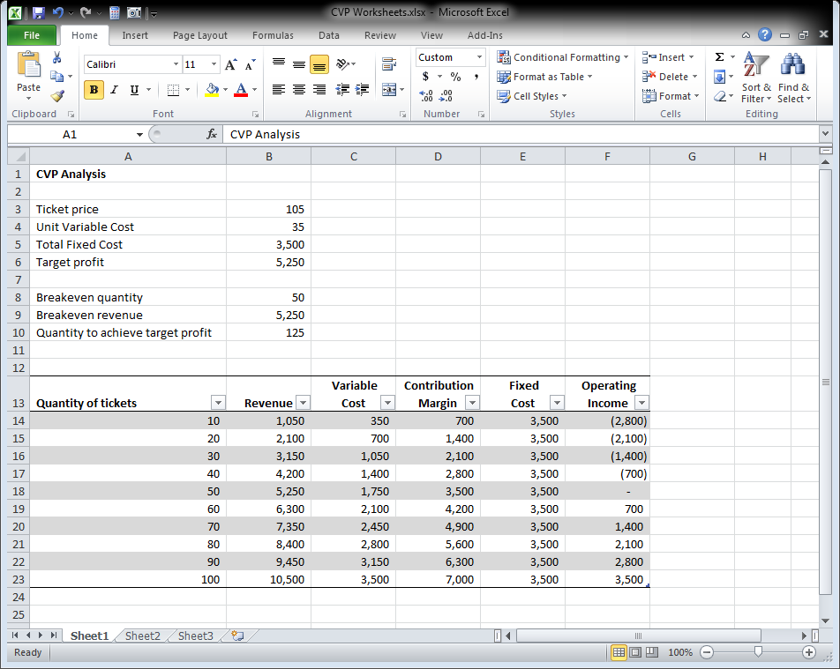

To add a graphical representation of the data, select the range B13:B22, click the Insert tab and click the Column icon in the Sparklines group.

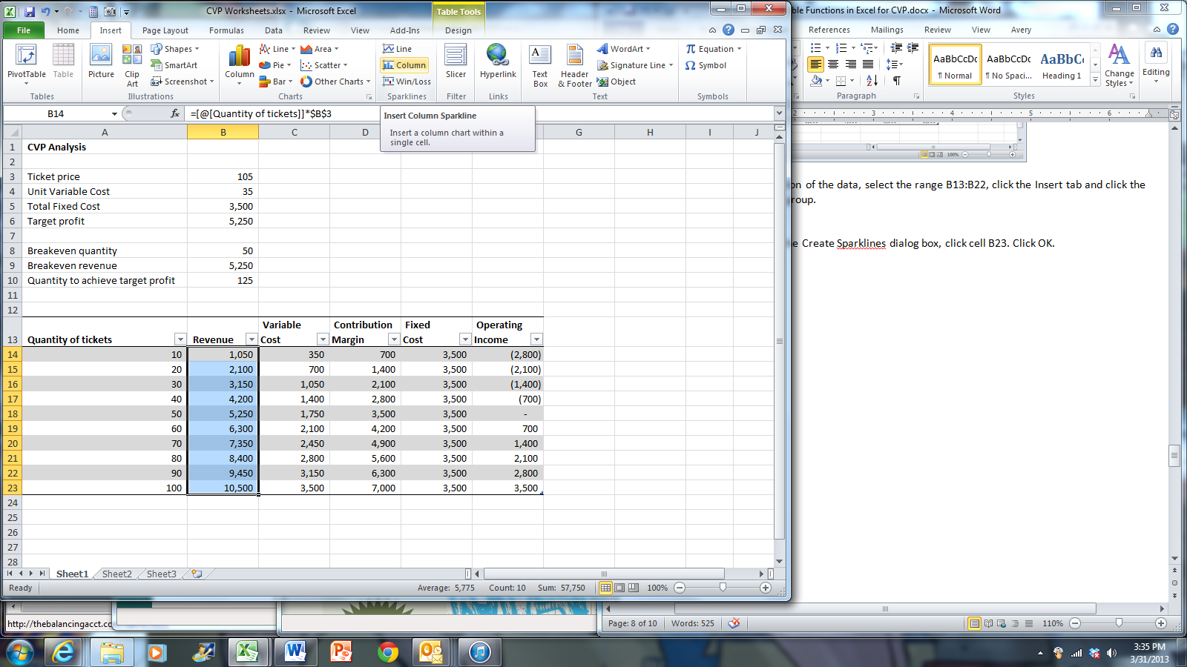
In the Location Range area in the Create Sparklines dialog box, click cell B23. Click OK.

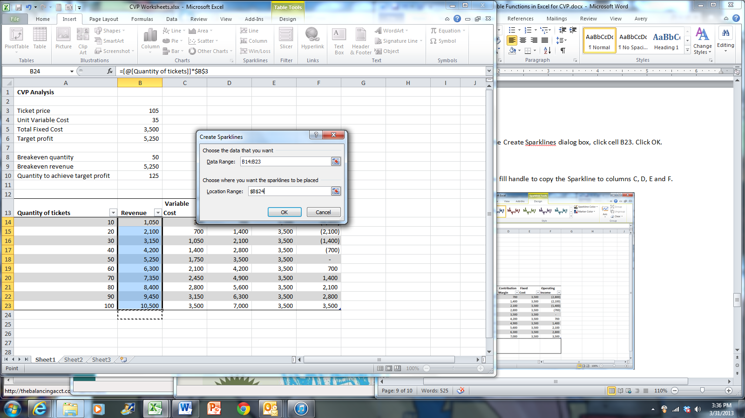

Make row 23 wider and use the fill handle to copy the Sparkline to columns C, D, E and F.

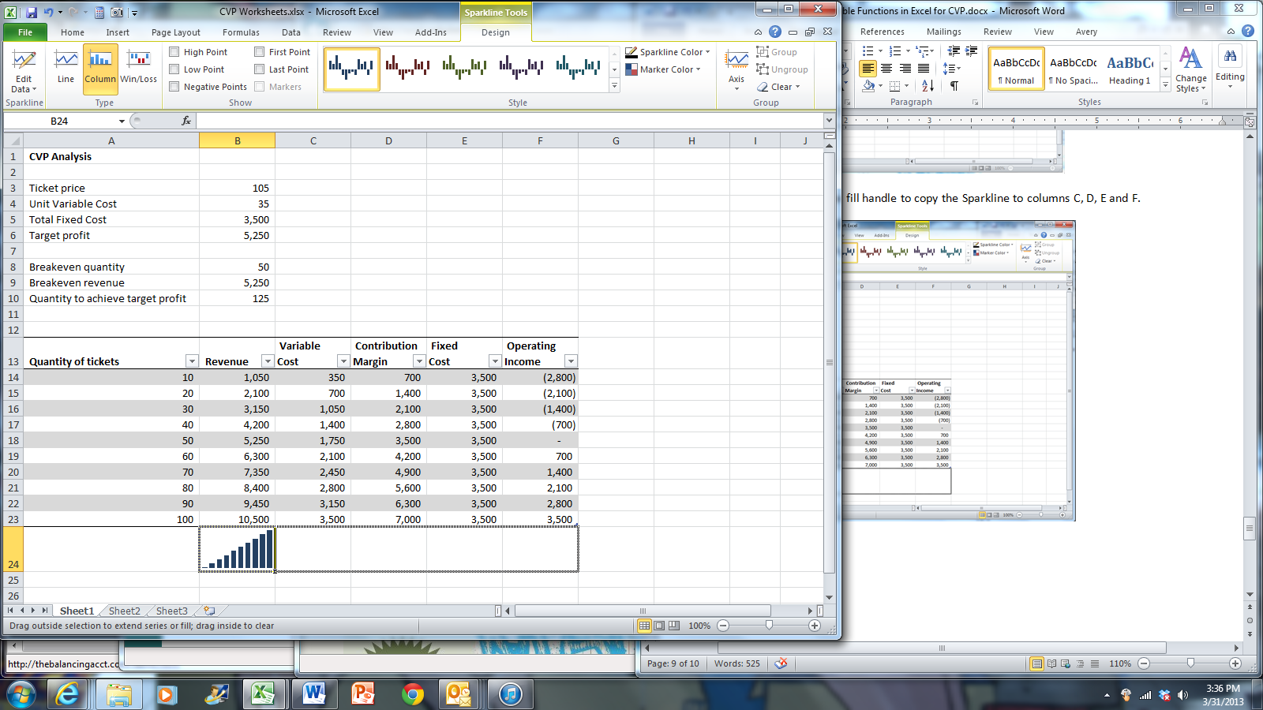+-

The resulting Sparklines will look like this.

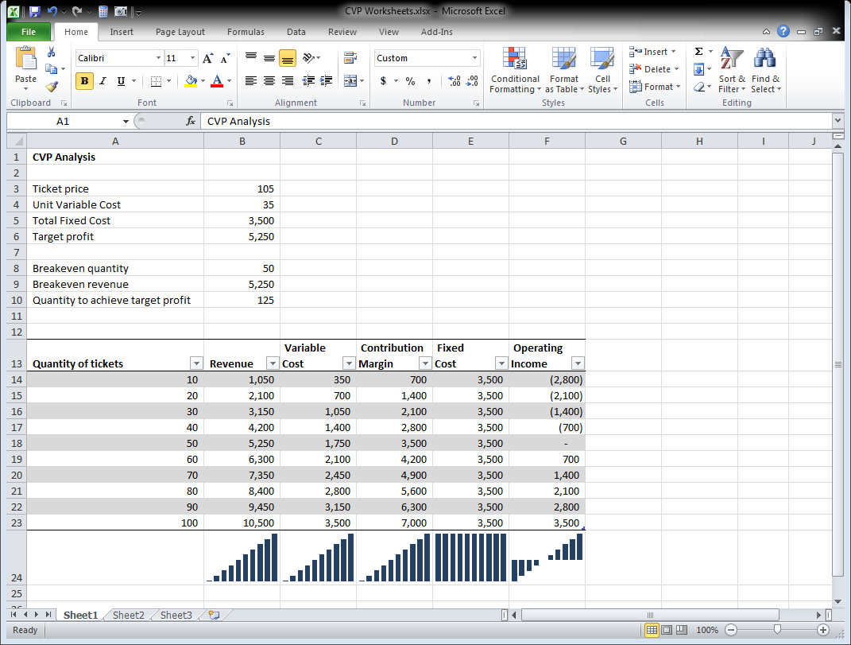

One Way Data Tables

As an alternative to the table creation method above, you can create one and two way data tables to automatically calculate and display the results of formulas. I have already entered the formulas to produce a contribution margin income statement, given a particular quantity. I chose a quantity of 60 tickets on which to base the data table.

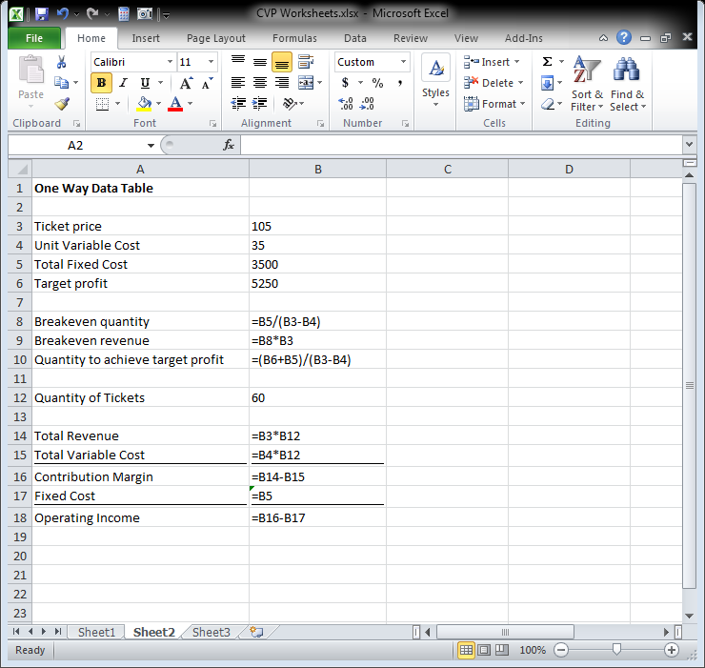

Click the Sheet2 tab. Suppose you wanted to create a table which shows how the breakeven point and the operating income would change if only the ticket price were changed from $90 to $125, given the quantity of tickets used for the income statement.

Click cell E1. Type an = sign and click cell B8, the cell which calculates the breakeven quantity.

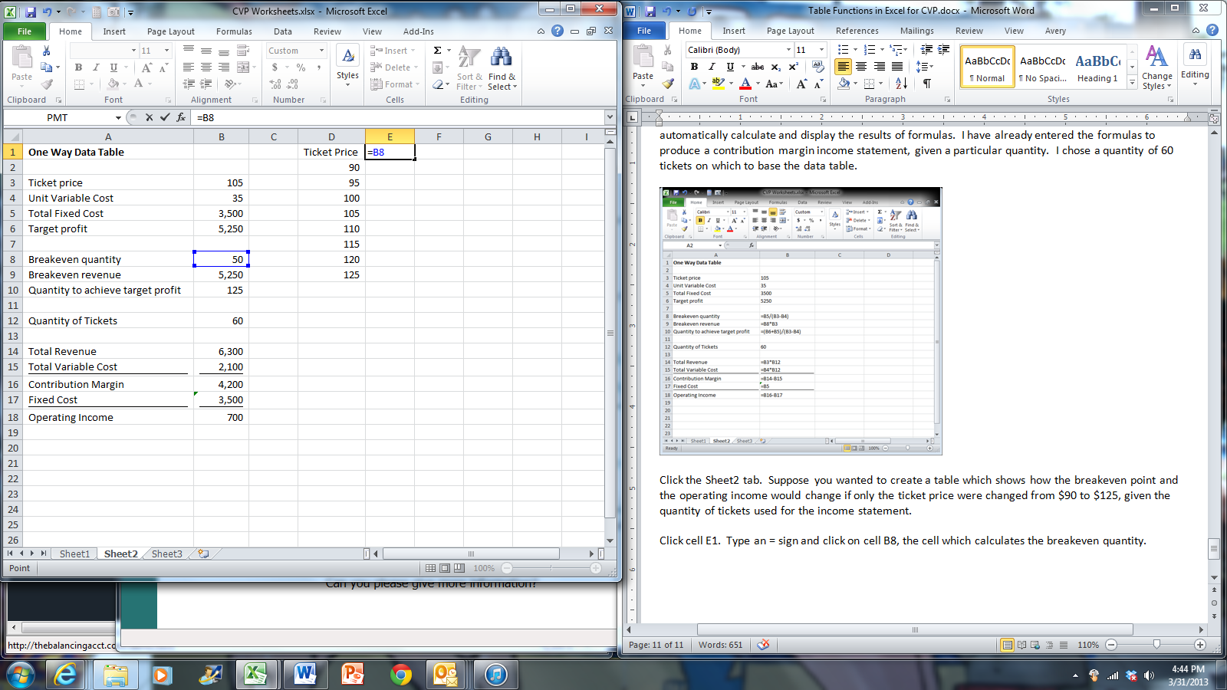
Click cell F1. Type an = sign and click cell B18, the cell which calculates the operating income.

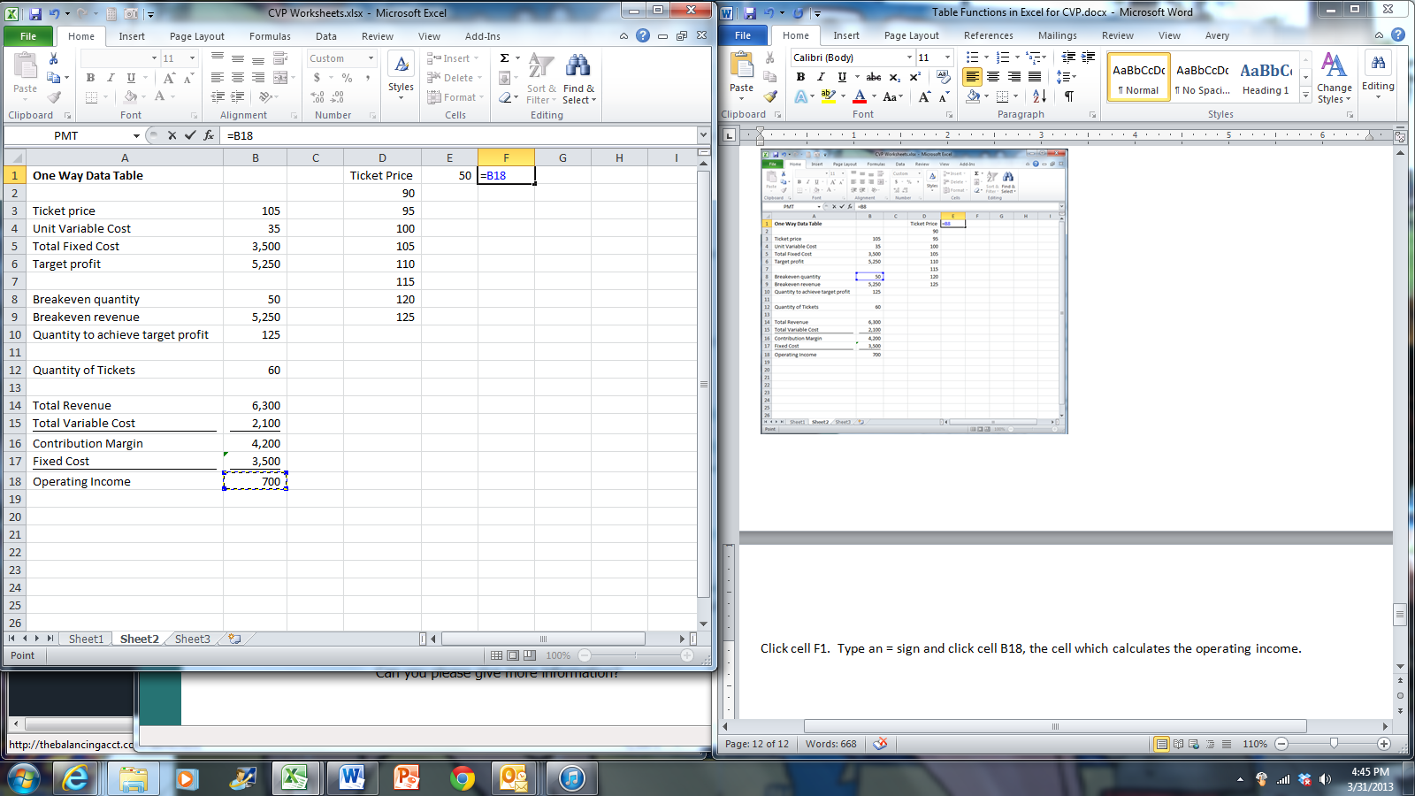

We will now tell Excel to substitute the values in column D for cell B3 the ticket price into the formulas we chose in cells E1 and F1. It is very important that the ticket price cell B3 is used in the calculation of the formulas chosen in the data table (the ones used in cells E1 and F1).

Select the range D1:F9. Click The Data tab. In the Data Tools group, click What-If Analysis and then Data Table.

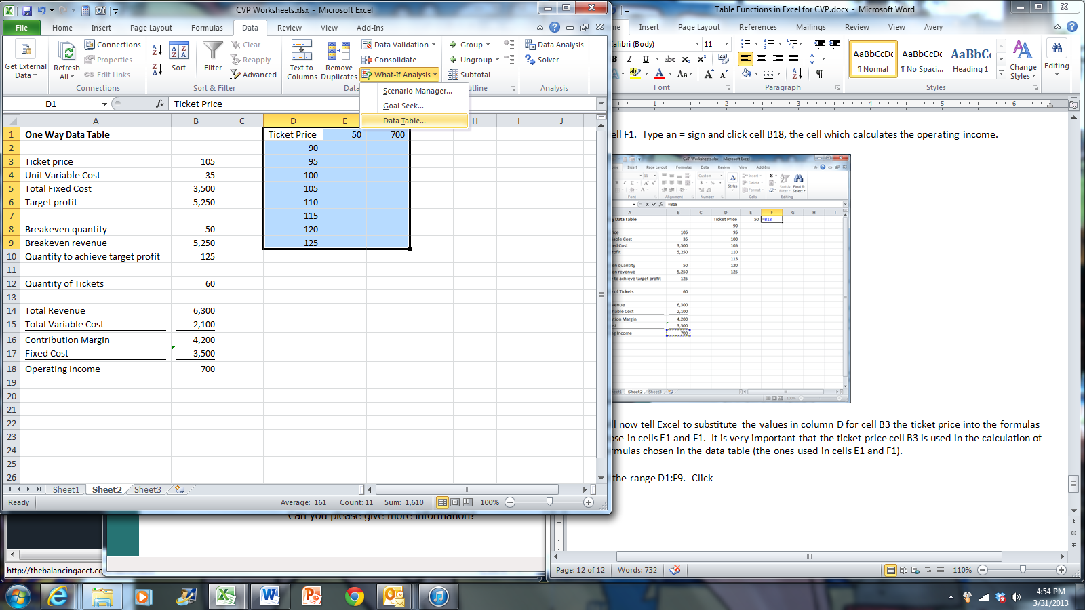

In the Data Table dialog box, click in the Column input cell box and click cell B3.

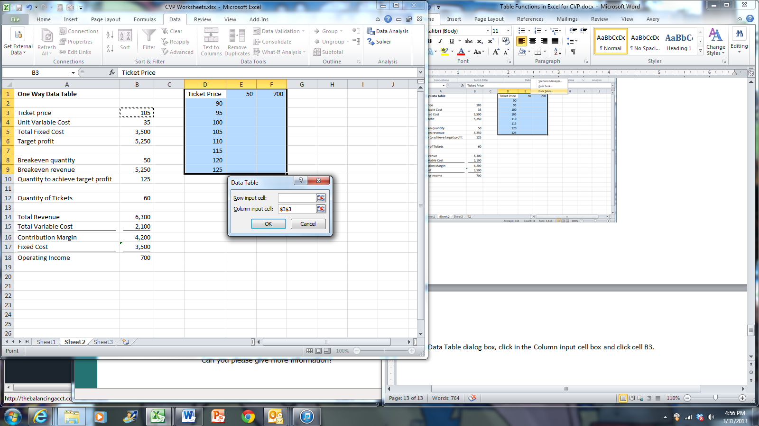

Click OK.

Click cell E1. Click the Home tab and click down arrow at the bottom right corner of the Number group.

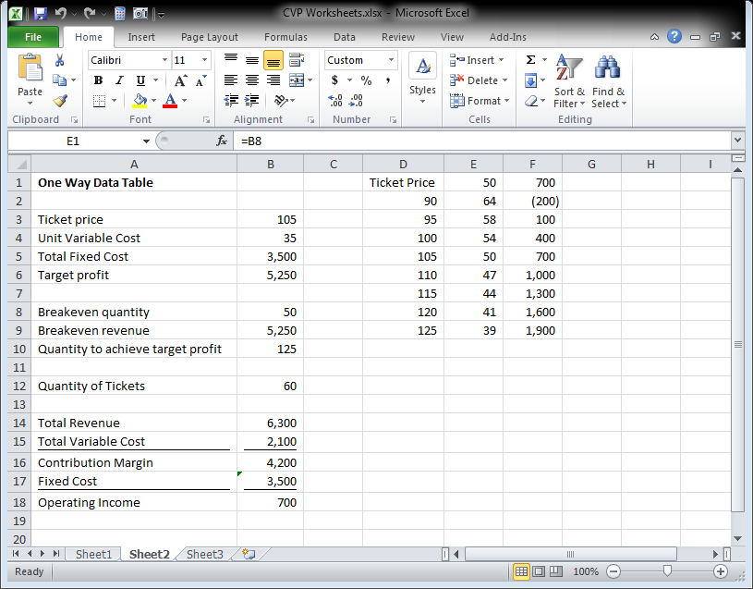

In the Format Cells dialog box, make sure the Number tab is selected. Under Category, click Custom. Click in the Type field and delete anything there. Then type “Breakeven Quantity” including the double quotes on both sides. Click OK.

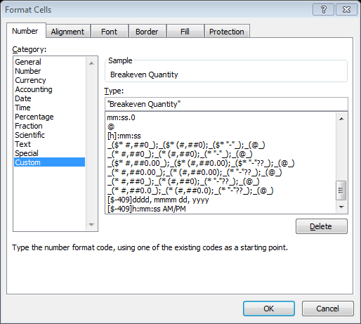

Click cell F1 and follow the same procedure to change the column header to “Operating Income”

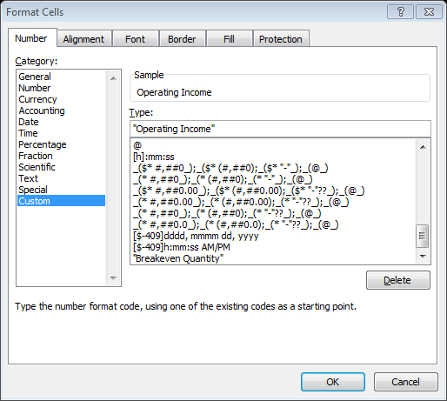

Click OK.

You have now created a table which calculates the breakeven quantity and operating income given different ticket prices.

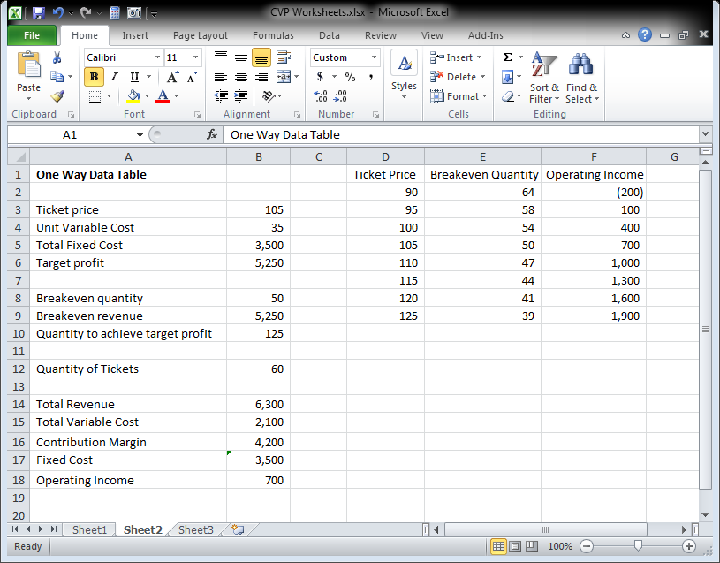

Two Way Data Table

With a two way data table we can analyze the effects of changing more than one input cell. Unfortunately, with a two way data table we can only have one result formula.

Let’s say that we want to calculate the operating income for various ticket prices and quantities. Click Sheet3. In column D I have already entered the ticket prices, and in row 1 I have entered in the quantities. Click cell D1, type an = sign and click cell B18, the operating income.

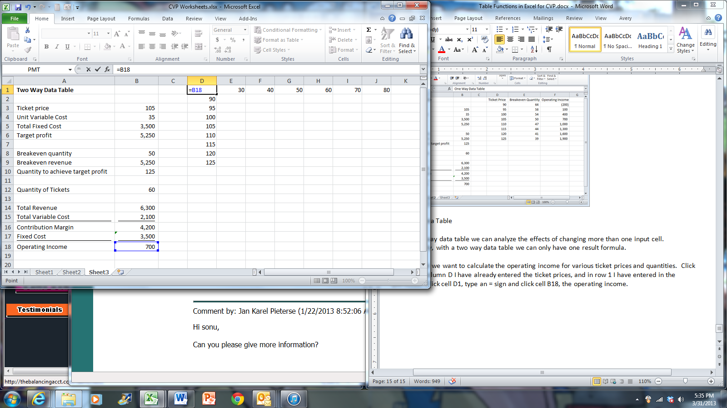

Select the range D1:J9. Click the Data tab. In the Data Tools group, click What-If Analysis, then Data Table.

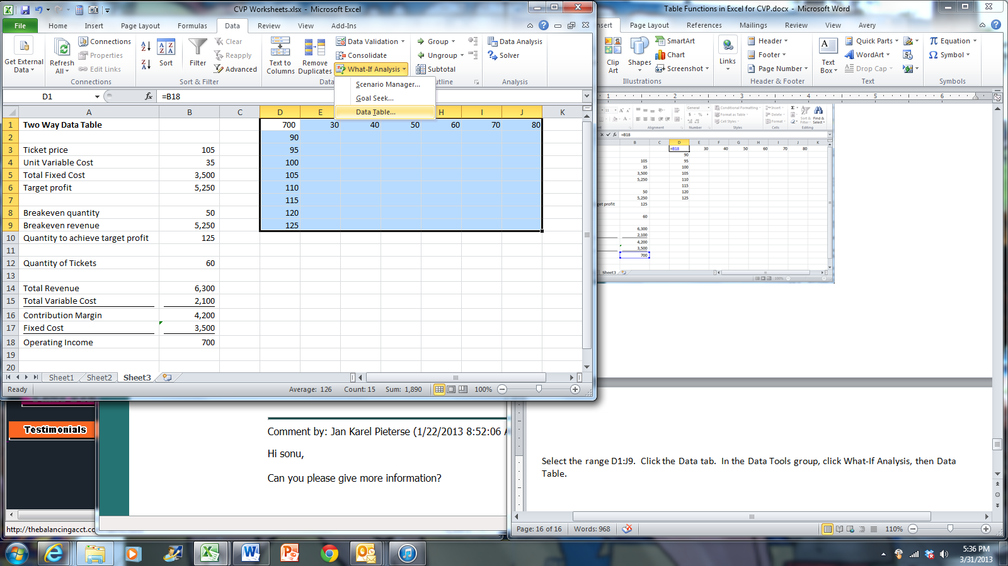

In the Data Table dialog box, click the Row Input cell box and click cell B12, the quantity of tickets. Then, click the Column Input cell box and click cell B3, the ticket price. You are instructing Excel to substitute the values found in column D for the ticket price in the operating income formula, and to substitute the values found in row 1 for the quantity of tickets in the operating income formula.

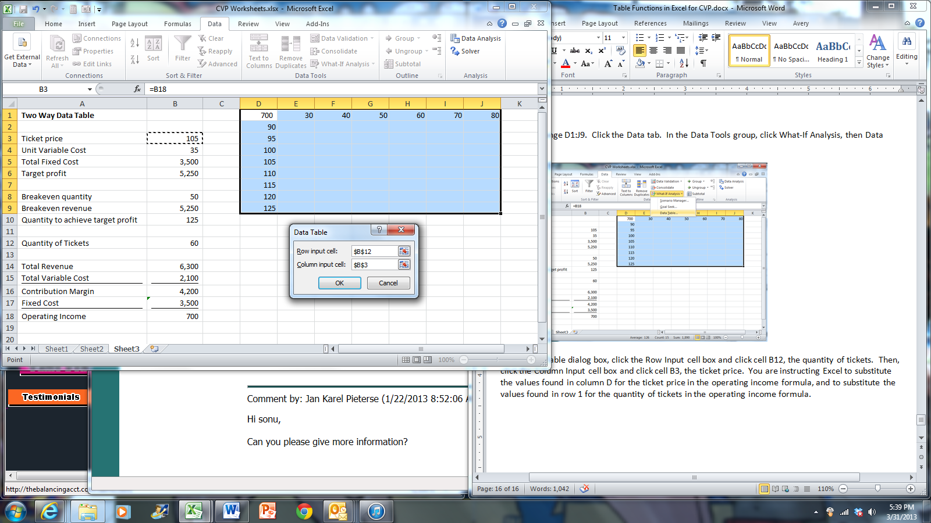

Click OK.

You have now created a table which calculates operating income based on different ticket prices and quantities. Use the custom formatting demonstrated above to change the display of the upper left hand corner cell of the table.

