Time Series and Comparative Financial Statements, Common Size Financial Statements

Time series financial statements show how well a company is doing over time. Comparative financial statements allow you to compare one company versus another. It is always best to compare companies in the same industry, for example BP vs. Exxon-Mobil, Apple vs. Microsoft.

Common Size Income Statement
It is very difficult to compare the income statement of one company to the income statement of another company. Each company has different amount of sales, cost of goods sold, operating expenses and taxes. Looking at the numbers alone, it is very difficult to judge performance.

Preparation of a common size income statement aids in the analysis. A common size income statement shows each line item as a percentage of that company’s sales. It is much easier to compare percentages than it is to compare numbers.

Open the Comparative Financial Statements worksheet. Click the Comparative Income Statement worksheet tab, if necessary.

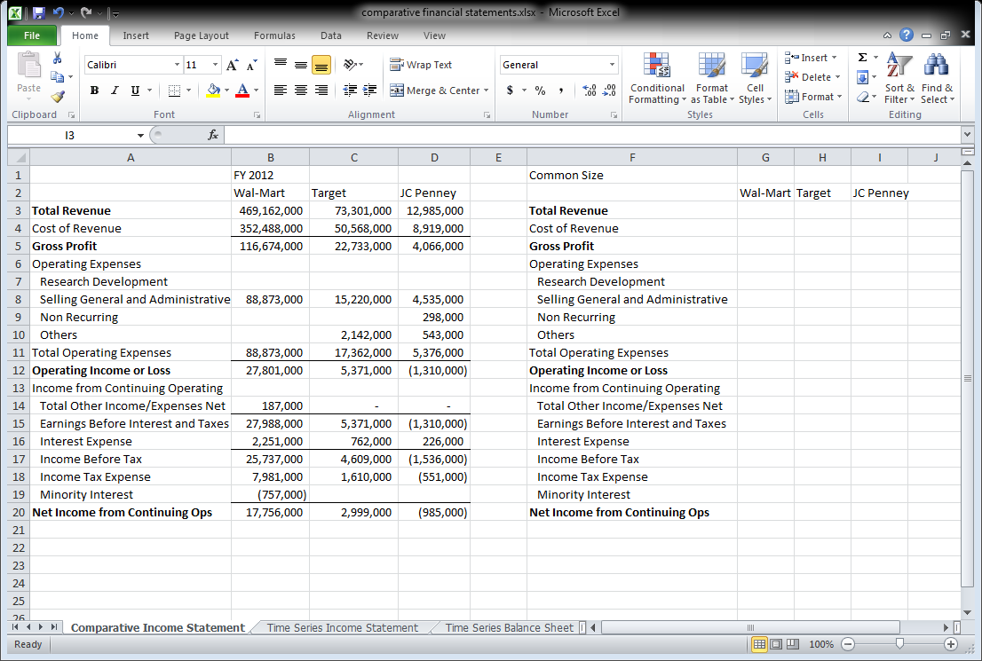
Exhibit TS- 1
Select the range G3:I20. Click the Home tab, if necessary. Click the Percent Style (%) icon in the number group. Click the increase decimal icon one time.


Exhibit TS- 2


Exhibit TS- 3

A side lesson on relative and absolute cell references

If I input the formula in =A1+B1 in cell C1, like this:


Exhibit TS- 4

I am NOT telling Excel to add the contents of cells A1 and B1 and display the results in cell C1. I am actually instructing Excel to take the cell that is in the same row as the current cell but two columns to the left and add the cell that is in the same row but only one column to the left, and display the results in the current cell.

If I copy that formula to cell E5 it will read =C5+D5.

If I change the formula in cell C1 to read =$A$1+B1, the dollar signs change the first cell reference to an absolute reference. I am now instructing Excel to take the contents of cell A1 and add it to the contents of the cell that is one column to the left, and in the same row, of the current cell. Therefore, when I copy the formula the first cell reference will always point to cell A1.

If I copy that formula to cell E5 it will read =$A$1+D5.

If I change the formula in cell C1 to read =$A1+B1, the dollar sign changes the first cell reference to a mix of relative and absolute references. I am now instructing Excel to take the contents of the cell that is in column A and in the same row as the current cell, and add it to the contents of the cell that is one column to the left, and in the same row, of the current cell.

If I copy that formula to cell E5 it will read =$A5+D5.

If I change the formula in cell C1 to read =A$1+B1, the dollar sign changes the first cell reference to a mix of relative and absolute references. I am now instructing Excel to take the contents of the cell that is two columns to the left of the current cell, but in row 1, and add it to the contents of the cell that is one column to the left, and in the same row, of the current cell.

If I copy that formula to cell E5 it will read =C$1+D5.
Common Size Income Statement

To produce a common size income statement, you take the income statement of one company and divide each line item by that company’s sales. Therefore, instead of being expressed in numbers, the company’s income statement is expressed as a percentage of sales.

To begin, click cell G3 and type the formula for sales as a percent of sales, =B3/B3. Do not hit enter yet.


Exhibit TS- 5

We could not copy this formula to any other cell as the results would be 100% for all formulas. If we use the formula =B3/$B$3, we could copy the formula down the Wal-Mart column, but it would not work for Target or JC Penney.

Instead, make the formula in cell G3 read =B3/B$3. That instructs Excel to take the cell that corresponds to the current cell, but to divide it by the amount in row 3 of the relative column. This one formula can now be copied to the range G3:I20 and have it work for all cells. Hit enter.

Double click the fill handle in cell G3 to copy the formula down column G. Then drag the fill handle to columns H and I to fill the formula in the desired area.


Exhibit TS- 6


Exhibit TS- 7

Common Size Balance Sheet
A common size balance sheet is similar to a common size income statement. With a common size balance sheet, all line items are expressed as a percent of total assets (which is the same as total liabilities and equity) as opposed to nominal dollar amounts.

Click the Comparative Balance Sheet worksheet tab in the comparative financial statements.xlsx workbook.

Select the range G4:I44. Click the

Click cell G4 and type the formula =B4/B$18. This divides the cash and cash equivalents of Wal-Mart by the total assets of Wal-Mart. The partial absolute reference ensures that we always divide by total assets, but the total assets will change to Target and JC Penney as we copy the formulas to the other columns.

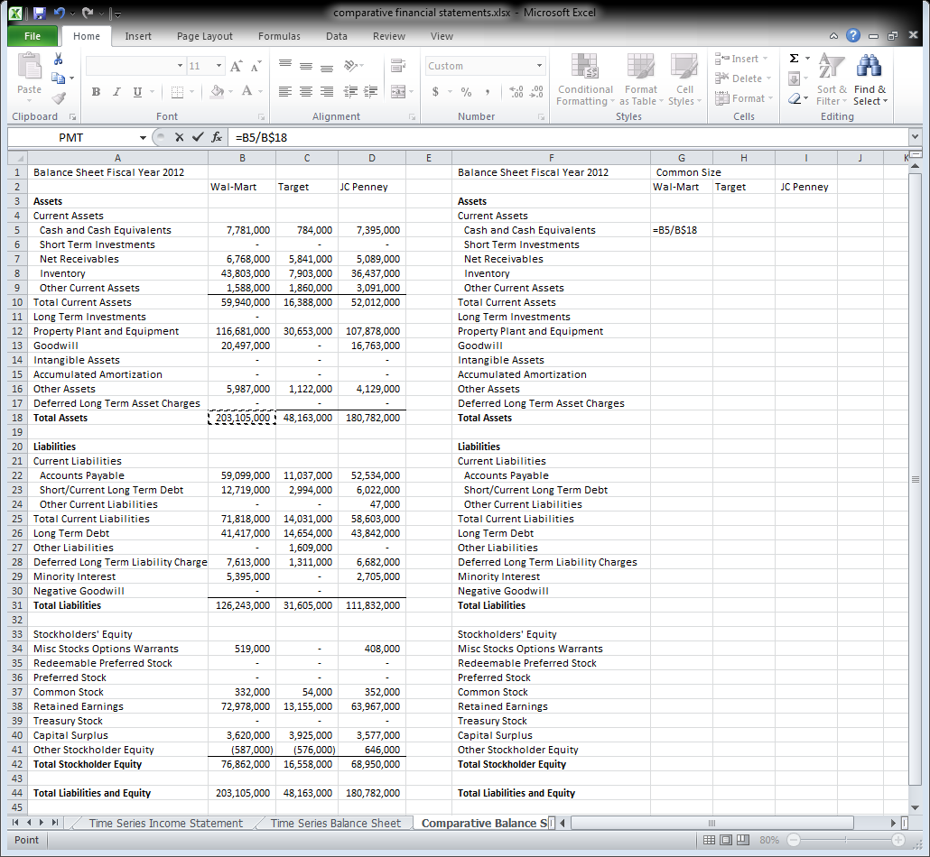
Exhibit TS- 8

Use the fill handle to copy the formula first across row 5 to column I and then down to row 18.

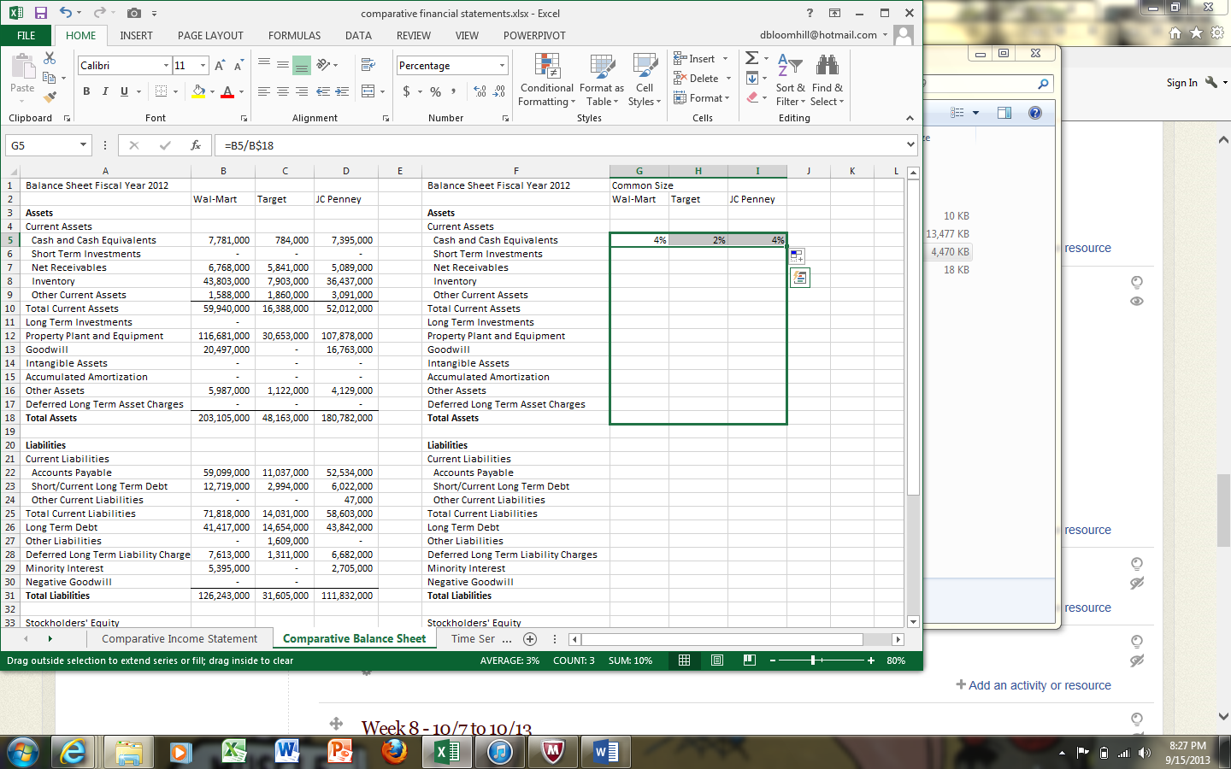
Exhibit TS- 9
Click cell G22. Enter the formula =B22/B$44. Hit enter.

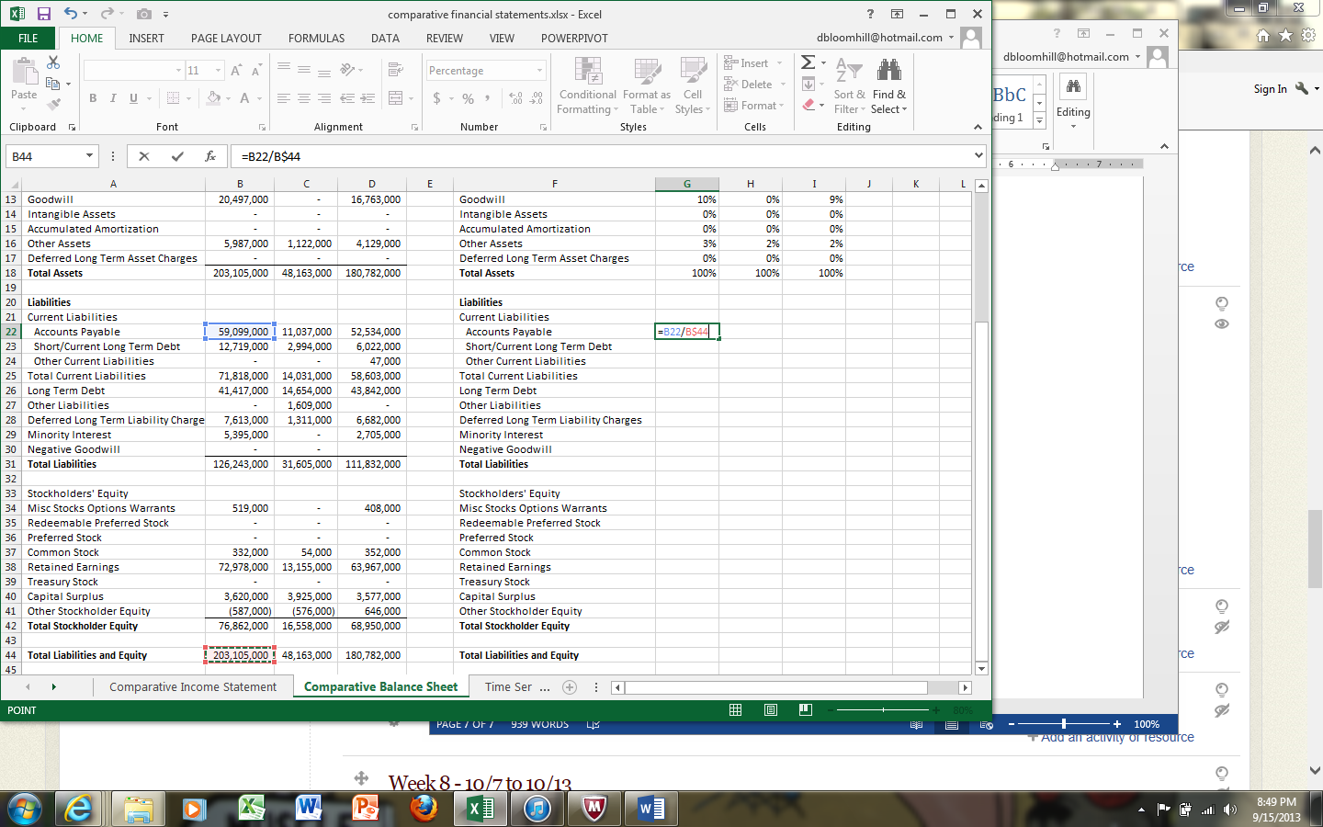
Exhibit TS- 10
Use the fill handle to copy the formula to the range G22:I31.

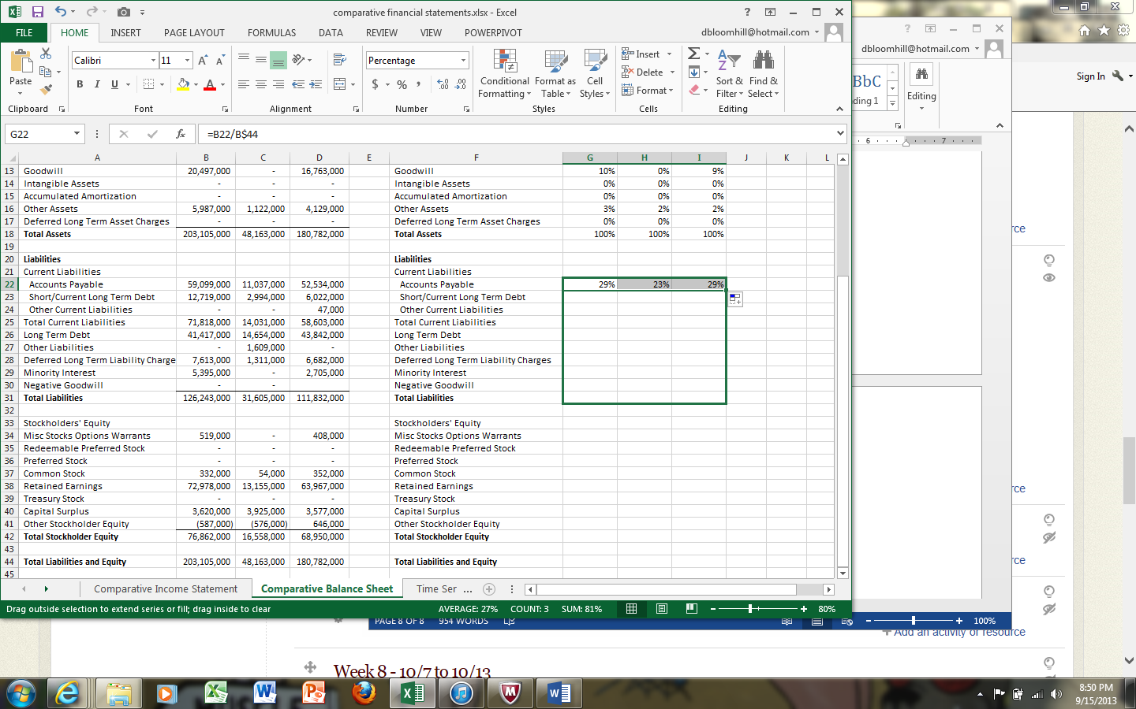
Exhibit TS- 11
Click cell G22 and click Copy (clicking any cell with the percentage formula will work). Then click cell G34 and click Paste. Then, use the fill handle to copy the formula first out to columns H and I, and then down to row 44.


Exhibit TS- 12

Exhibit TS- 13
Suppose you wanted to highlight all cells which are more than 25% of total assets. Select the range G3:I44, click the Home tab if necessary, and click Conditional Formatting in the Styles group.

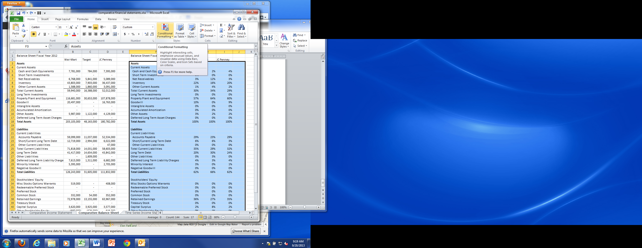
Exhibit TS- 14

Click Highlight Cells Rules, then Greater Than.


Exhibit TS- 15
Type 25% in the Format Cells that are GREATER THAN. Click OK.


Exhibit TS- 16
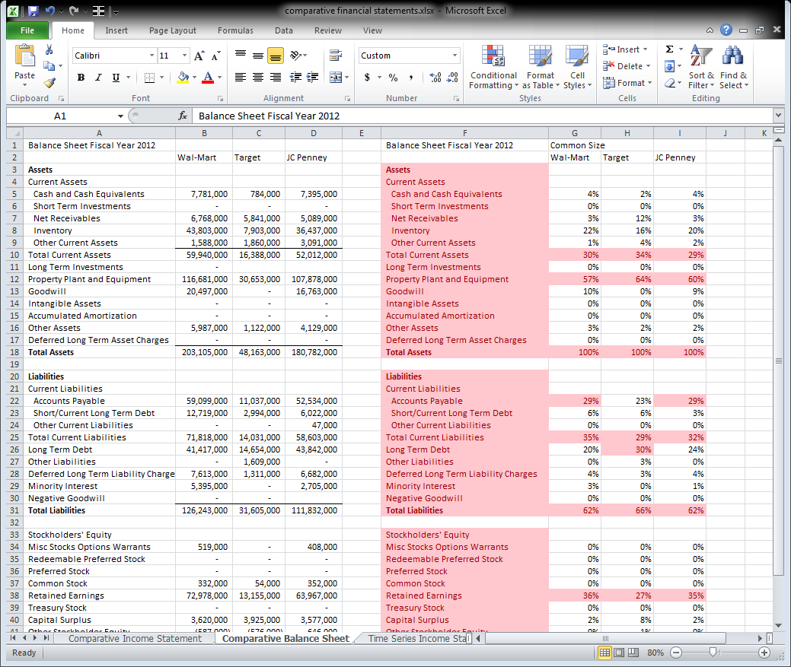
Exhibit TS- 17
Time Series Financial Statements

With time series financial statements, you are trying to figure out how one company is doing over time. You pick a base year, which is the earliest year you have financial statements for. Then, each line item is divided by the base year line item. For example, for sales, you would take 2011 sales and divide by 2011 sales (if 2011 is the base), then take 2012 sales and divide by 2011 sales, then take 2013 sales and divide by 2011 sales. You would do the same for cost of goods sold, 2011 COGS divided by 2011 COGS, 2012 COGS divided by 2011 COGS, and 2013 COGS divided by 2011 COGS.

Click the tab names “Time Series Income Statement.” Click cell E3.

We want to use a mix of relative and absolute cell references. What we want to do is take the number for the current year, and always divide by the number in the same row but in column B.

In cell G3, type the formula =D3/$D3.

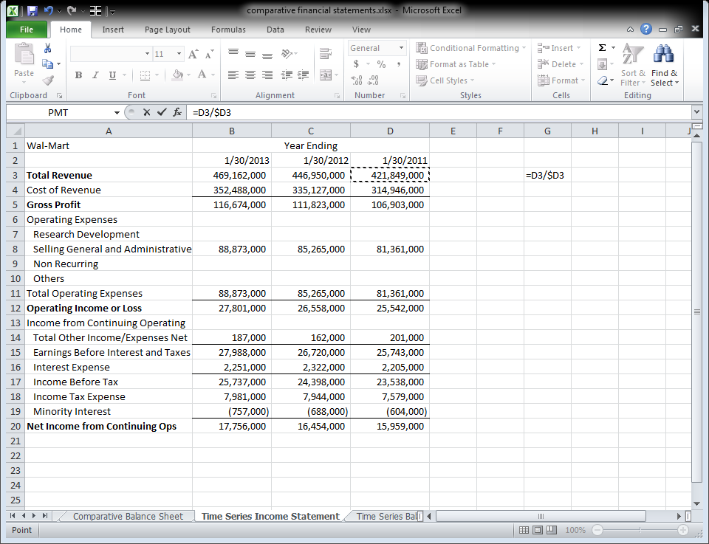
Exhibit TS- 18
Use the fill handle to copy the formula first to columns F and E, and then down to row 20. Delete all the cells which read #DIV/0!


Exhibit TS- 19
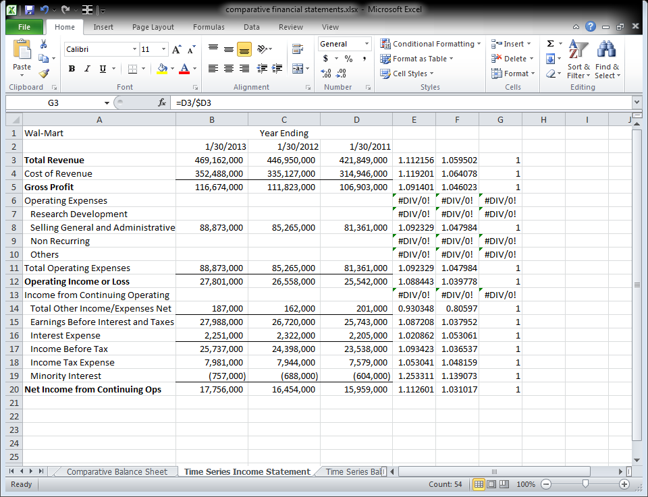
Exhibit TS- 20
Try to create the time series balance sheet on your own this weekend.

