**Scenario Manager**

Scenario manager in Excel is ideal to demonstrate what if analysis. Scenario manager allows you to input changing cells, and save and display the results of the analysis. I will demonstrate the use of scenario manager with flexible budgeting.

I have already input the formulas and constants necessary to calculate the flexible budget given a selling price and unit costs for materials, labor and overhead. I will use quantities of 10,000 15,000 and 20,000 units.

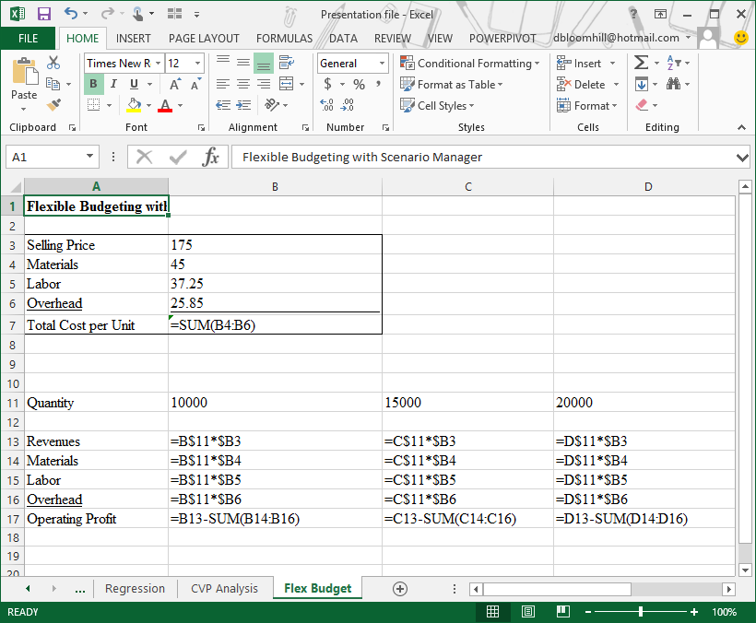

For the Scenario Manager to work correctly, you input changing cells, and use formulas which depend upon the values in the changing cells. I intend to allow the computer to change the unit values in the box, and display the resultant flexible budget below.

*Note: the use of absolute references allows me to input the formulas in column B of the flexible budget, and copy those formulas to columns C and D. This would also be a good topic for an Excel class.*

Click the Flex Budget worksheet tab. Before we use scenario manager, we will name some cells. Click cell B3, right click and choose Define Name from the menu.

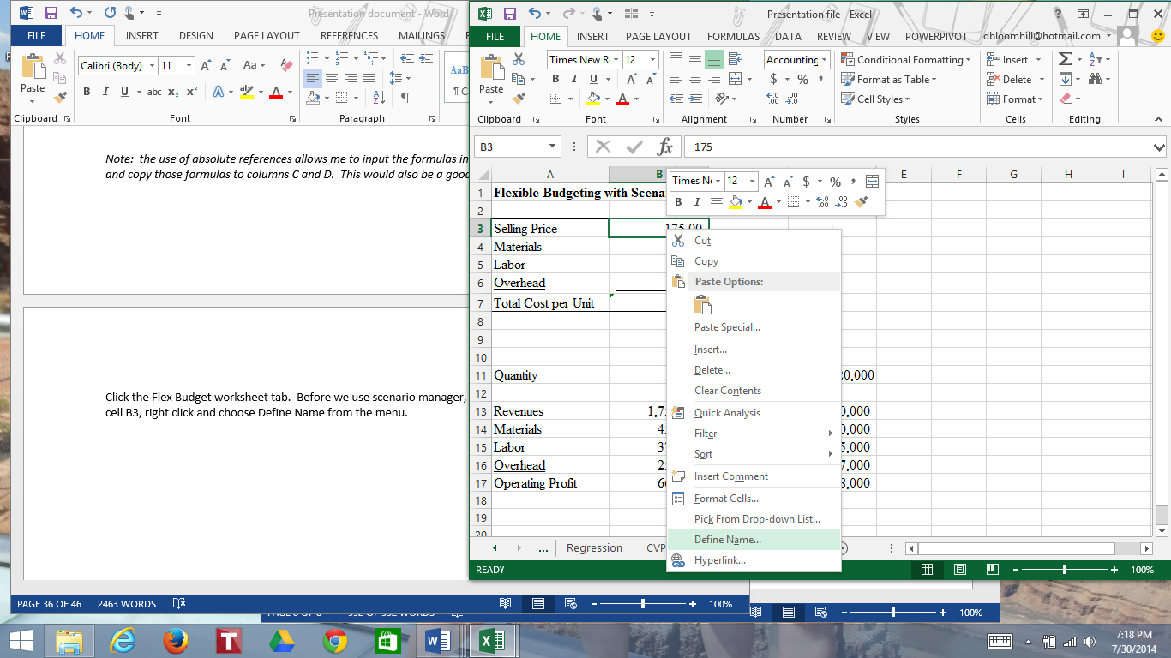

When the New Name dialog box appears, type Price in the Name box. Click OK.

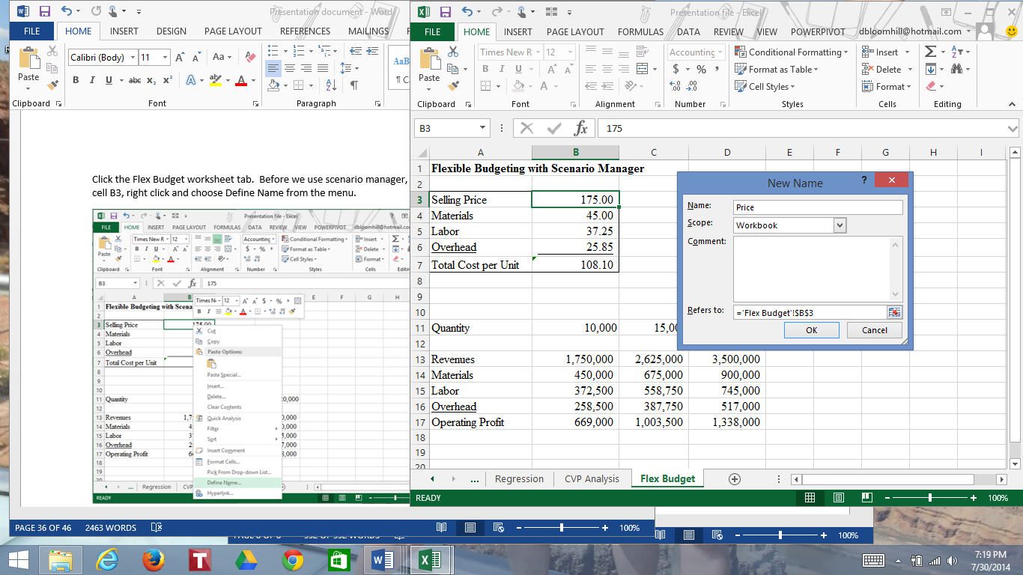

Use the same procedure to name cell B4 Materials, name cell B5 Labor and name cell B6 Overhead.

Click the Data tab, and in the Data Tools group click What if Analysis, then Scenario Manager.

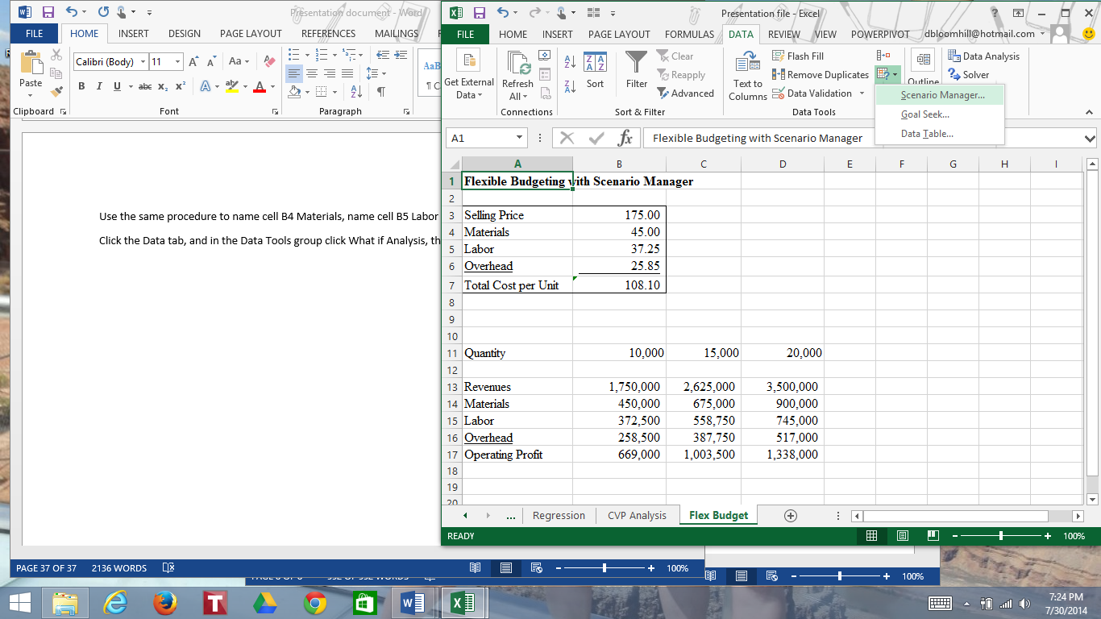

When the Scenario Manager dialog box appears, click Add to create a new scenario.

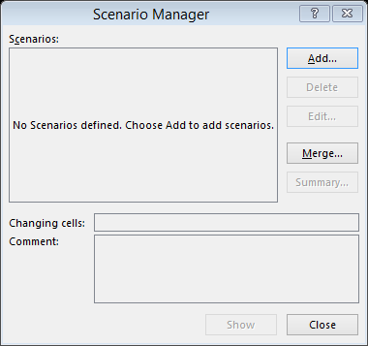

When the Add Scenario dialog box appears, type Most Likely in the Scenario name box. In the changing cells box, click the range B3:B6. Click OK.

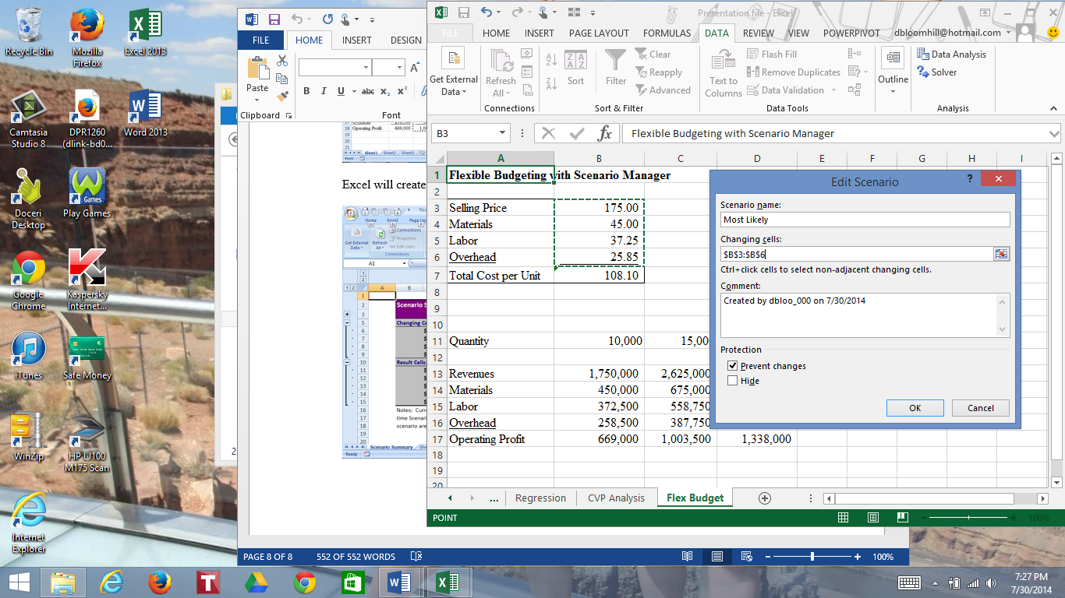

When the Scenario Values dialog box appears, accept the defaults for price, materials, labor and overhead. Click Add (click OK when you are finished entering scenarios).

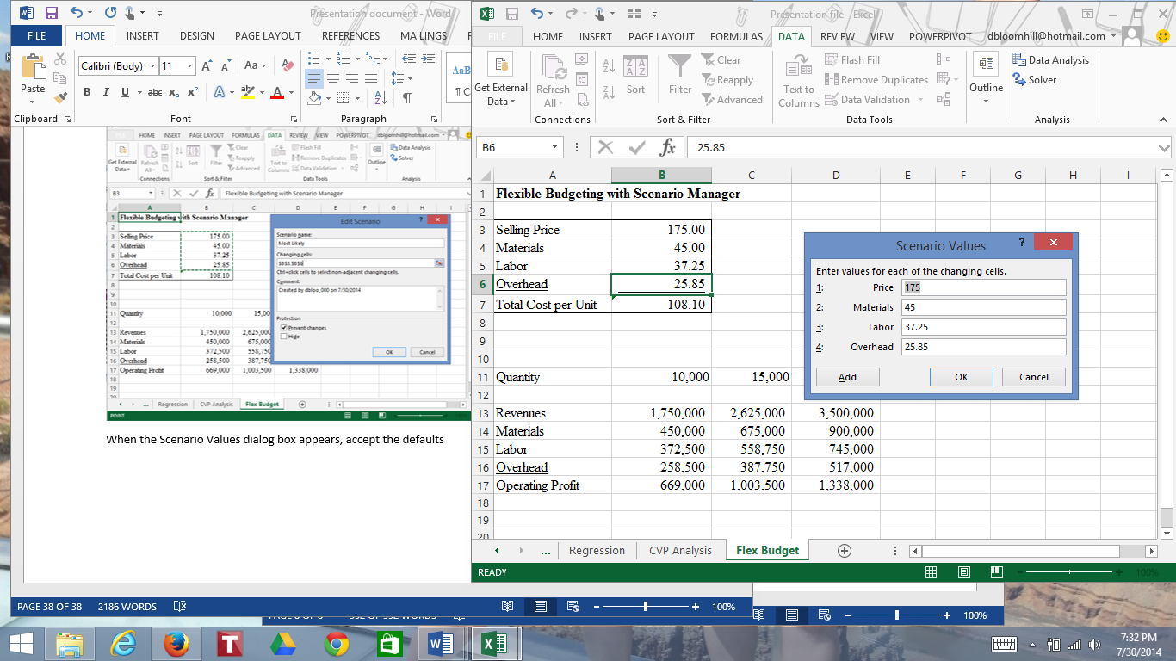

When the Add Scenario dialog box appears, call the new scenario High Price and Cost. Use the same changing cells and comment.

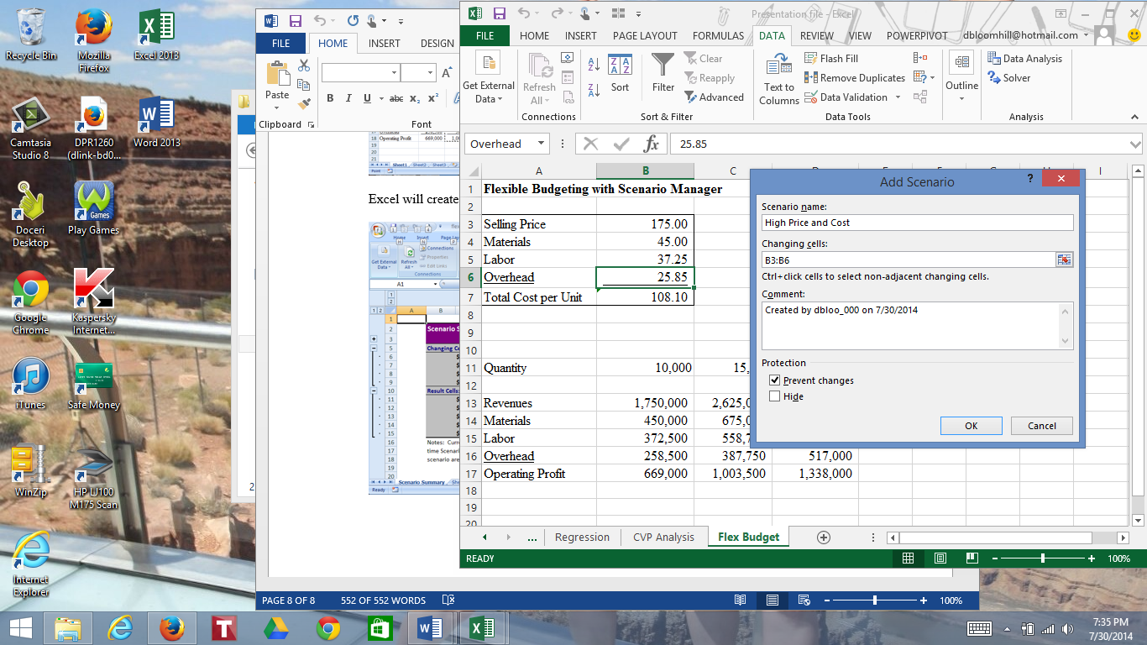

When the Scenario Values dialog box appears, enter the values Price of 200, Materials of 60, Labor 45 and Overhead 30. Click Add.

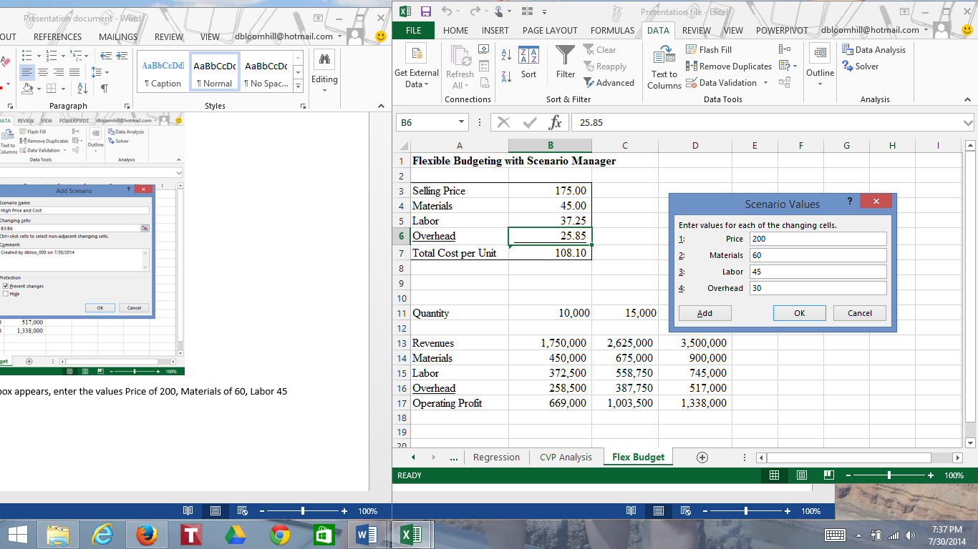

When the Add Scenario dialog box appears, enter Low Price and Cost in the scenario name, and accept the other defaults. Click OK.

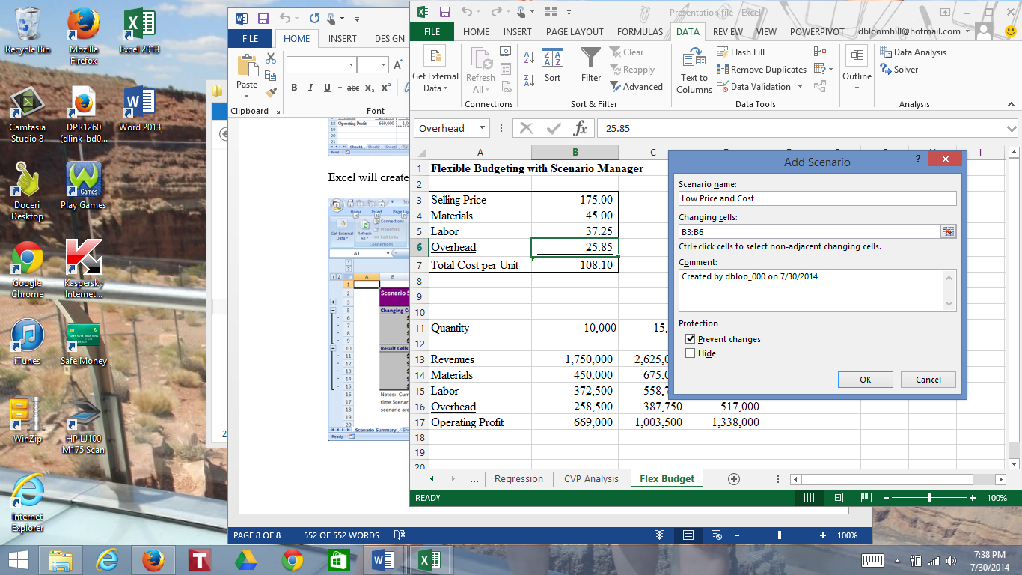

When the scenario values dialog box appears, enter 150 for Price, 40 for Materials, 30 for labor and 20 for Overhead. Click OK.

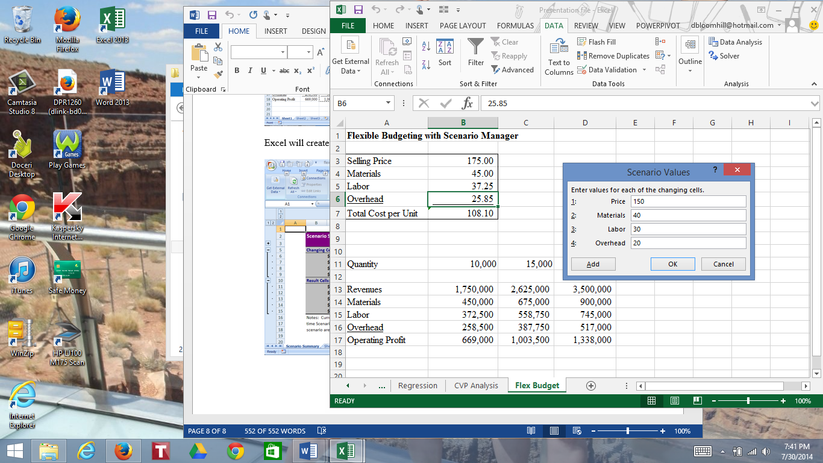

When you get to the Scenario Manager dialog box, you can show the results of any scenario by clicking the scenario name at the top and then the Show button at the bottom of the dialog box.

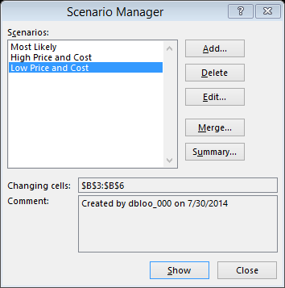

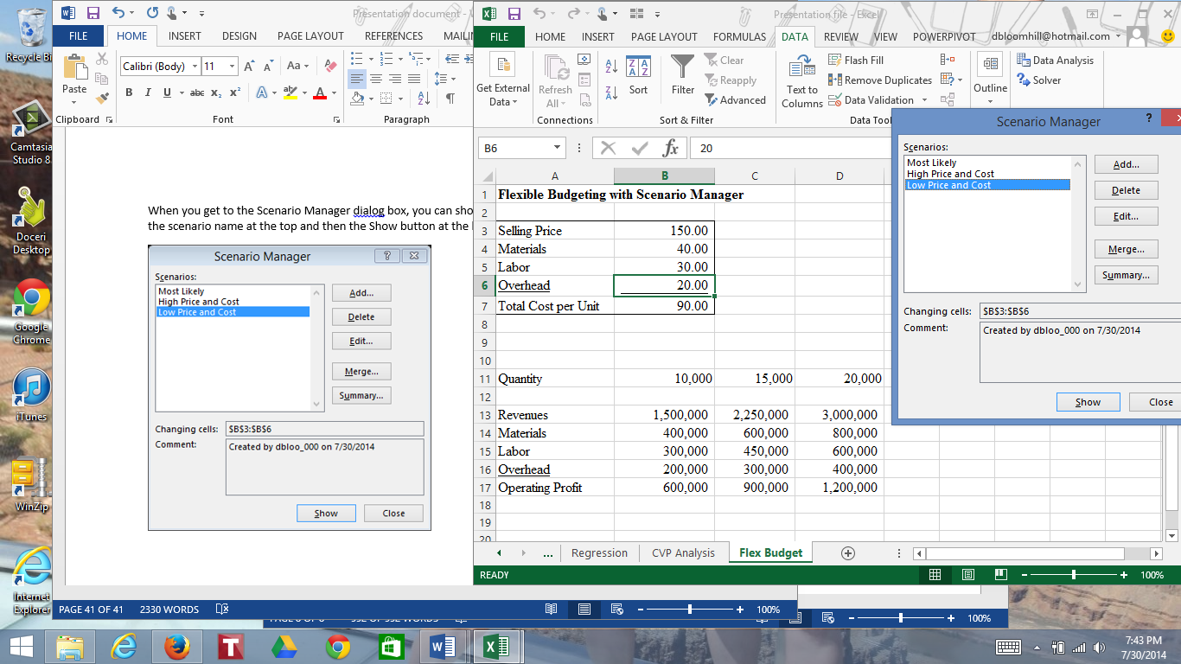

We will now create a scenario summary report. I have already named the appropriate ranges.

In the Scenario Manager, click the Summary button on the right.



Accept the default for Scenario summary report, for result cells, click cell C11, hold down the Control key, and click the range C13:C16. Click OK.

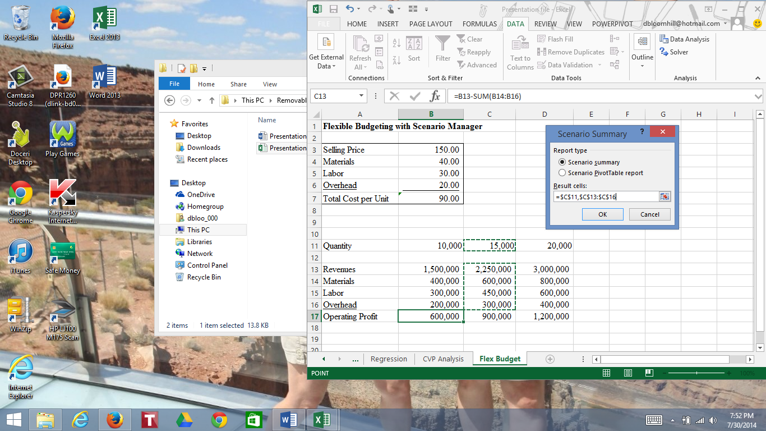

What you get is a nice summary report which shows the values of the changing and result cells.

