**Liabilities Part 2**

**Leases**

Leases are similar to installment loans. Installment loans have equal payments. They are designed so that each payment pays all interest due and a part of the principal. At the time the last payment is made, all principal and interest have been repaid.\

With a lease, you also make equal payments. Each payment is also designed to pay all of the interest due plus a part of the principal. The difference is that with a lease, at the time of the final payment you still owe principal on the loan.

We will not prepare an amortization chart for a lease because it is identical to the amortization chart for an installment loan. The difference is that the amortization chart for an installment loan ends at zero, because all principal and interest are repaid after the final payment. With a lease, the amortization chart ends with the residual value (the principal still owed after the last payment of the lease).

Example:

You would like to compare the monthly payments on an installment loan and a lease. The details of the installment loan are: cost of car $20,000; down payment $3,000, annual rate 5.5%, 5 year term. The details of the lease are: cost of car $20,000; term of lease 3 years, imputed interest rate 9%; residual value $13,000.

Input the basic information for both loans:

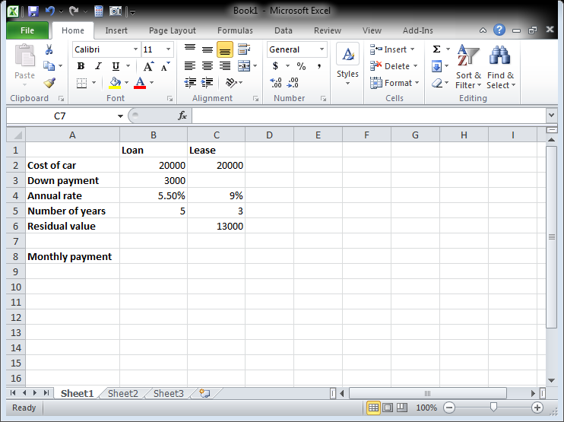

Exhibit Liab-

Click cell B8. Click the Formulas tab. Click the down arrow next to Financial in the Function Library group and click PMT.

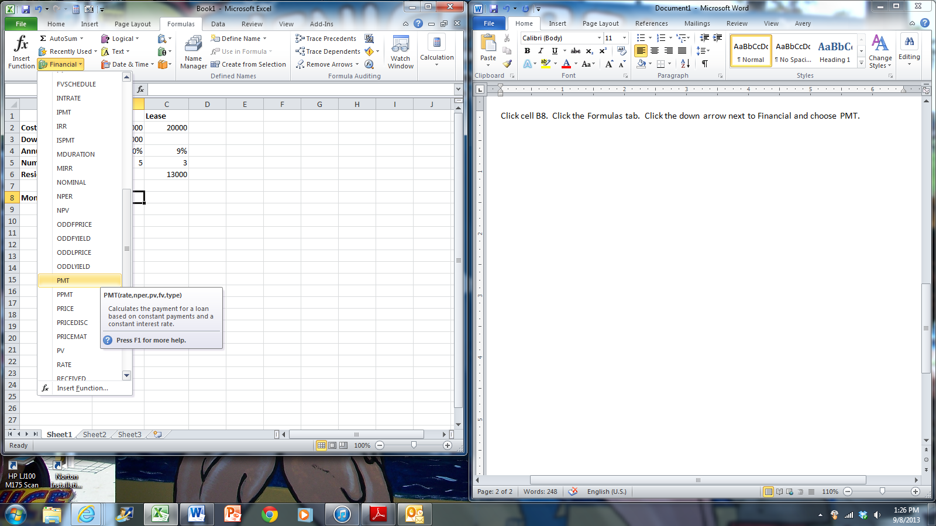

Exhibit Liab-

In the Rate box, click cell B4 and type /12 (divide by 12). In the Nper box, click cell B5 and type 812 (multiply by 12). In the PV box, type –(B2-B3). This is the cost of the car minus the down payment, expressed as a negative number. Click OK.

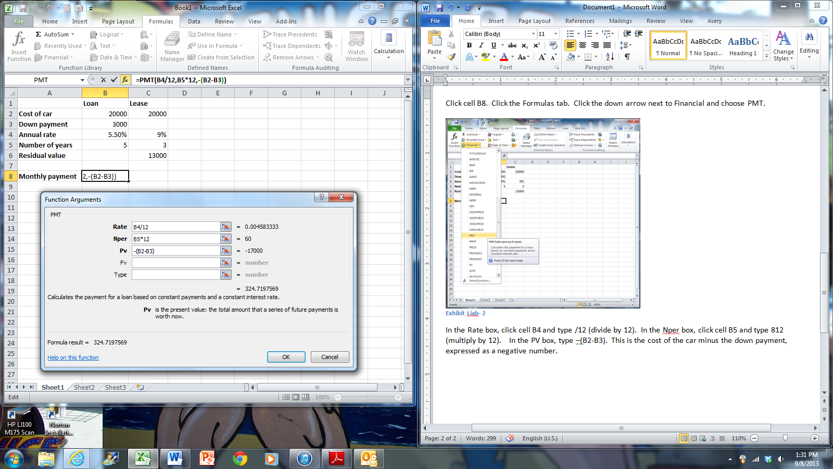

Exhibit Liab-

To calculate the payment on the lease, click cell C8. Click the Formulas tab, click the down arrow next to Financial in the Function Library group, and choose PMT.

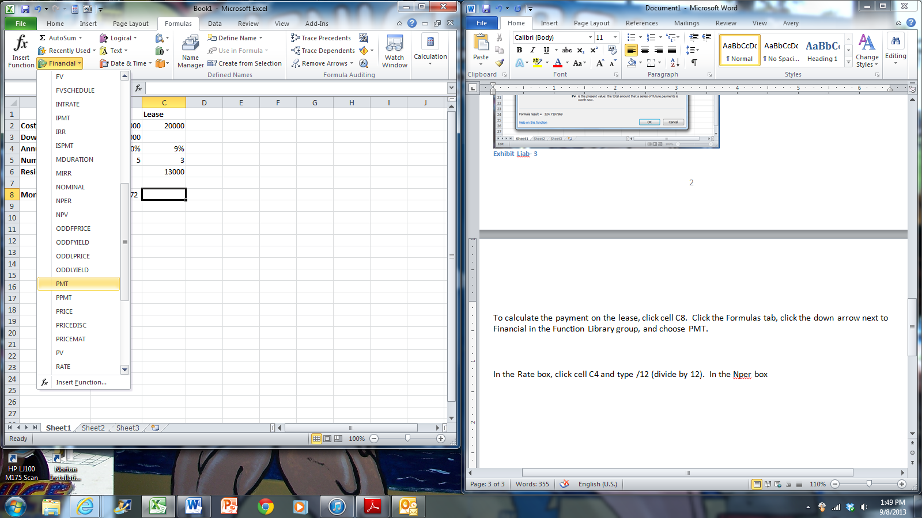

Exhibit Liab-

In the Rate box, click cell C4 and type /12 (divide by 12). In the Nper box, click cell C5 and type 812 (multiply by 12). In the PV box, type a – sign and click cell C2. In the FV box, click cell C6. Click OK.

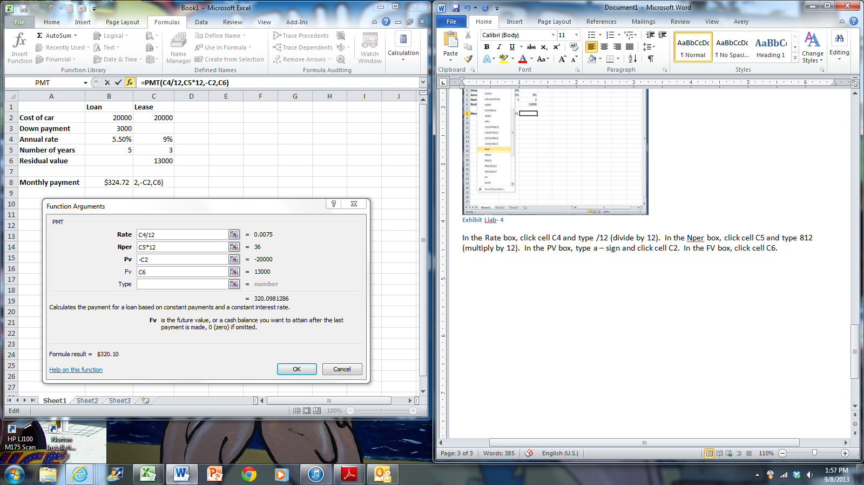

Exhibit Liab-

To calculate the total interest paid, take the sum of all payments and subtract the principal paid over the loan. For the installment loan, calculate the total of all payments and subtract the amount financed, which is the cost minus the down payment. The total of all payments is the monthly payment * the number of years * 12. Click cell B9 and enter the formula =B8*-B5*12-(B2-B3). Hit enter.

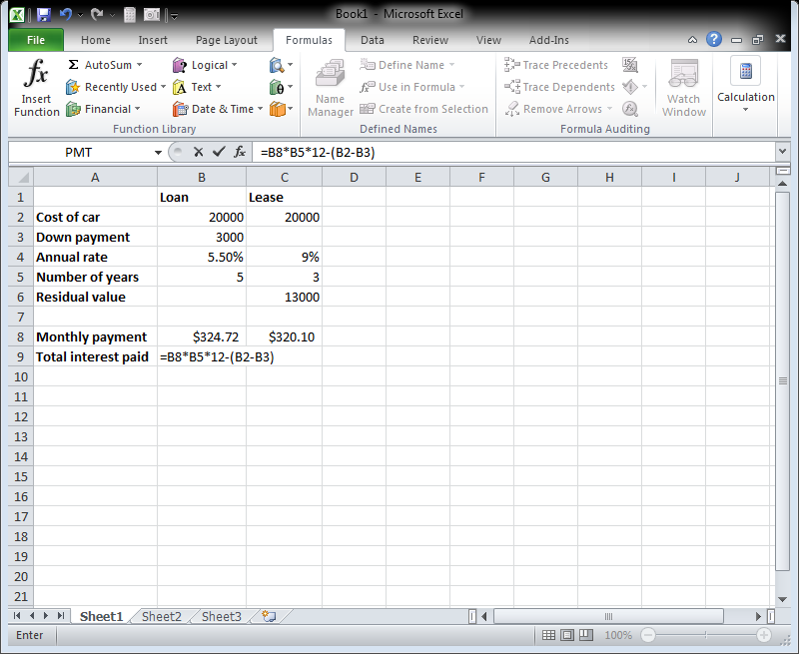

Exhibit Liab-

For the total interest paid on the lease, it is the total of the payments minus the principal paid. The total of the payments is the monthly payment * the number of years * 12. The principal paid is the cost minus the residual value. Click cell C9 and enter the formula =C8*C5*12-(C2-C6). Hit enter.

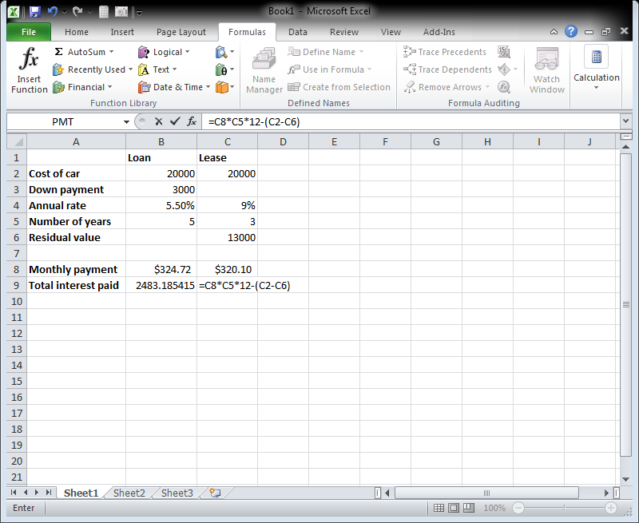

Exhibit Liab-

**To calculate the annual interest rate on a lease**

You see an advertisement for a car lease. The terms are $200 per month for 3 years with a residual value of $11,000. You check online and find that the cash price for a similar car is $14,500. As one of the pieces of information you need in the decision to lease or buy, you want to calculate the interest rate the dealer is imputing on the lease.

Click Sheet2. Click cell B7. Click the Formulas tab. In the Function Library group, click the down arrow next to Financial and click RATE.

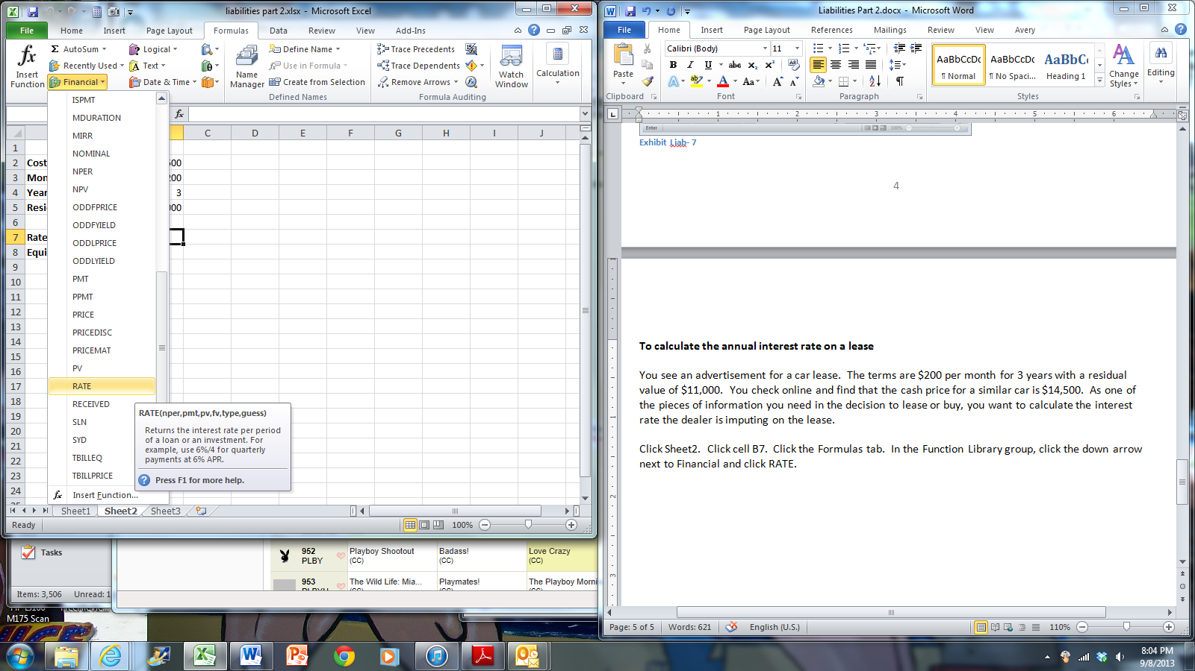

Exhibit Liab- 8

In the Nper box, click cell B4 and type *12 (multiply by 12). In the Pmt box, type a – sign and click cell B3. In the PV box, click cell B2. In the FV box, type a – sign and click cell B5. Click OK.

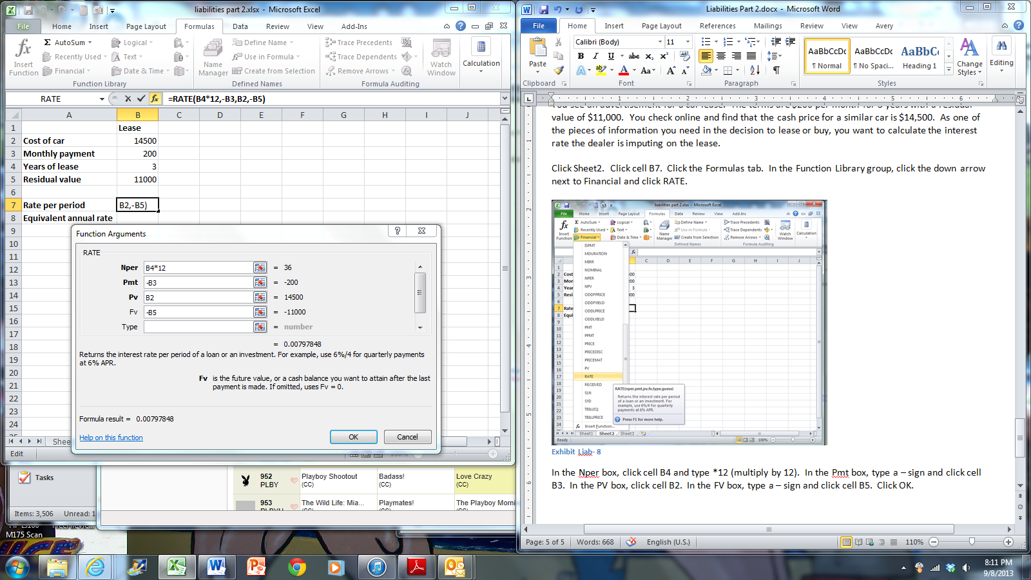

Exhibit Liab- 9

VERY IMPORTANT! The answer is the rate per MONTH, not the annual rate. To get the equivalent annual rate, you need to multiply the rate per period by 12.

Click cell B8. Type the formula =B7*12. Hit enter.

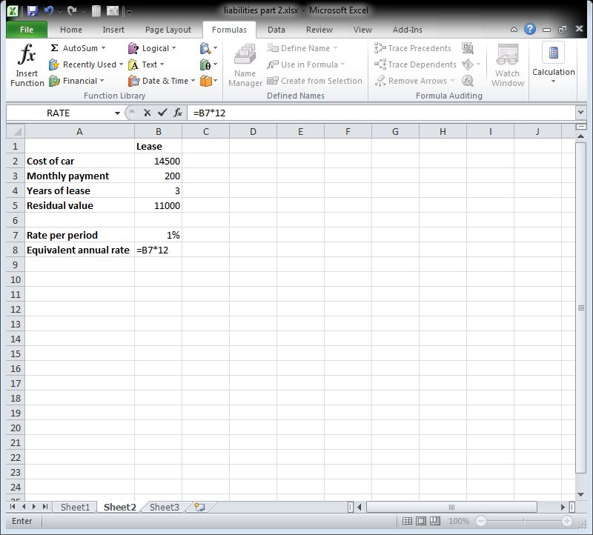

Exhibit Liab- 10

The interest rate the dealer is charging is 9.6%.

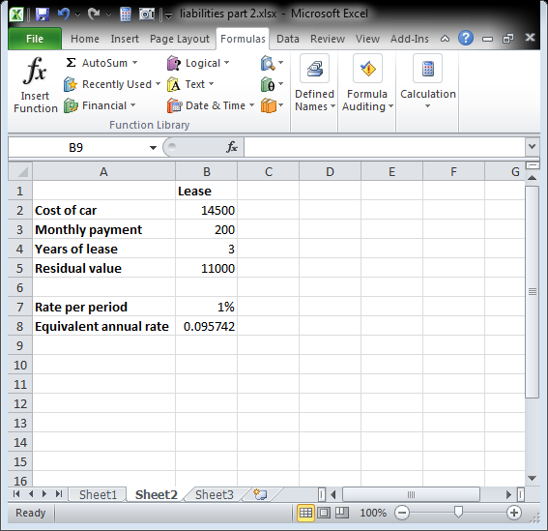

Exhibit Liab- 11

**Bonds**

Bonds are a particular type of liability. When a company issues a bond, it is borrowing money. When investors buy bonds, they are loaning money to companies.

Bonds have qualities which do not change over the life of the bond: face value, coupon rate, and maturity date. Those qualities determine how much money, and when, the company pays (and the investor receives).

For example, a bond with a $1,000 face value, 6% coupon payable semi-annually with maturity in 10 years means that the company must pay:

$1,000 * .06 * ½ = $30 every 6 months for the next 10 years, plus

A one time payment of $1,000 at the end of 10 years

These qualities and cash flows do not change, even if an investor sells the bond to another investor. Whoever buys the above bond, whether they pay $1, $1,000 or $100,000, is entitled to $30 every 6 months for 10 years and $1,000 at the end of 10 years.

Since the bond is a tradable instrument, the price changes every day and is a function of the underlying interest rates in the economy and the relative financial soundness of the issuing company. To find the price an investor is willing to pay, calculate the cash flows (like above) and take the present value at a rate of return the investor would like to earn (yield rate). Let’s use 3% for a yield rate.

Click Sheet3. Click cell B10 and click the Formulas tab. In the Function Library group, click the down arrow next to Financial and click PV.

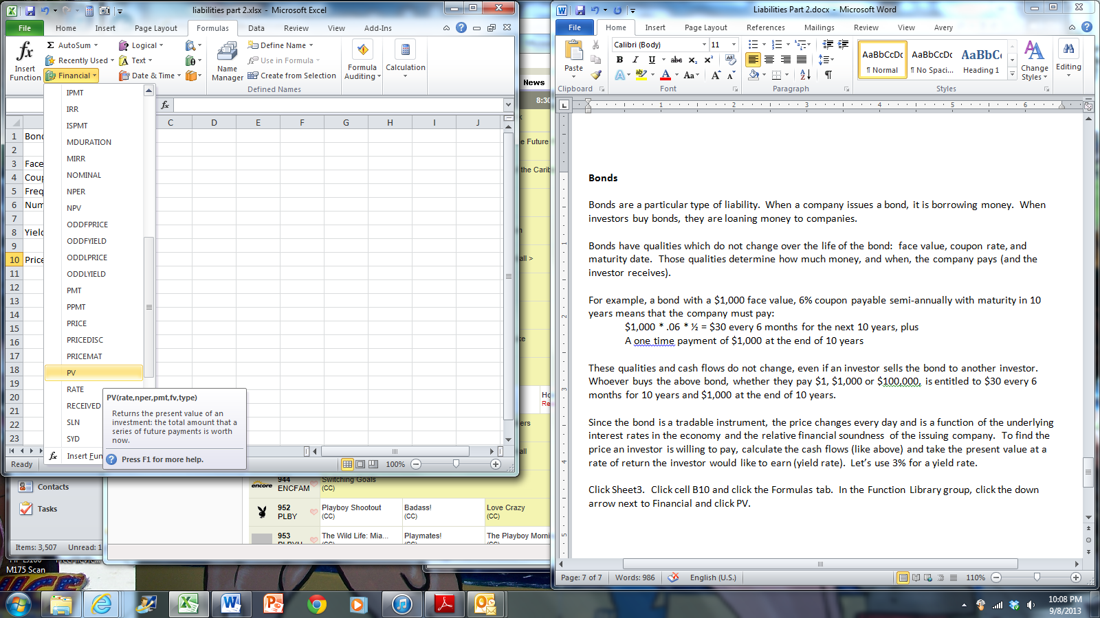

Exhibit Liab- 12

In the Rate box, type B8/B5. Hint: If you use the coupon rate, the answer will be exactly $1,000. In the

Nper box, type B6*B5. In the Pmt box, type -B3*B4/B5. In the Fv box, type –B3. Click OK.

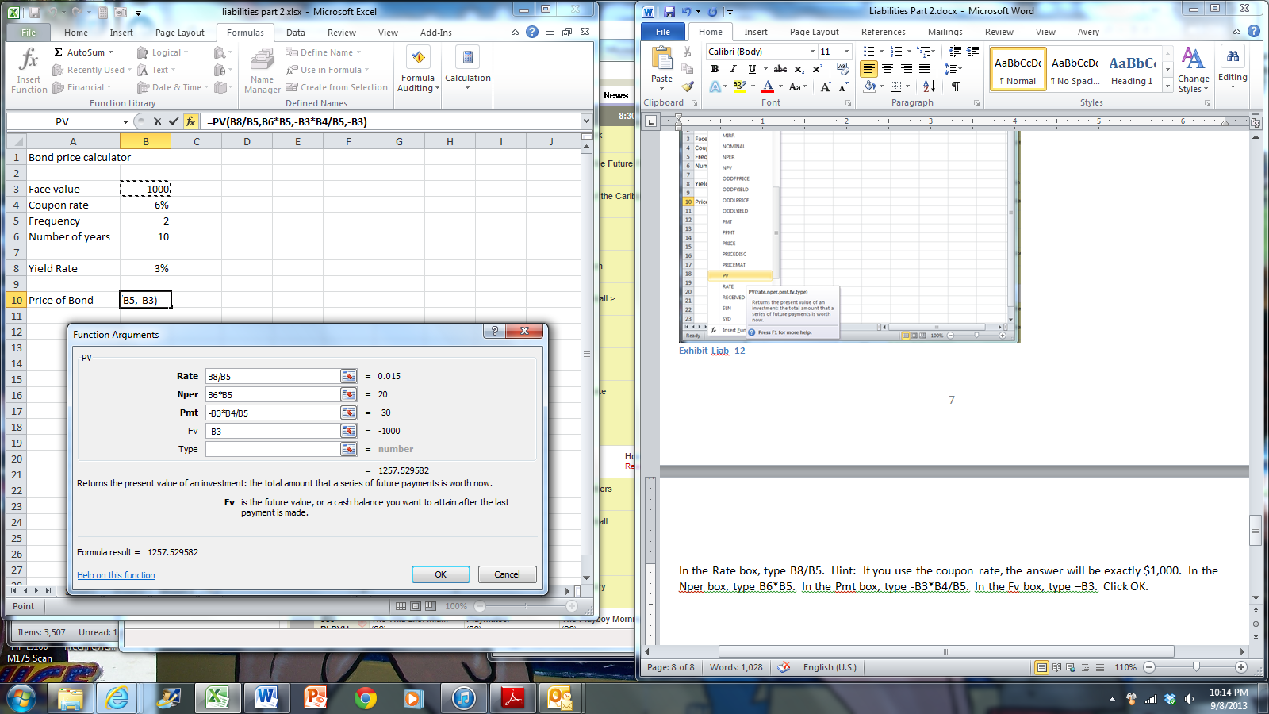

Exhibit Liab- 13

To construct the amortization chart, use the fill handle to fill the numbers 1-20 from cell A14 down.

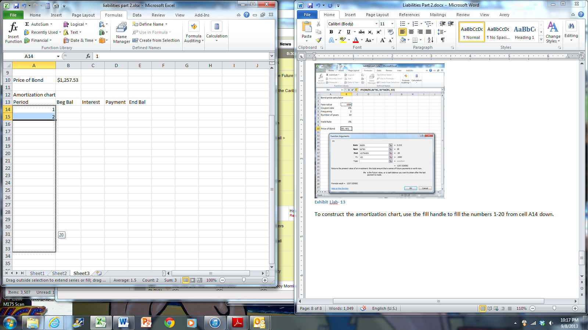

Exhibit Liab- 14

The beginning balance of the obligation is the price of the bond. In cell B14, type the formula =B10.

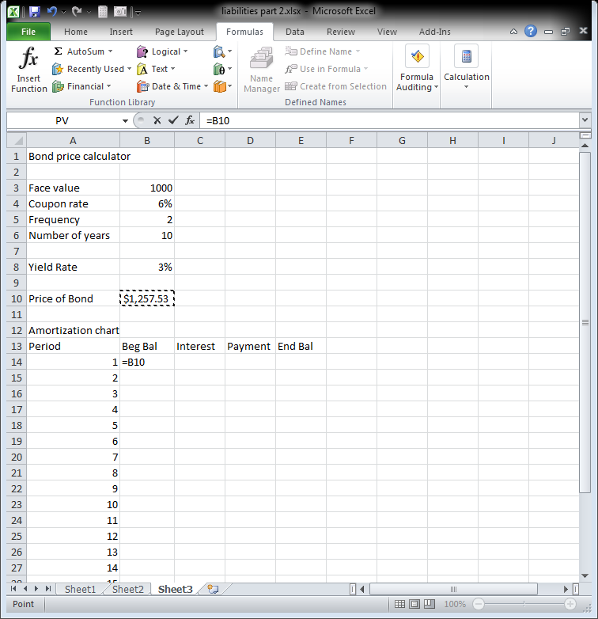

Exhibit Liab- 15

Use the principal * rate * time formula to calculate the interest. In cell C14, type the formula =B14*$B$8/$B$5 (note the use of absolute cell references for the yield rate and the frequency)..

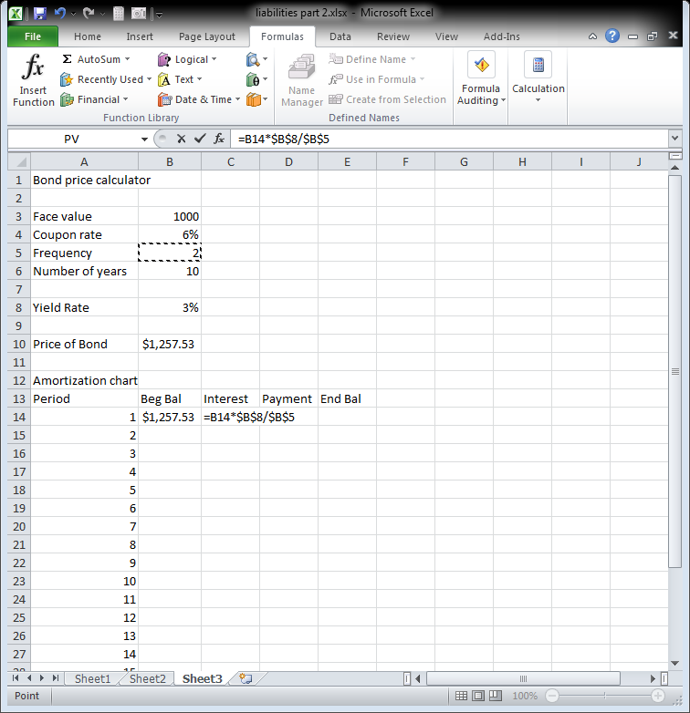

Exhibit Liab- 16

The payment is the face value * the coupon rate / frequency. In cell D14, type the formula =$B$3*$B$4/$B$5.

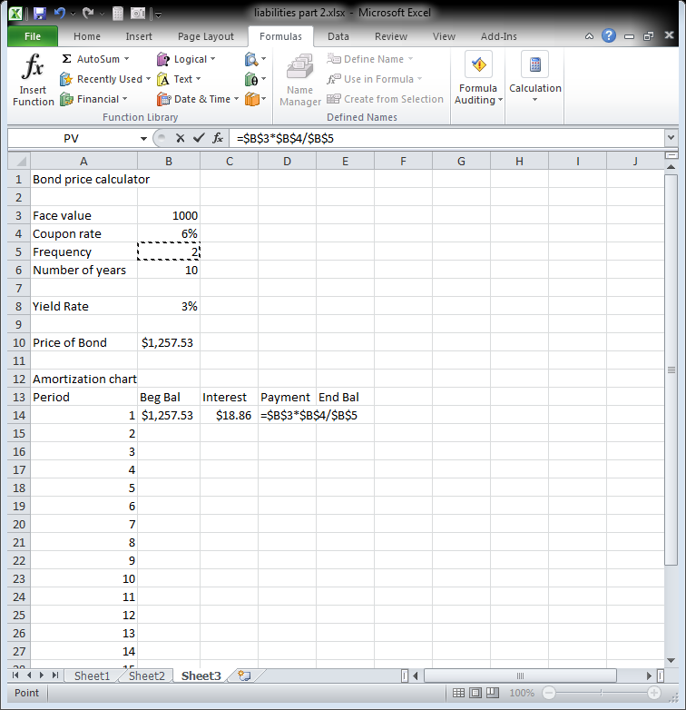

Exhibit Liab- 17

Just like the amortization chart for an installment loan, the ending balance is the beginning balance + interest – the payment. In cell E14, type the formula =B14+D14-E14.

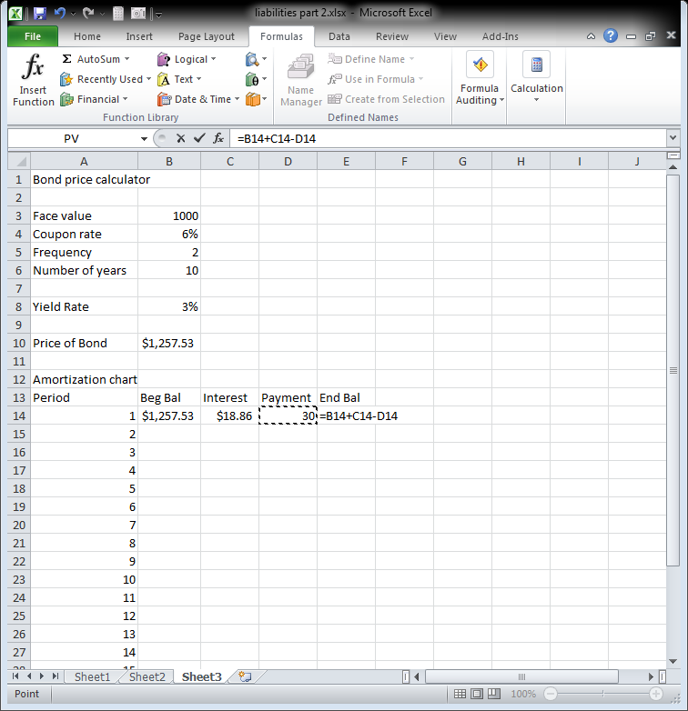

Exhibit Liab- 18

The final formula we need to enter: the ending balance of one period is the same as the beginning balance of the next period. In cell B15, type the formula =E14.

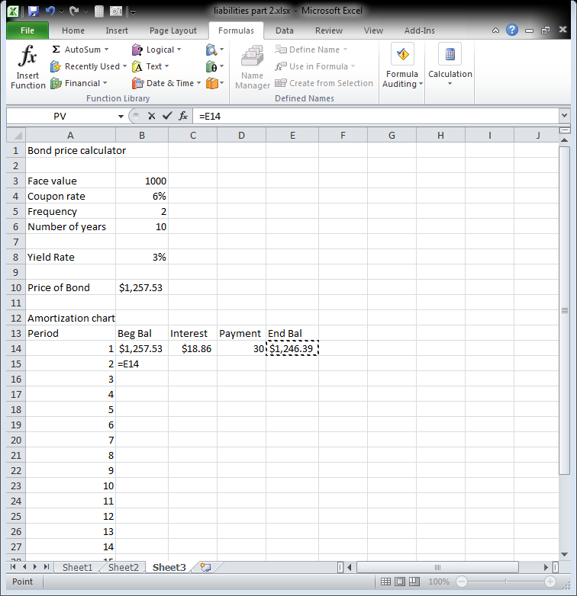

Exhibit Liab- 19

Use the fill handle to fill the formula in cell B15 down the remaining rows. Double click the fill handle in cell B15. Then, select cells C14-E14 and double click the fill handle to fill the remaining formulas down the rows. Your amortization chart is correct if the ending balance is $1,000 at the end of period 20.

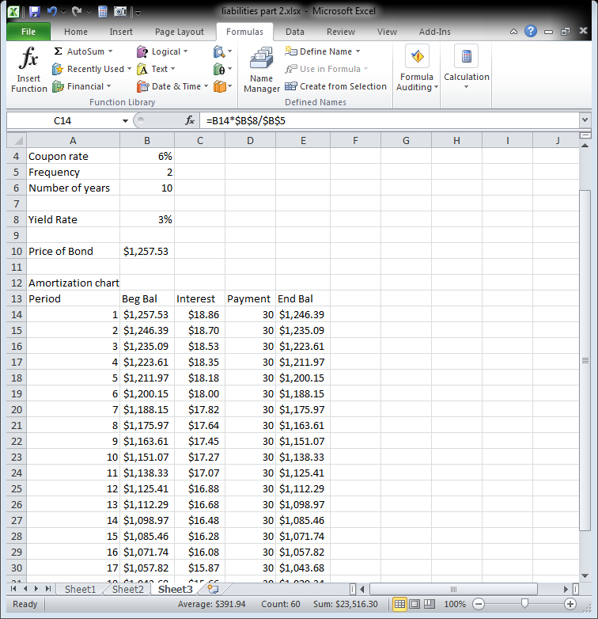

Exhibit Liab- 20