**Principles of Accounting & Intermediate Accounting– Short Term Interest Receivable and Payable**

**Working With Dates in Excel**

Open the Excel file dates in excel.xls. Click the Dates worksheet tab.

Excel allows you to do calculations with dates. As long as you input the date in a way that Excel recognizes it, it will store it as a serial number (the number of days since 1/1/1900). If you omit the year, Excel will store it with the current year as the year. You can use number formats to display the date any way you wish.

To calculate the number of actual days between two dates, input the start date and the end date into cells, then subtract the start date from the end date. In cell B4, enter =B2-B1 and hit enter.

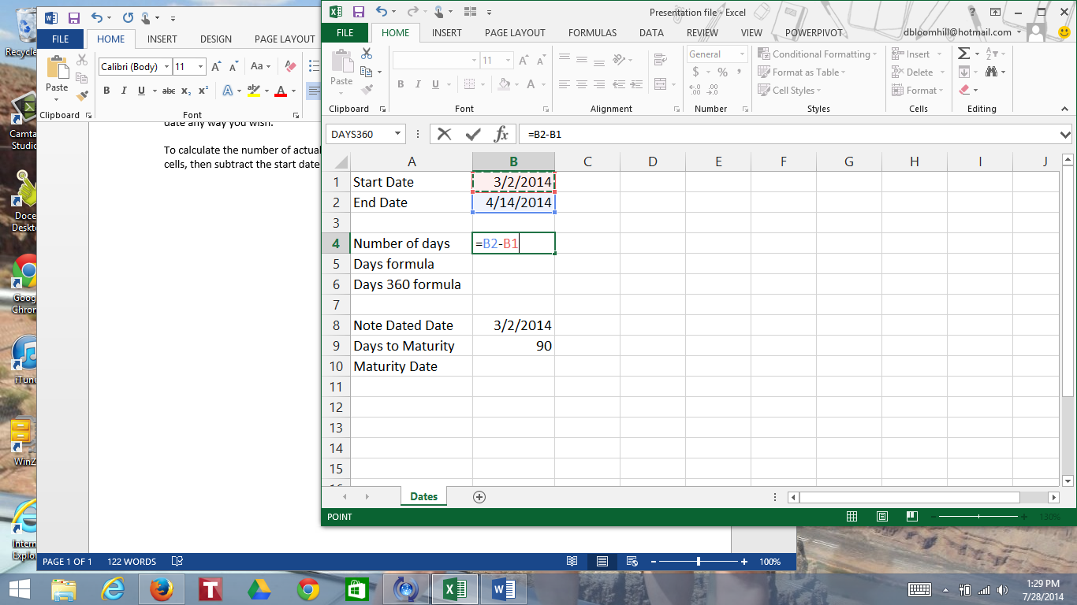

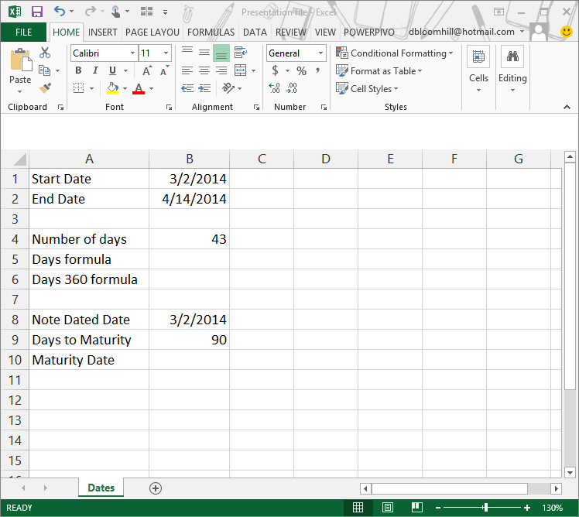

**Fun class activity – have the students calculate how many days they have been alive, or calculate the number of days until their next “big” birthday.**

You can use the functions Days and Days360 to calculate the number of days between dates, using either a 365 day basis (Days) or 360 day basis (Days360).

Click cell B5. Click the Formulas tab. In the Function Library group, click Date & Time, then click Days.

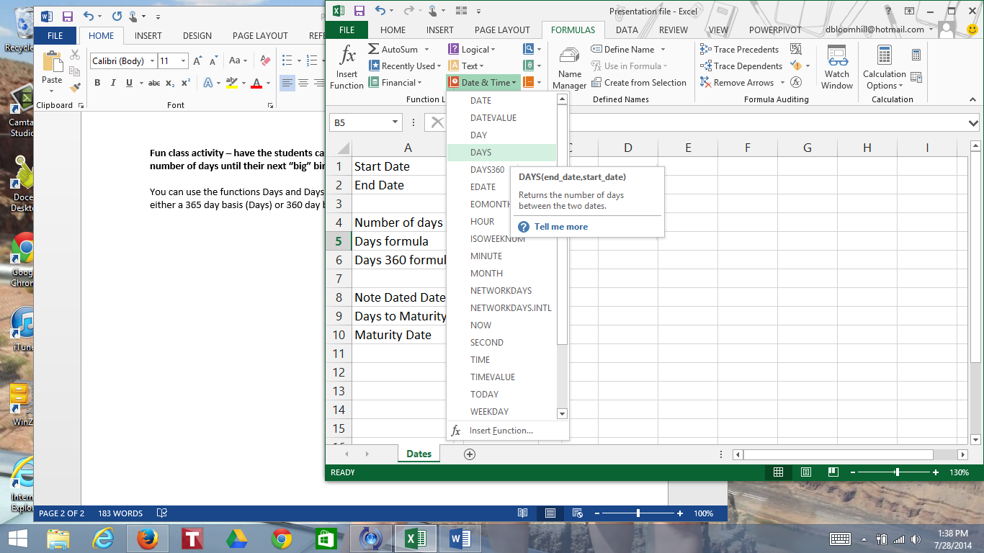

Click in the End date box and click cell B2. Click in the Start date box and click cell B1. Click OK.

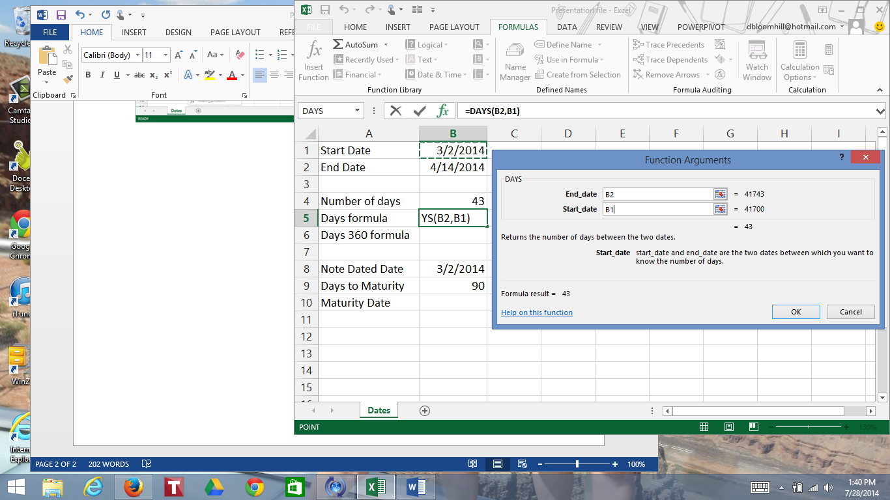

Notice you get the same answer as the formula.

Click cell B6. Click the Date & Time icon in the Function Library group, then click Days360.

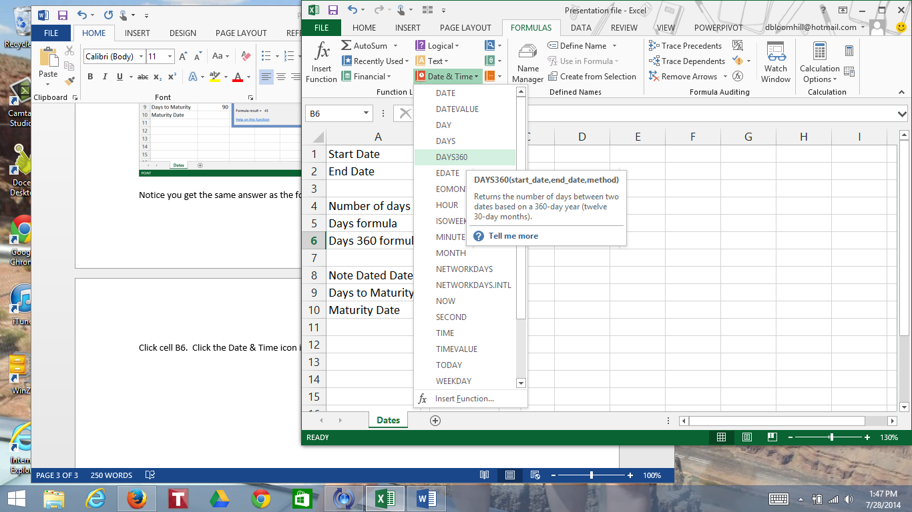

Click in the Start date box and click cell B1. Click in the End date box and click cell B2. You can omit the Method box since the default is the US method. Click OK.

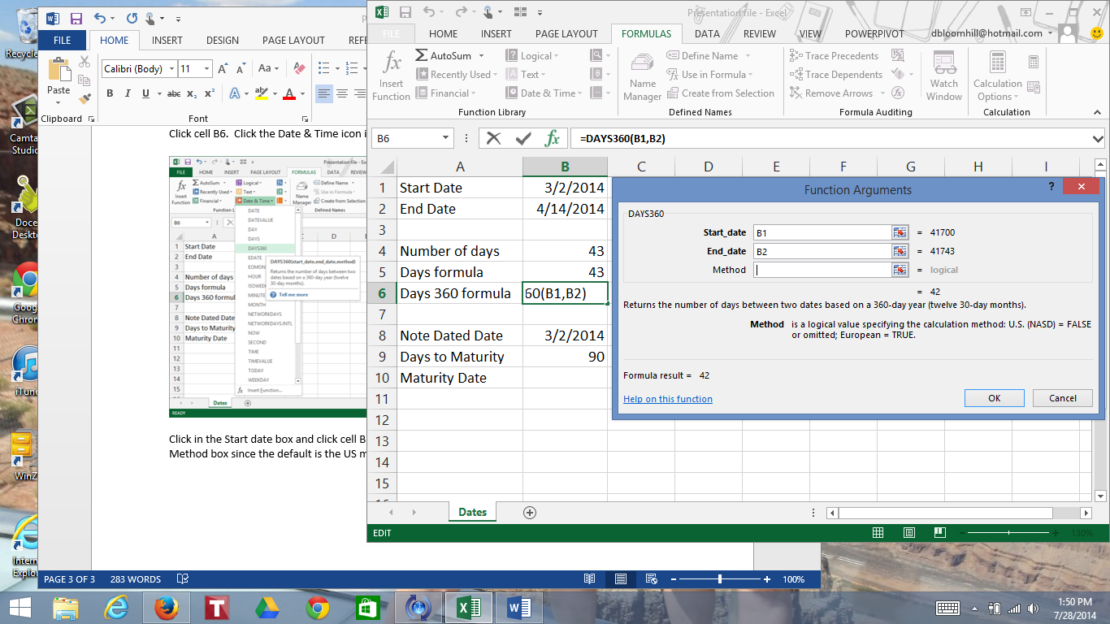

You can also use Excel to calculate the maturity date. You can add a certain number of days to a date to calculate the due date. For example, calculate the maturity date for a 90 day note dated 3/2/14.

Click cell B10. Enter the formula =B8+B9. Hit enter.

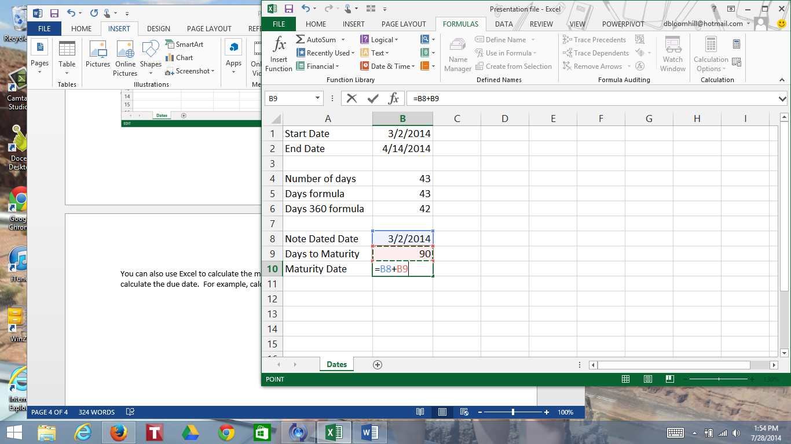

If the answer is a number rather than a date, use the number formatting tool (on the home tab or on the right-click menu) to change it to a date format.

