**Solver**

Open the Excel file solver and scenario manager.xls. We are solving a problem of how much to make of each product, given that we want to maximize the profit, but there are constraints. Notice how I set up the spreadsheet to calculate the total profit. (Press Control plus ~ to display the formulas, and Control plus ~ to show the normal spreadsheet.)

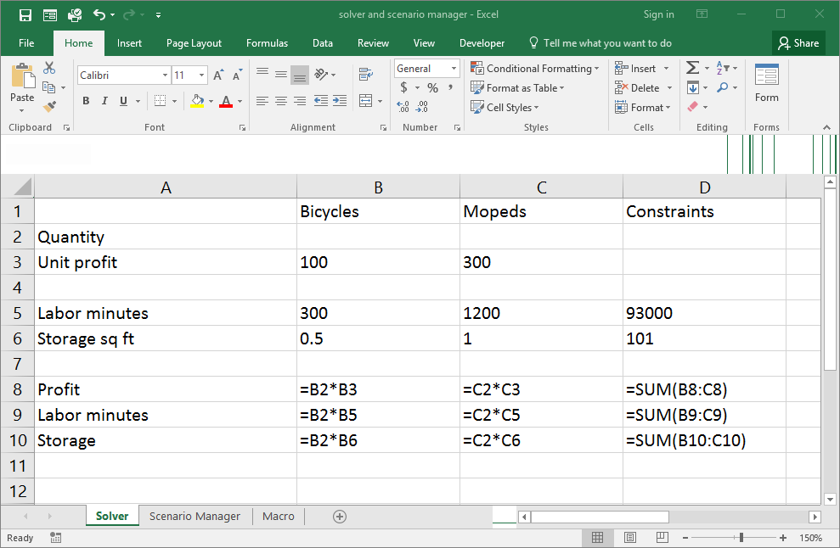

To use the solver, it must be installed first in the Options menu. Click File, then Options

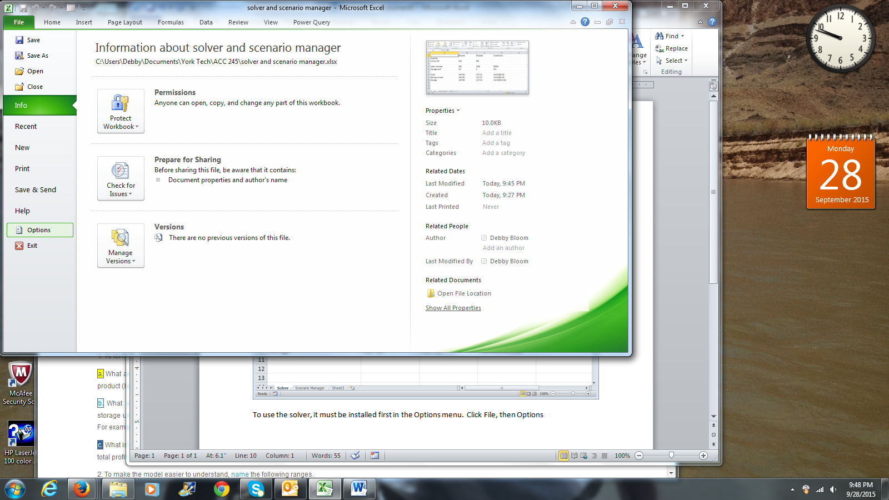

Click Add ins on the left. On the bottom, next to Manage, make sure that Excel Add-Ins is chosen, then click the Go button.

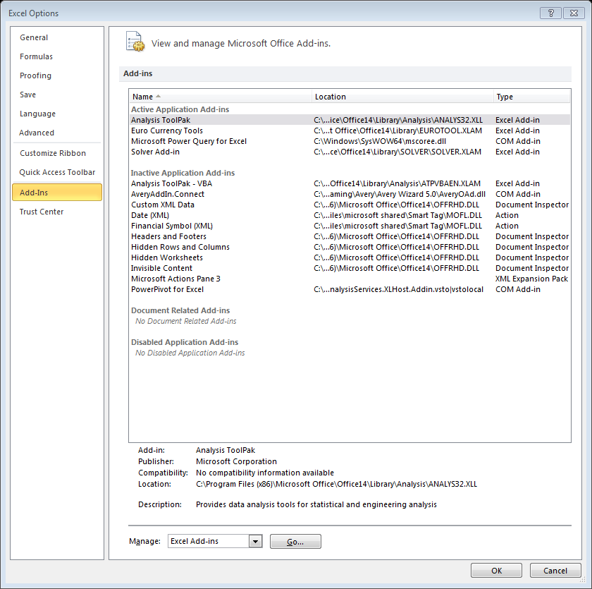

Click the check box for Solver Add-In and click OK.

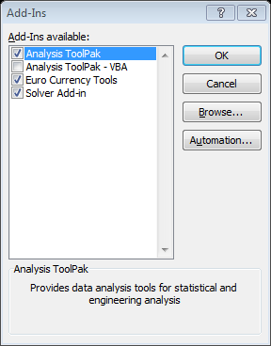

Click the Data tab. In the Analysis group all the way to the right, click Solver.

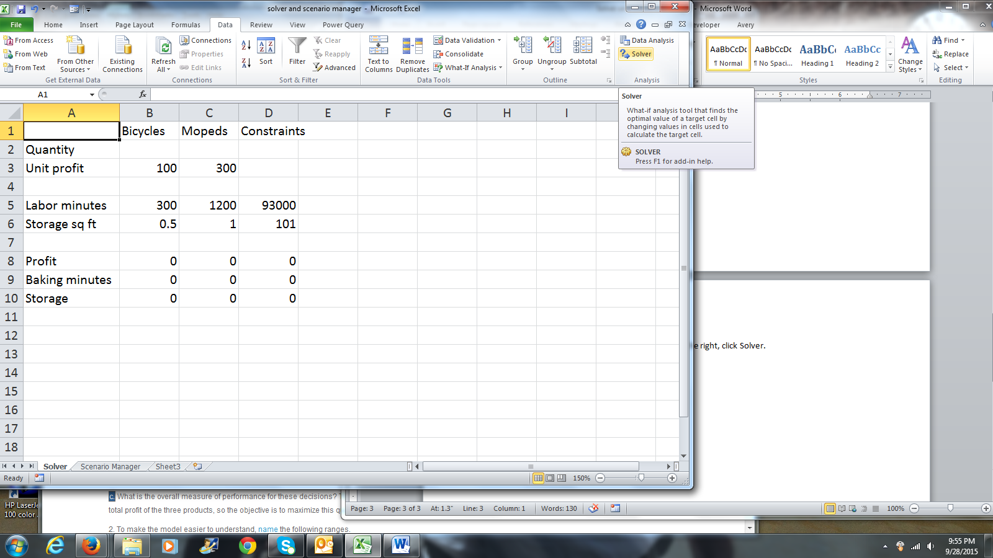

In the Set objective box, click dell D8 (total profit). Click the radio button for Max just below. In the By Changing Variable Cells dialog box, click the range B2:C2. Then, next to the Subject to Constraints box, click Add.

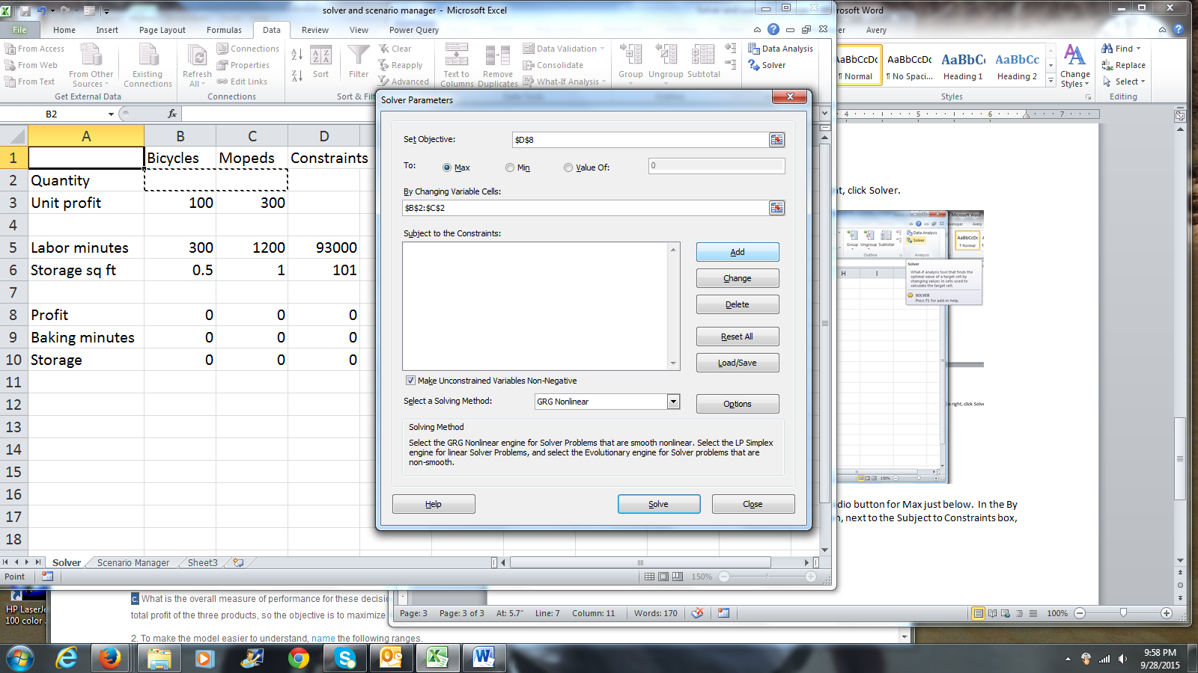

In the add constraint dialog box, Cell Reference D9 (total labor minutes) must be less than or equal to total labor minutes available (cell D5). Click Add to add another constraint.

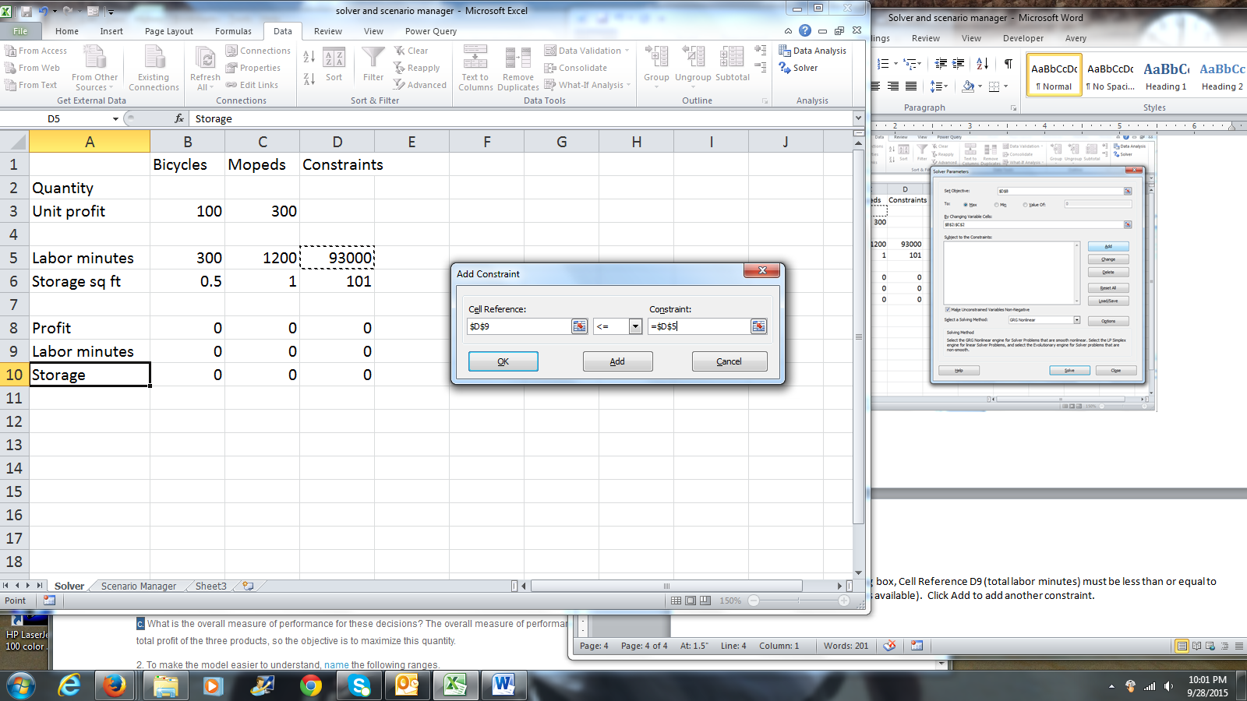

Total storage square feet (cell D10) must be less than or equal to the storage available (cell D6). Since we have no other constraints to add, click OK.

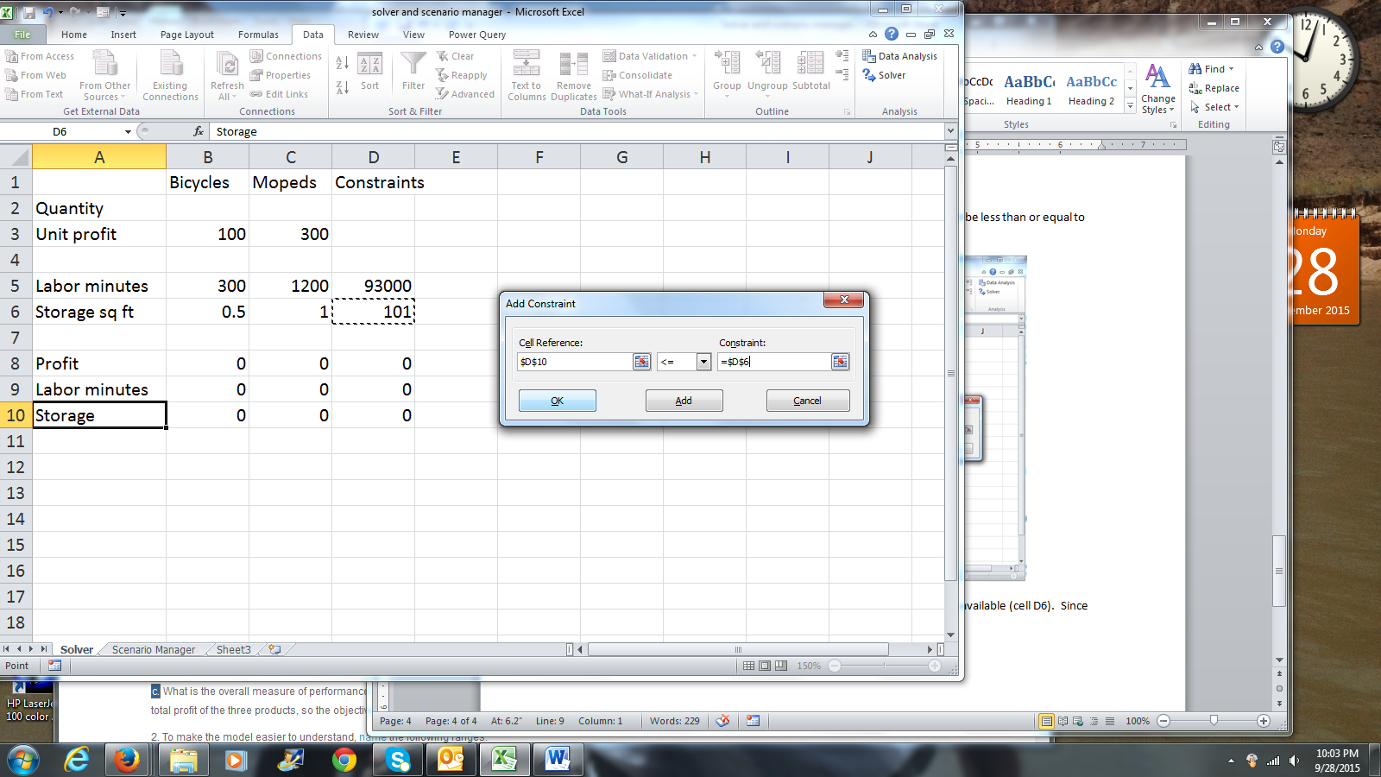

You will be taken back to the Solver dialog box. Click Solve.

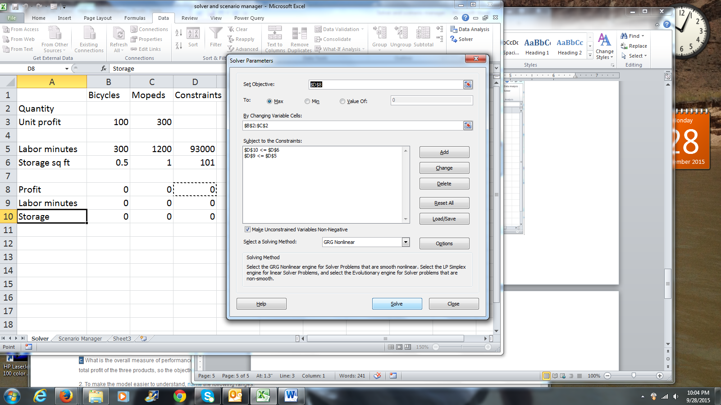

Solver has come up with a solution. You can get answer and sensitivity reports by clicking the reports and clicking OK.

