Text Functions
First, we will use Excel functions to separate text strings.
Open the file text functions worksheet.xlsx and click the Text Separate worksheet tab.
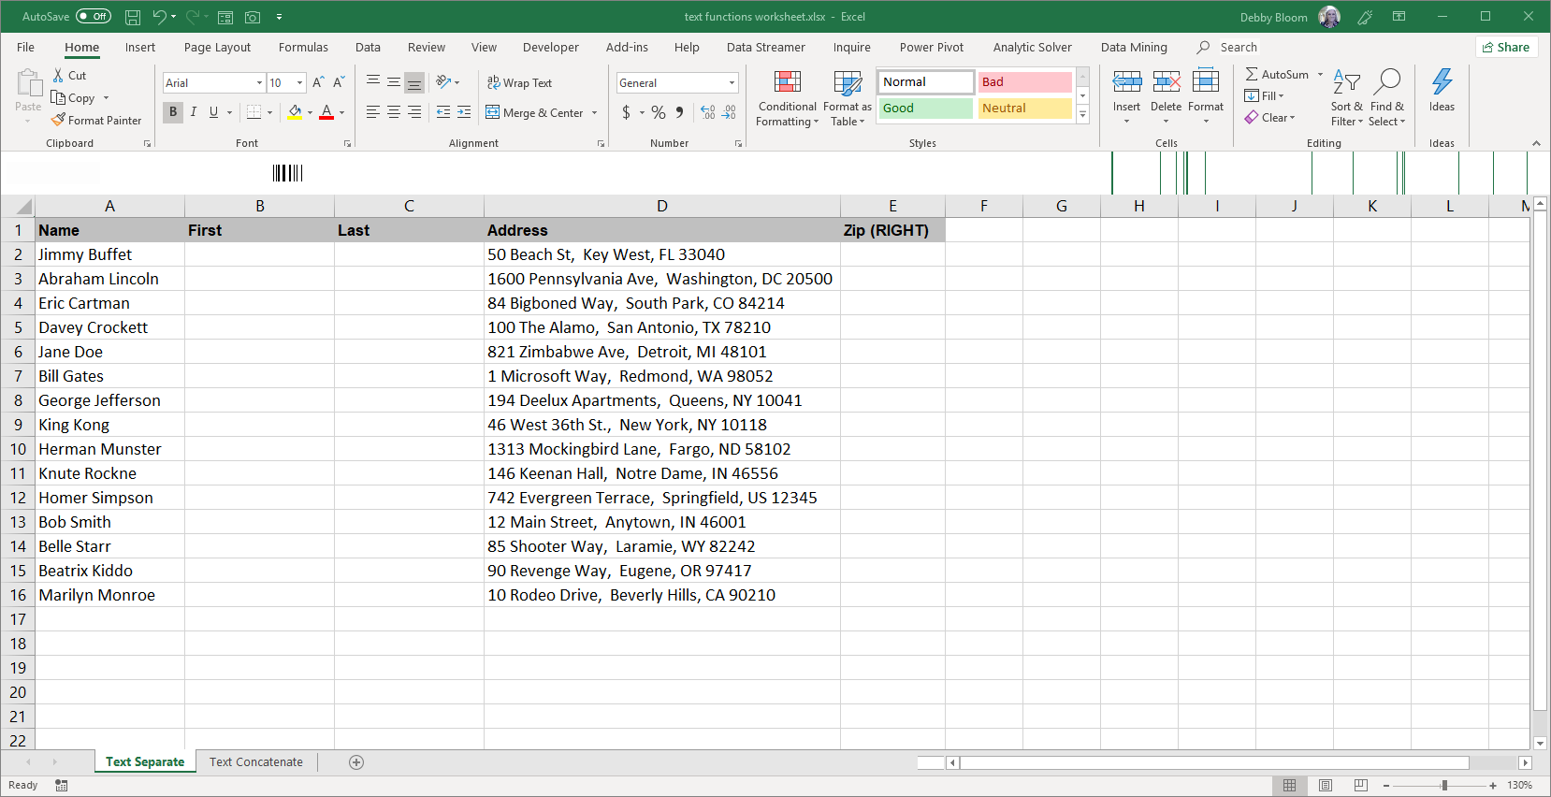
Using Flash Fill to Separate the First and Last Names
Click cell B2. Type the word Jimmy. Click cell C2. Type the word Buffet.
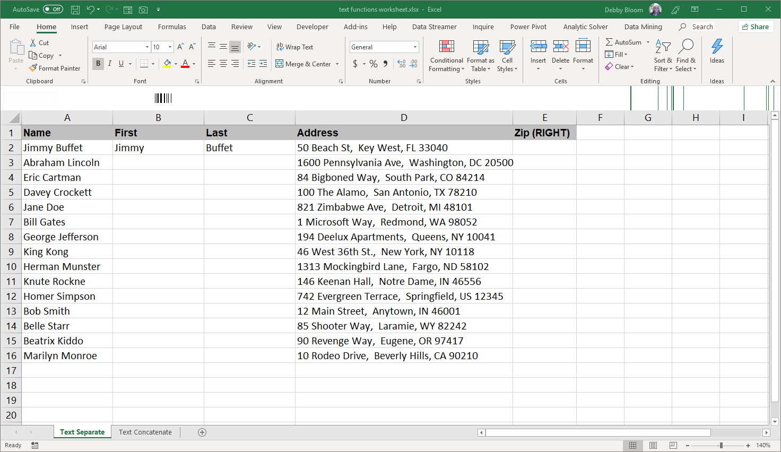

Click cell B2. Click the Data tab. In the Data Tools group, click Flash Fill.
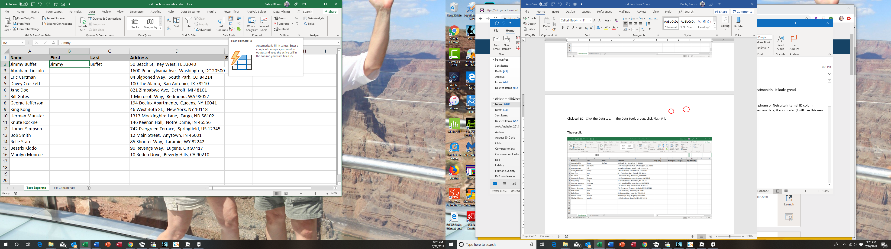
The result.
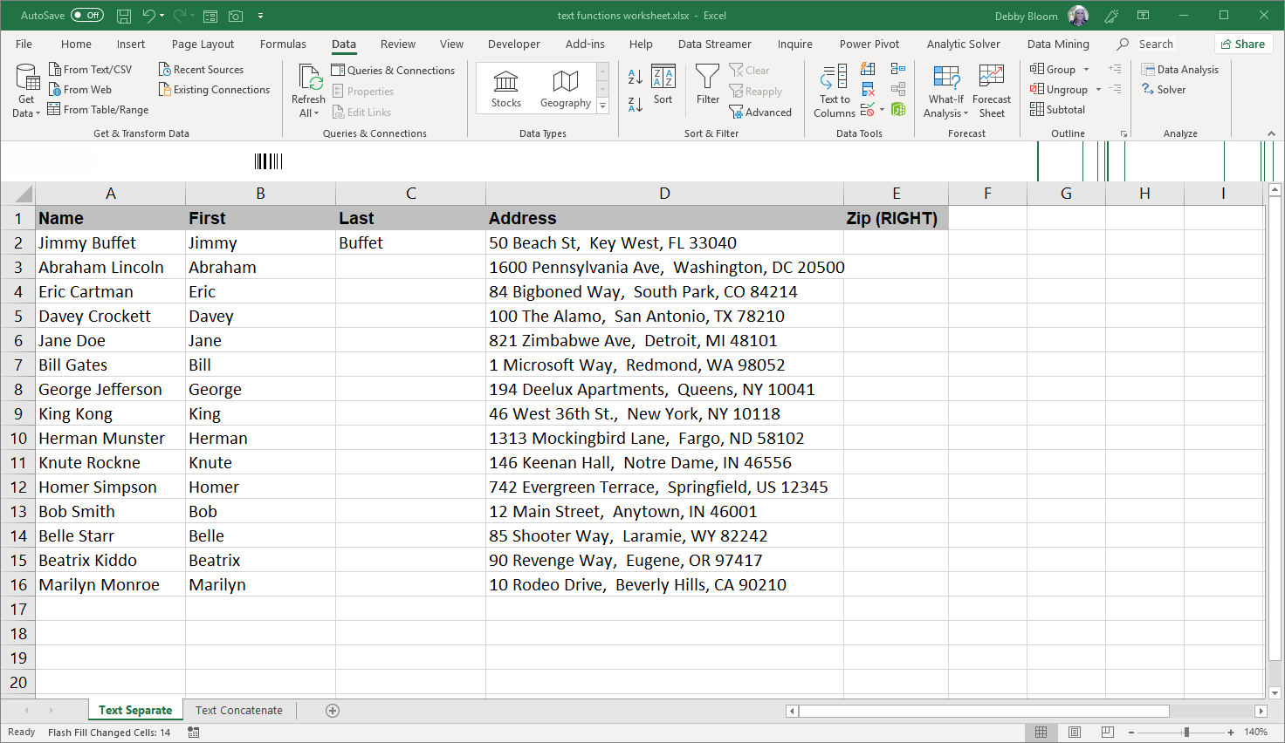

Unfortunately, you cannot flash fill both columns at the same time.
Click cell C2. Click the Data tab (if necessary). In the Data Tools group, click Flash Fill.
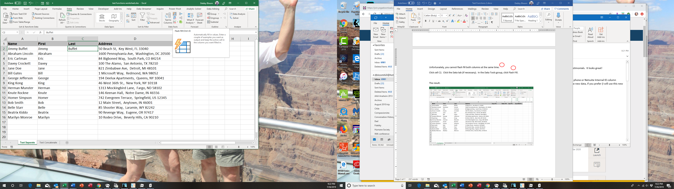
The result.
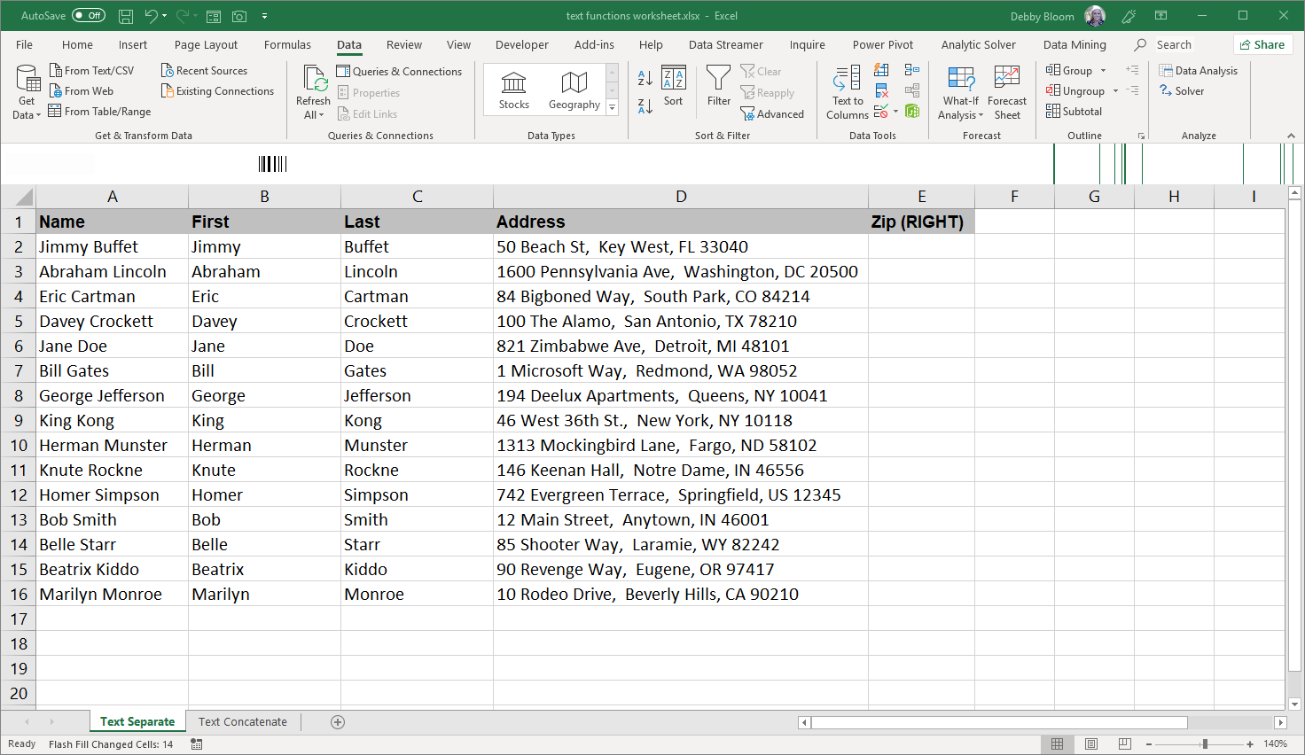

Text to Columns
Text to Columns can be used to separate data that has the same separator (delimiter), such as a space, comma or semi-colon.
Click the grey B column header. Right click and click Insert on the pop-up menu.
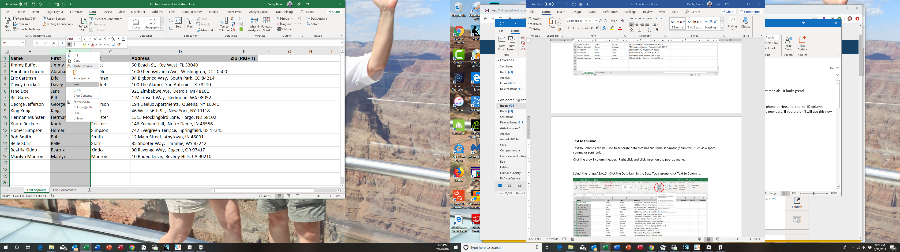
Select the range A2:A16. Click the Data tab. In the Data Tools group, click Text to Columns.
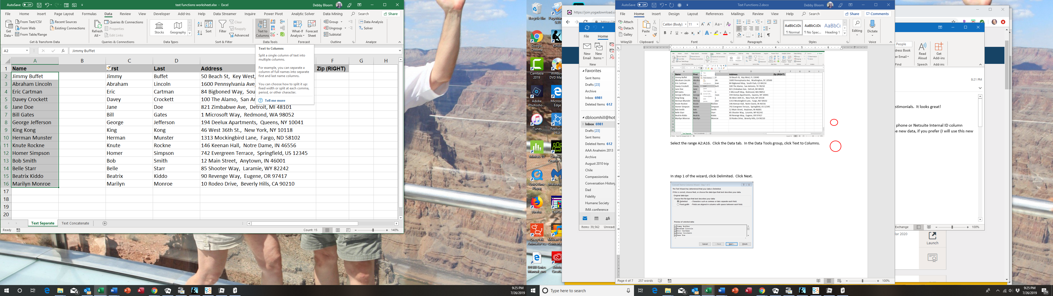

In step 1 of the wizard, click Delimited. Click Next.
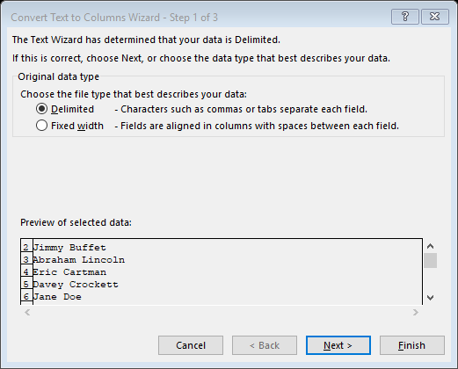
In step 2 of the wizard, make sure Space is the only delimiter selected.
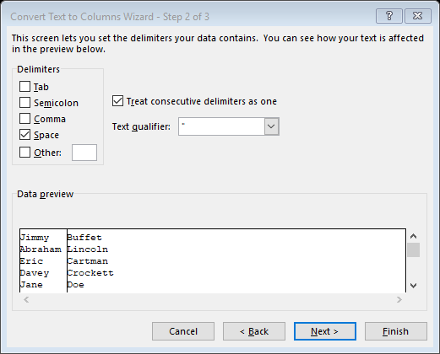
At this point you can click Finish. Step 3 allows you to apply formats to different columns. Click Finish.
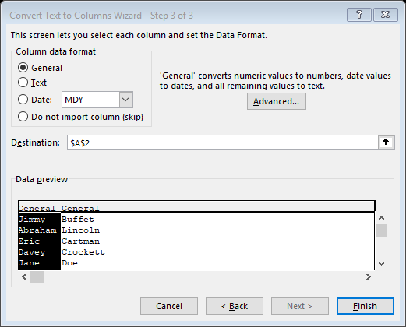

The names have now been separated.
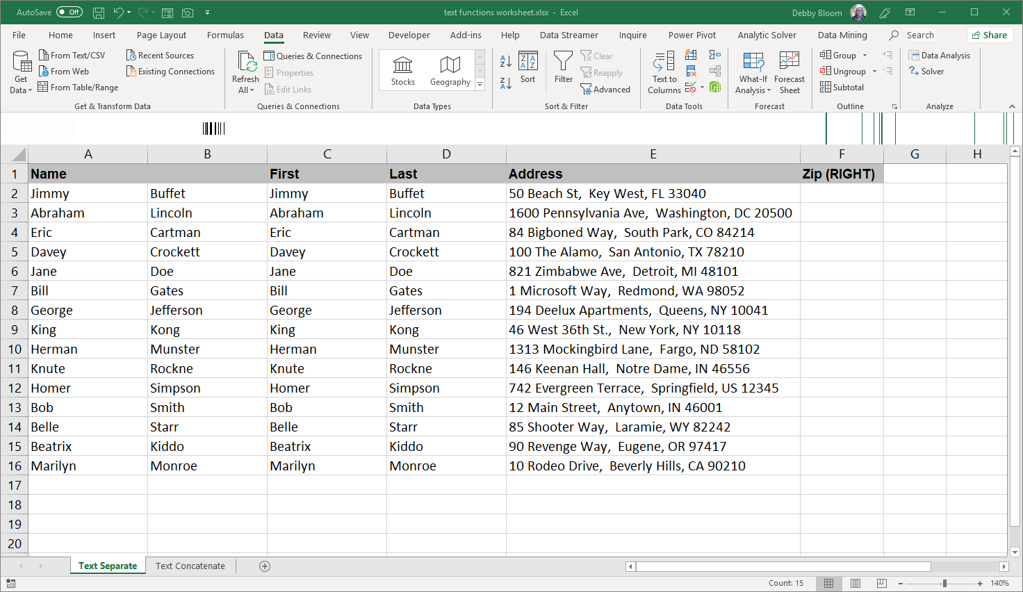
You can use Flash Fill to extract the Zip, or you can use the RIGHT function, since the Zip is 5 digits.
Click cell F2. Click the Formulas tab. In the Function Library group, click the Text icon, then click RIGHT.
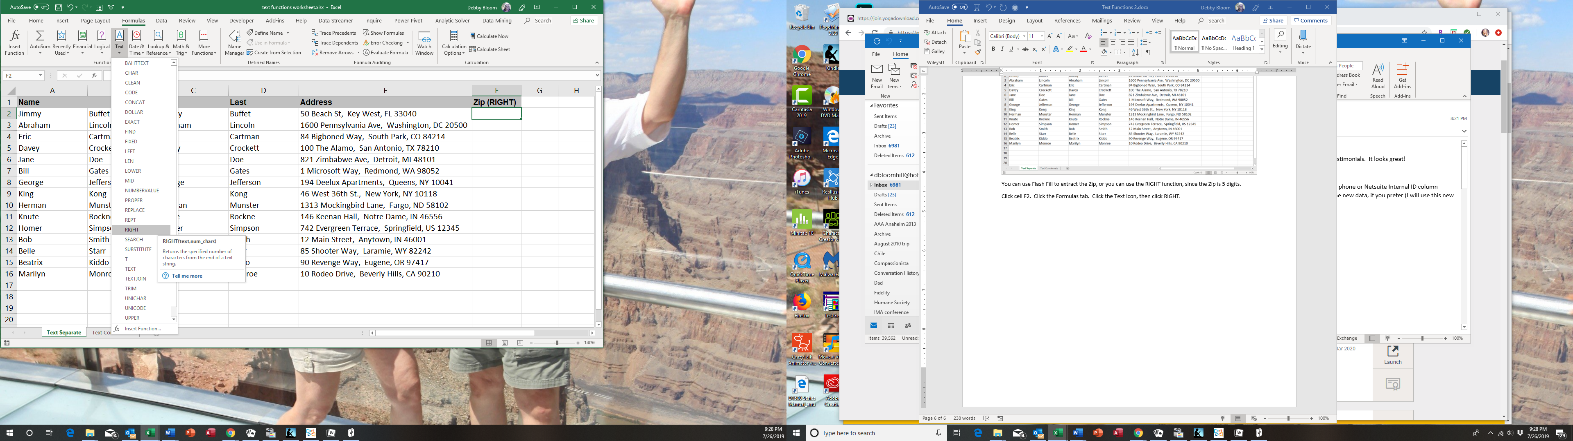

In the Text box, click cell E2. In the Num_chars box, type the number 5. Click OK.
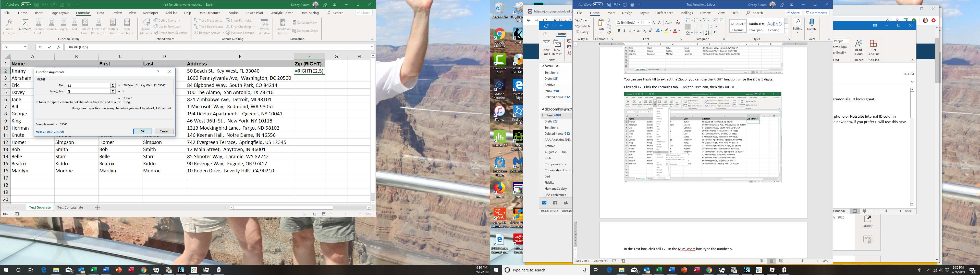
Double-click the fill handle to copy the formula down column F.
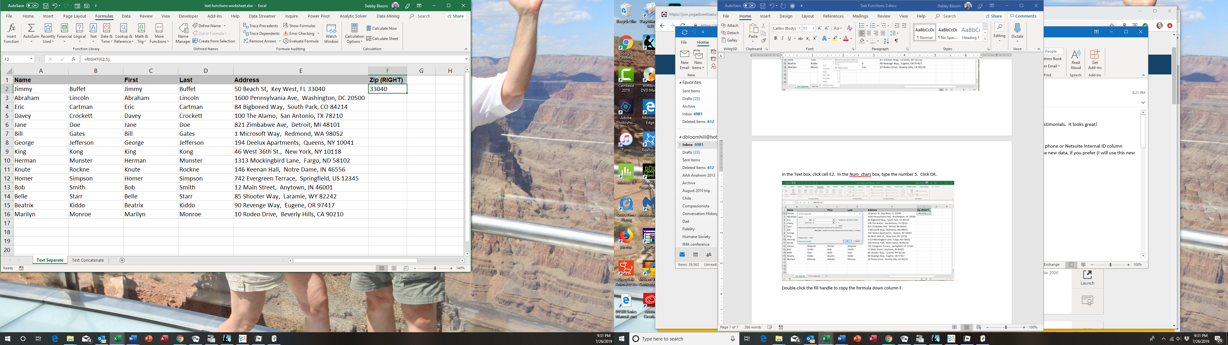
The fill handle

The result
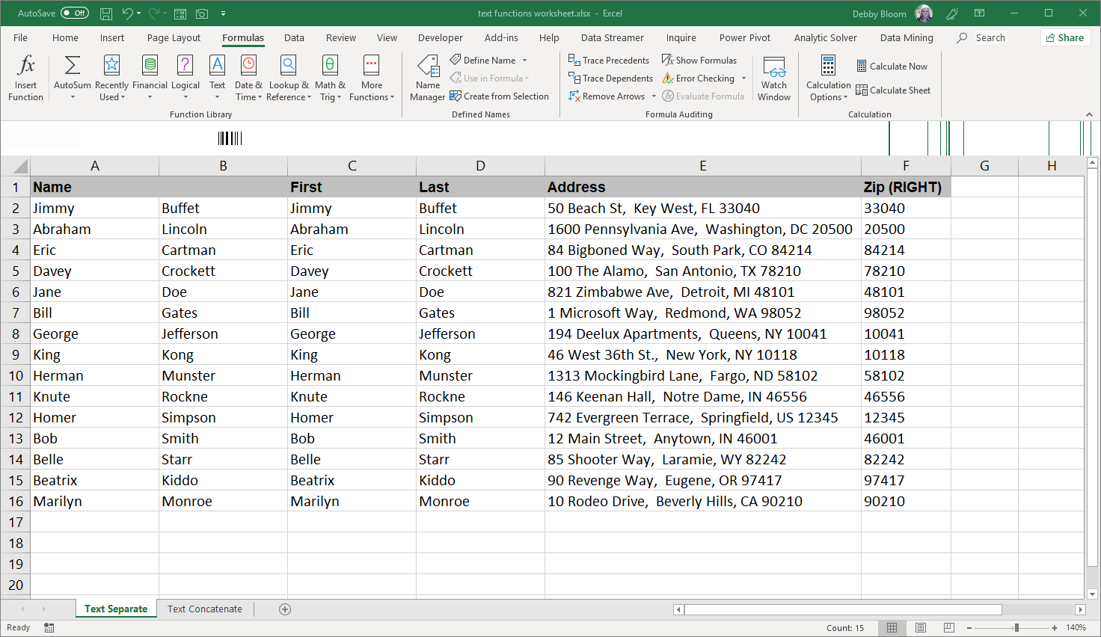
There are also several ways to join text together. Click the Text Concatenate worksheet tab.
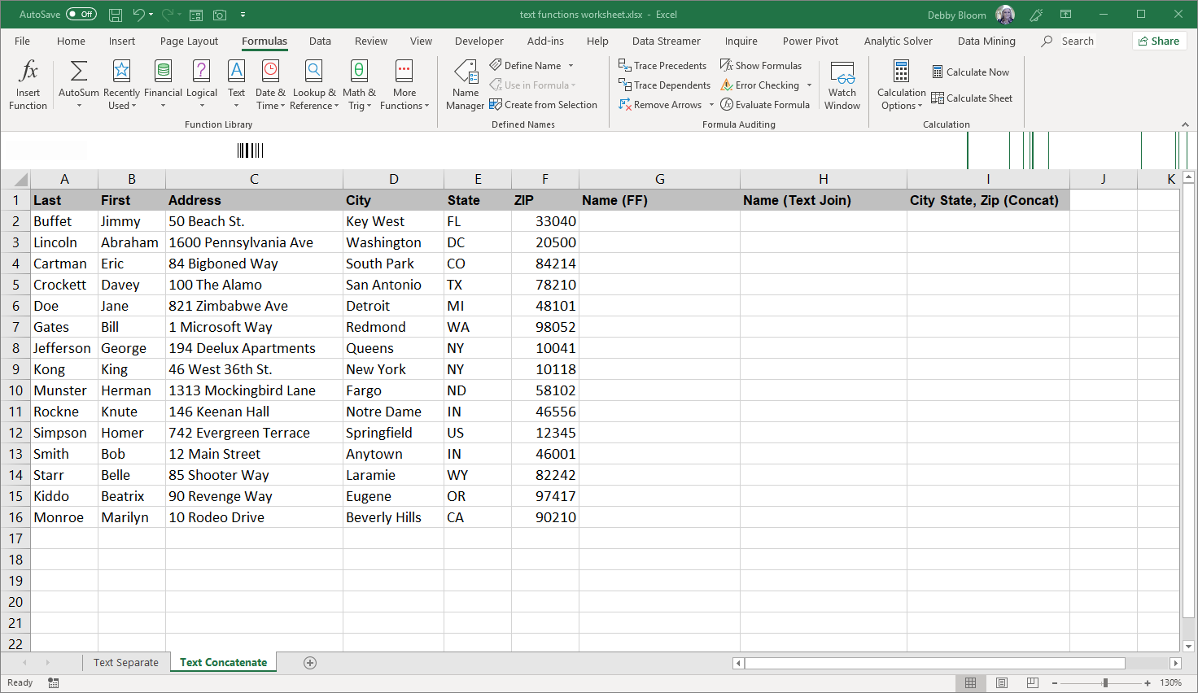

Click cell G2. Type Jimmy Buffet and hit enter. Click back on cell G2. Click the Data tab. In the Data Tools group, click Flash Fill.
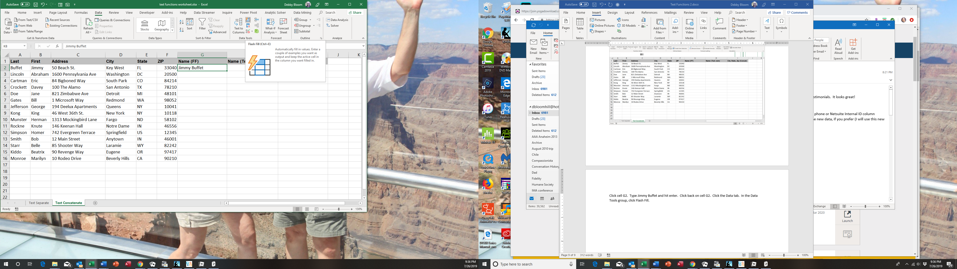
The result.
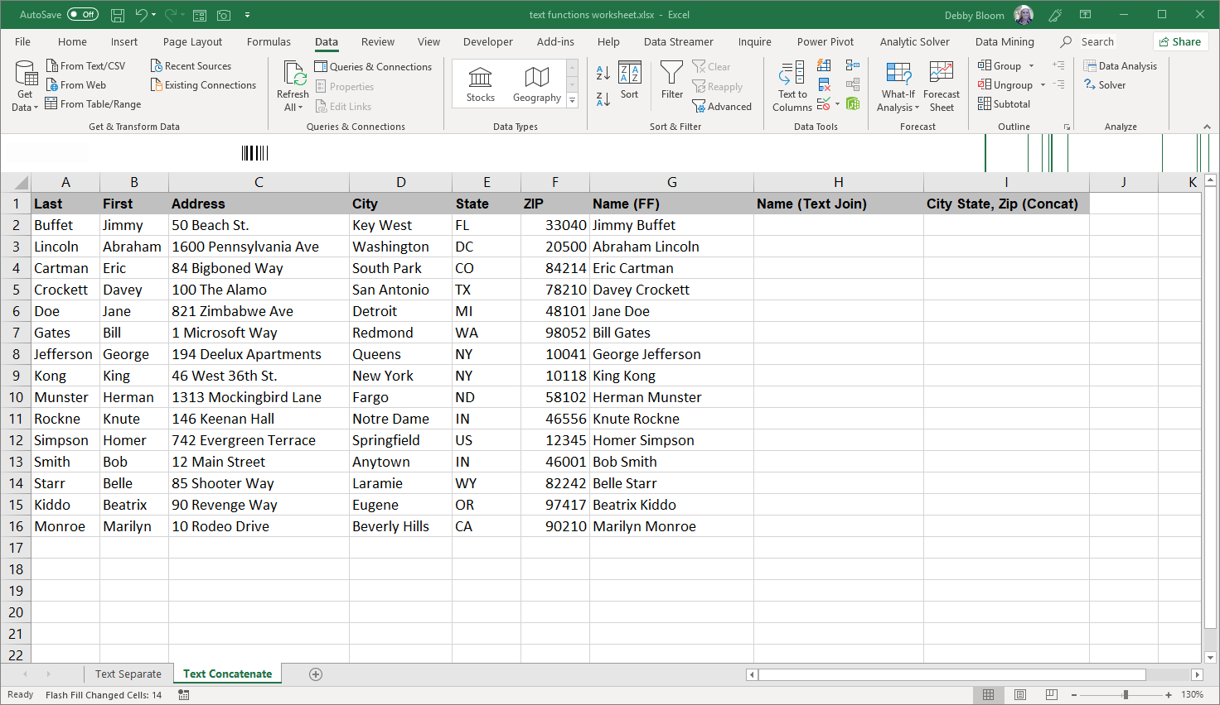

There is a new function in Excel 365 called TEXTJOIN that can join several text fields with the same delimiter (such as a space). If you do not see this function, it means you do not have Office 365.
Click cell H2. Click the Formulas tab. In the Function Library group, click Text, then TEXTJOIN.
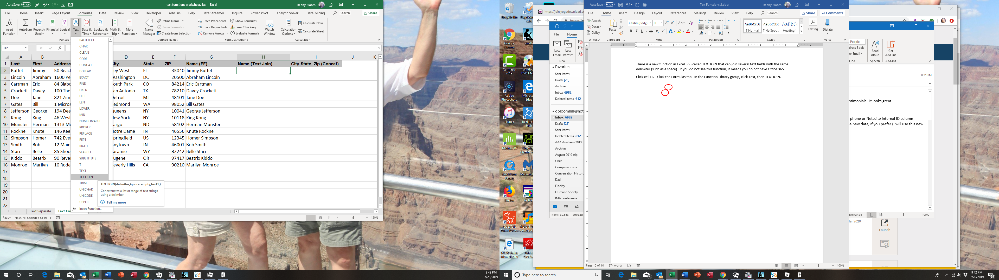
In the Delimiter box, type a space. In the Ignore_empty box, type TRUE. In the Text1 box, click cell B2. In the Text2 Box, click cell A2. Click OK.
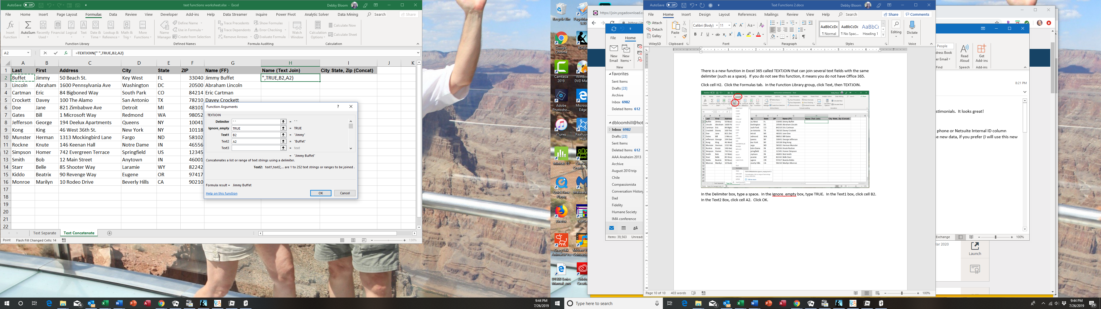

If you want to join cells with different delimiters, you can use CONCAT (CONCATENATE in older versions of Excel). In this case, we want to produce City(space)State(comma)(space)ZIP.
Click cell I2. Click the Formulas tab. In the Function Library group, click Text, then CONCAT (or CONCATENATE).
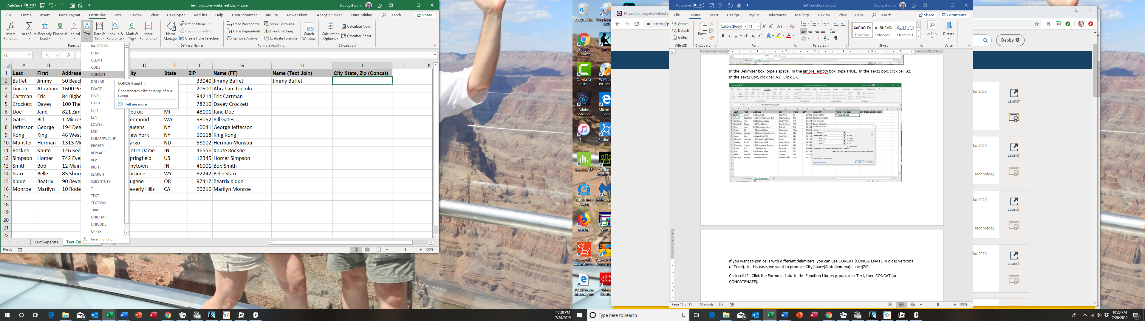
In the Text1 box, click cell D2. In the Text2 box, type a space. In the Text3 box, click cell E2. In the Text4 box, type a comma and then a space. In the Text5 box, click cell F2. Click OK.
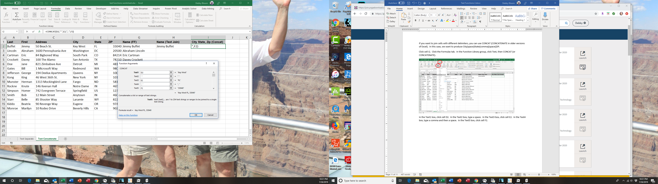

Select the range H2:I2. Double-click the fill handle to copy the formulas down to row 16.
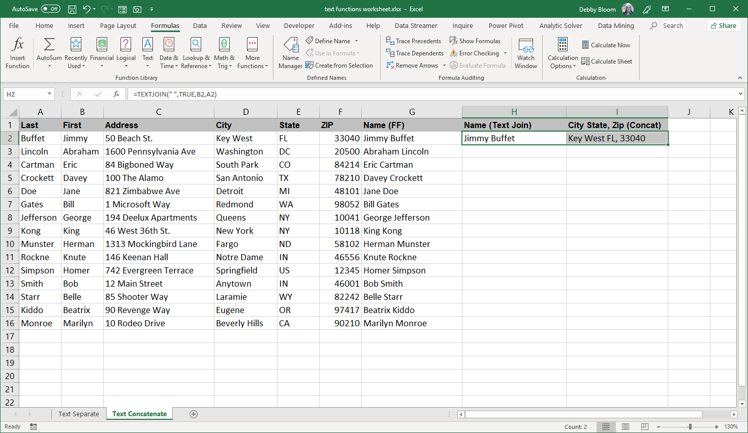
The fill handle
The result.
