Time Value of Money
Open the Excel workbook “time value workbook.xlsx.”
There are 4 basic problems related to the time value of money:
- Future value of $1
- Future value of an annuity
- Present value of $1
- Present value of an annuity
With any one or a combination of the 4 basic problems, you can solve almost any problem related to time and interest, for example leases and bonds.
Problem 1: Future value of $1
Where you place an amount of money into an interest-bearing account, and you make no further deposits or withdrawals. What is the balance at the end of the term?
Example: You deposit $5,000 into an interest-bearing account for 10 years that earns an interest rate of 2.5% compounded quarterly.
Click the FV $1 worksheet tab.
Click cell B6. Click the Formulas tab. In the Function Library group, click Financial, then FV.
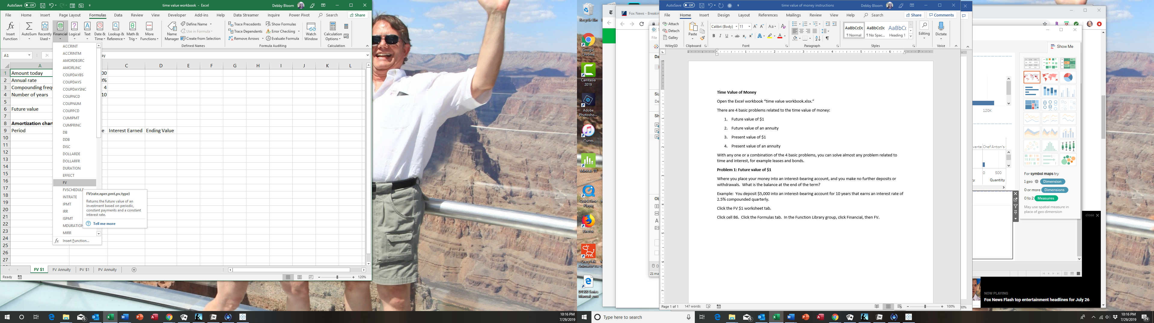
In the Rate box, click cell B2, type a / and click cell B3 (B2/B3). In the Nper box, click cell B4, type an * and click cell B3 (B4*B3). Leave the PMT box blank (because we are not depositing $5,000 every quarter, just once). In the PV box, type a – sign and click cell B1 (-B1). Click OK. (Note: the negative sign is because you are putting money into [negative cash flow] a savings account).
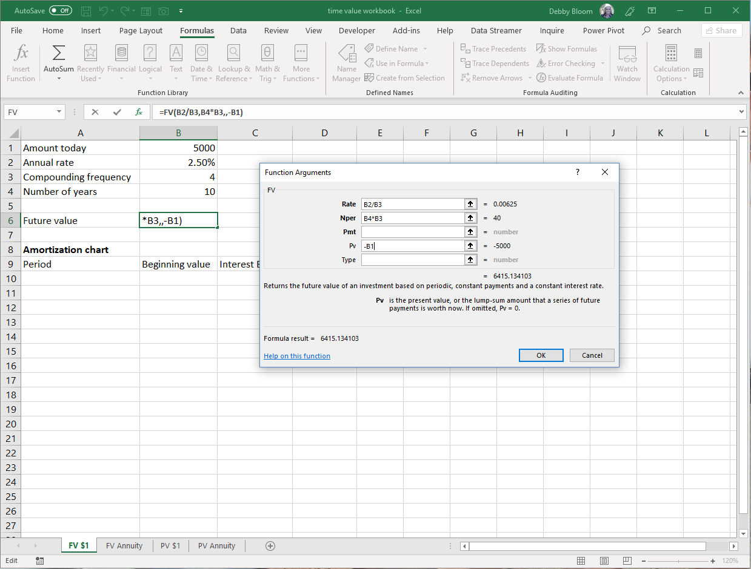
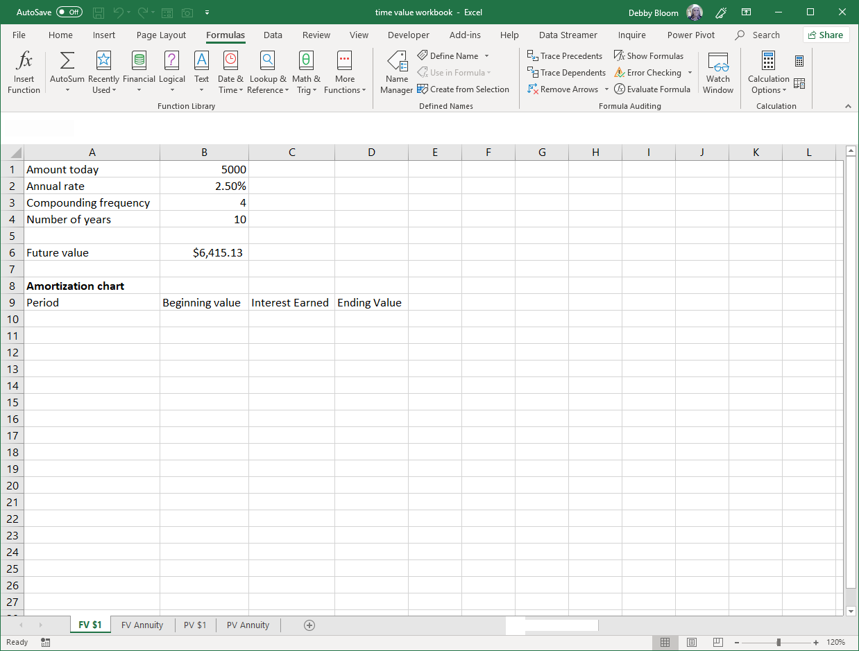
To create the amortization chart, type the number 0 in cell A10 and type the number 1 in cell A11. Select the range A10:A11. Use the fill handle to fill the numbers down column A until you reach the number 40.
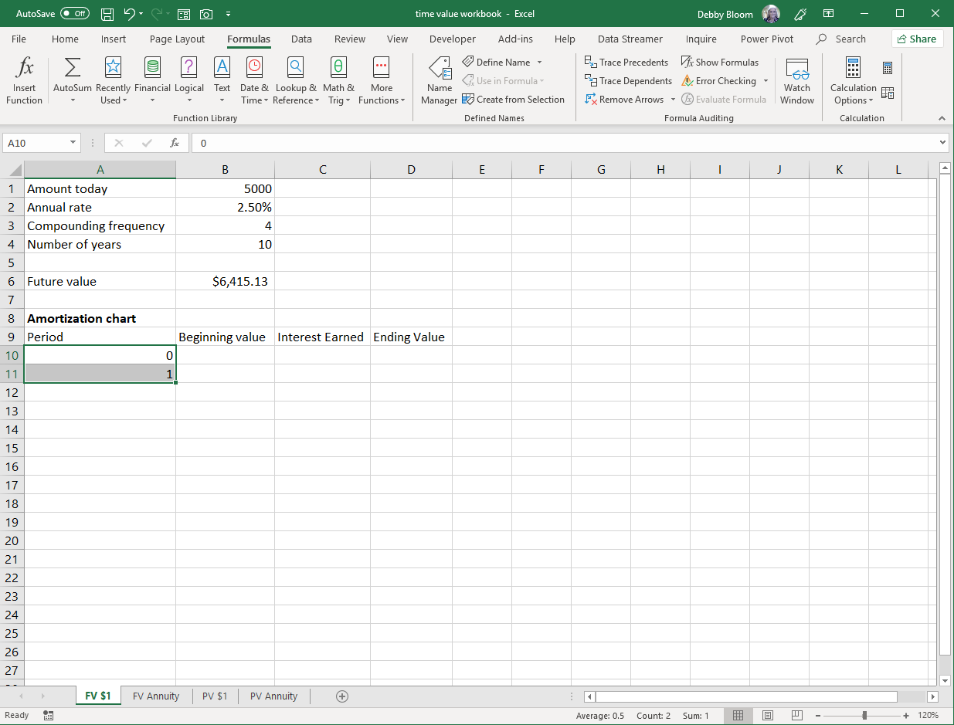
The fill handle
Click cell D10. Enter the formula =B1. Hit enter.
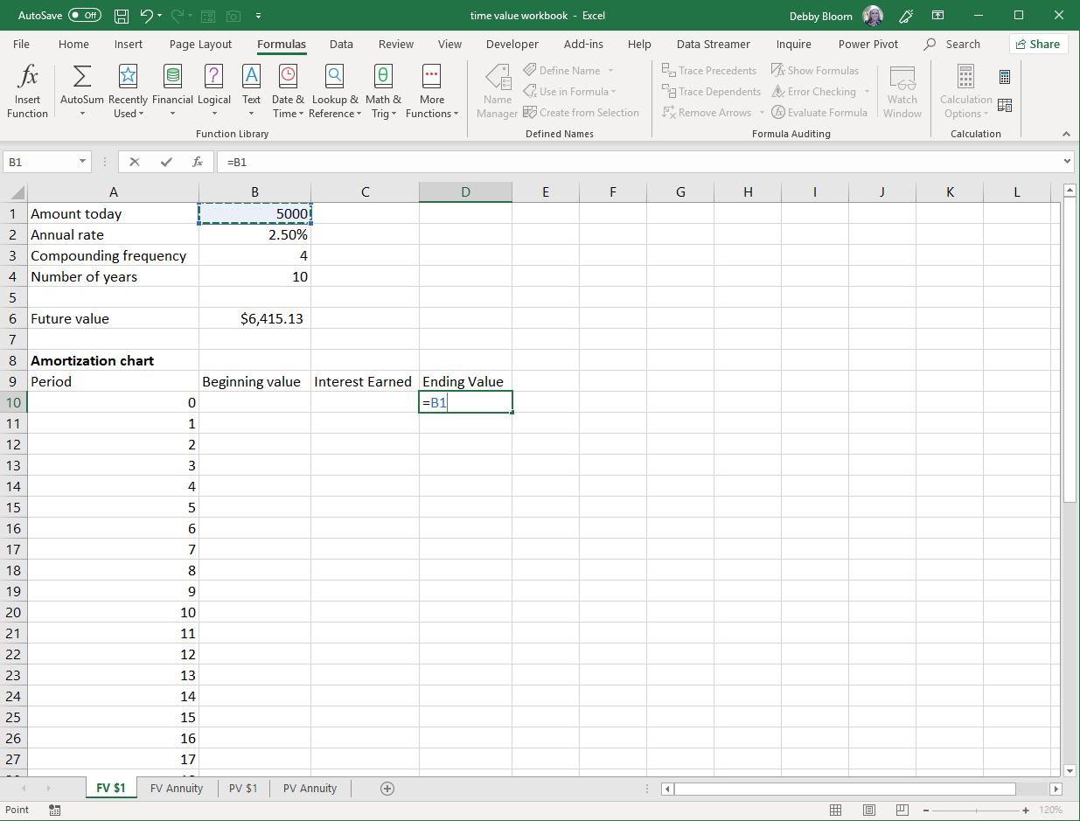
Click cell B11. Enter the formula =D10. Hit enter.
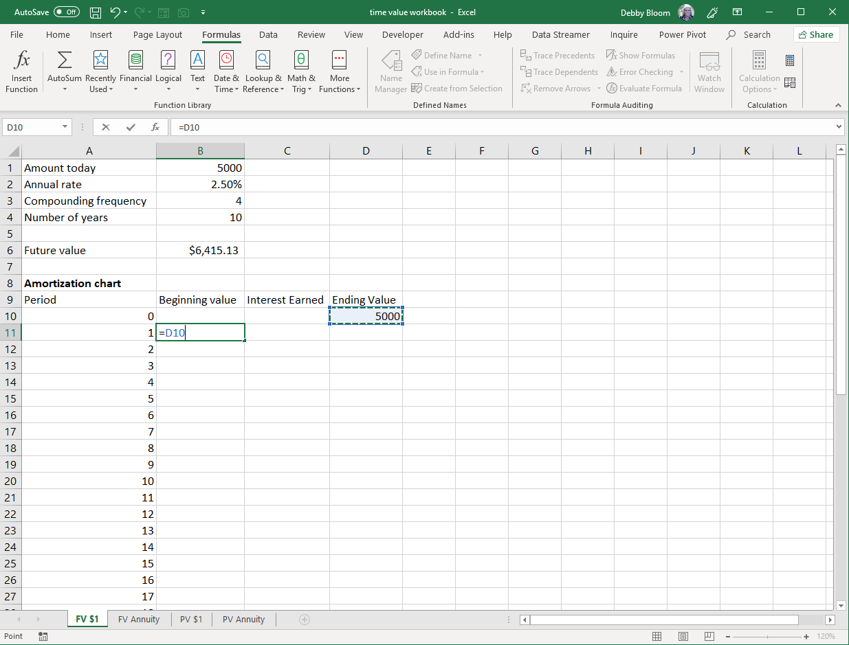
Click cell C11. Enter the formula =B11*$B$2/$B$3 (use the F4 key on the keyboard to insert the dollar signs or type them). Hit enter.
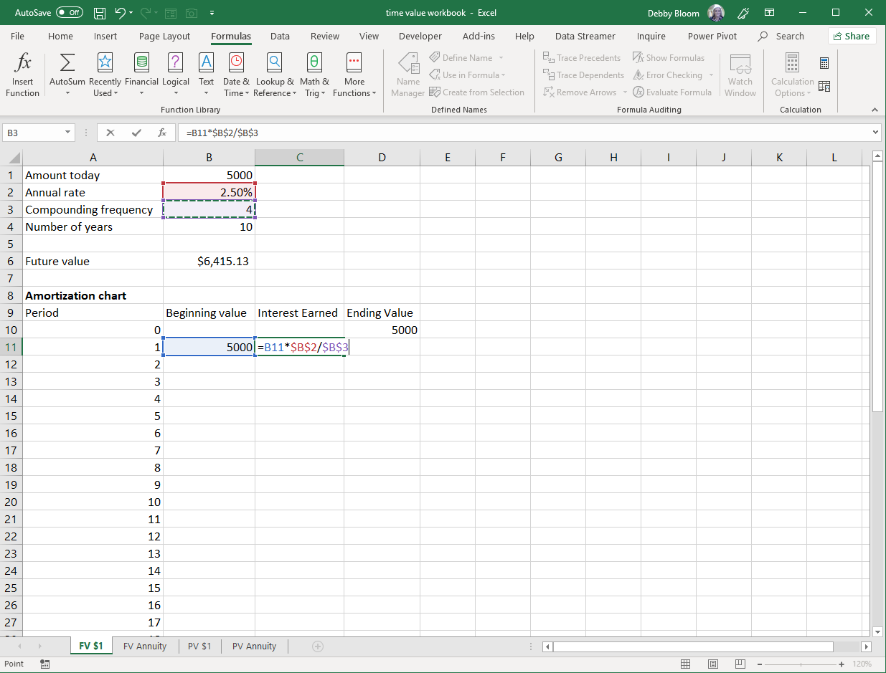
Click cell D11. Enter the formula =B11+C11. Hit enter.
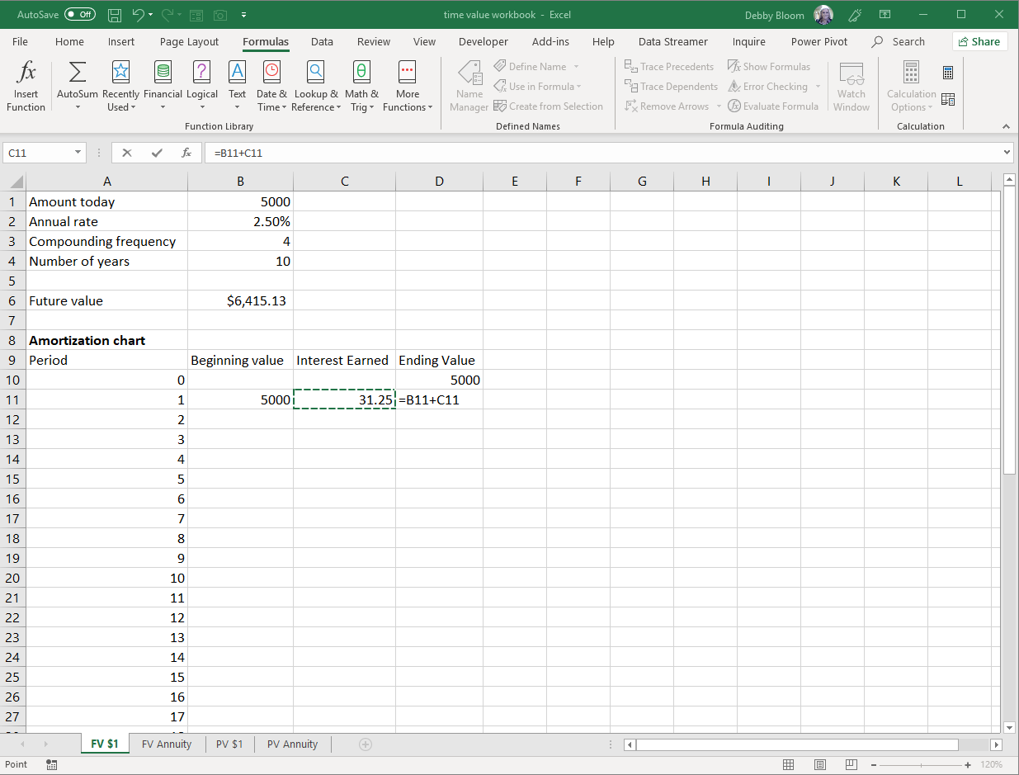
Select the range B11:D11. Double click the fill handle to copy the formulas down to period 40. The value in cell D50 should match the value in cell B6.
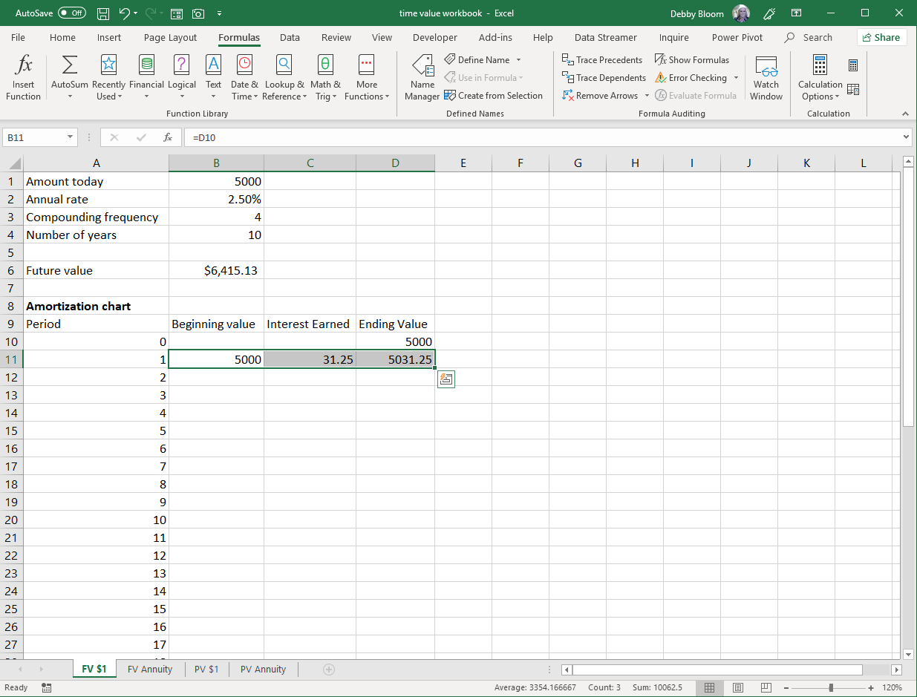
The fill handle
The result.
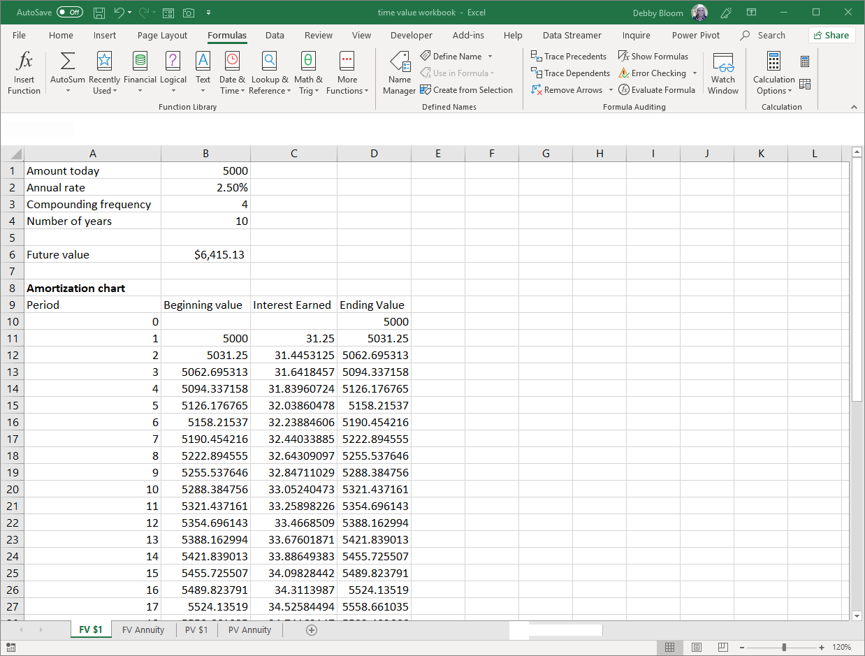
With this worksheet design, you can change the amount today, annual rate, compounding frequency, and/or number of years (any value in cells B1 to B4) and have the future value and the amortization chart be correct (you may need to add or delete periods to/from the amortization chart).

Future Value of an Annuity
Where you make periodic equal payments into an interest-bearing account. What is the balance at the end of the term?
Example: you are saving $500 a month for a down payment for 4 years at an annual rate of 3.2%. How much will you have at the end of the 4 years?
Click the FV Annuity worksheet tab. Click cell B6. Click the Formulas tab. In the Function Library group, click Financial, then FV.
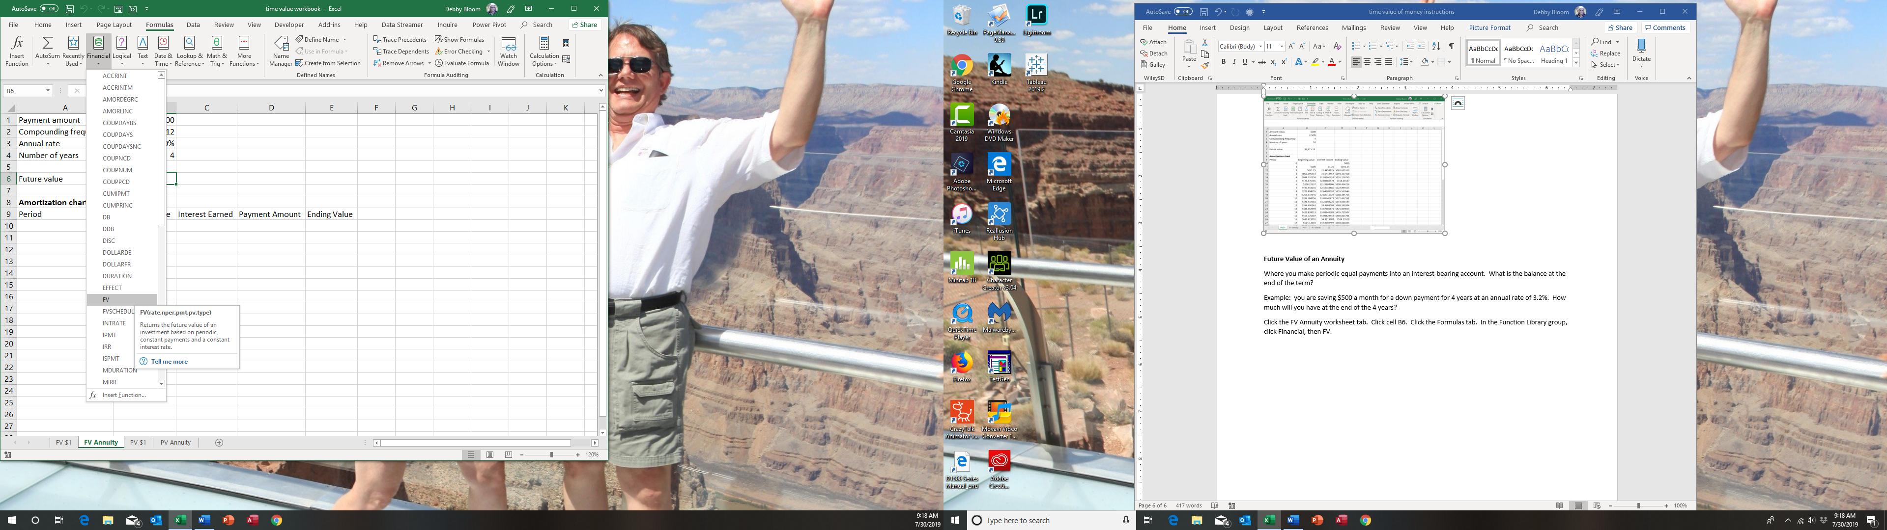
In the Rate box, type B3/B2. In the Nper box, type B4*B2. In the Pmt box, type -B1. Click OK. (Note: the negative sign is because you are putting money into a savings account.)
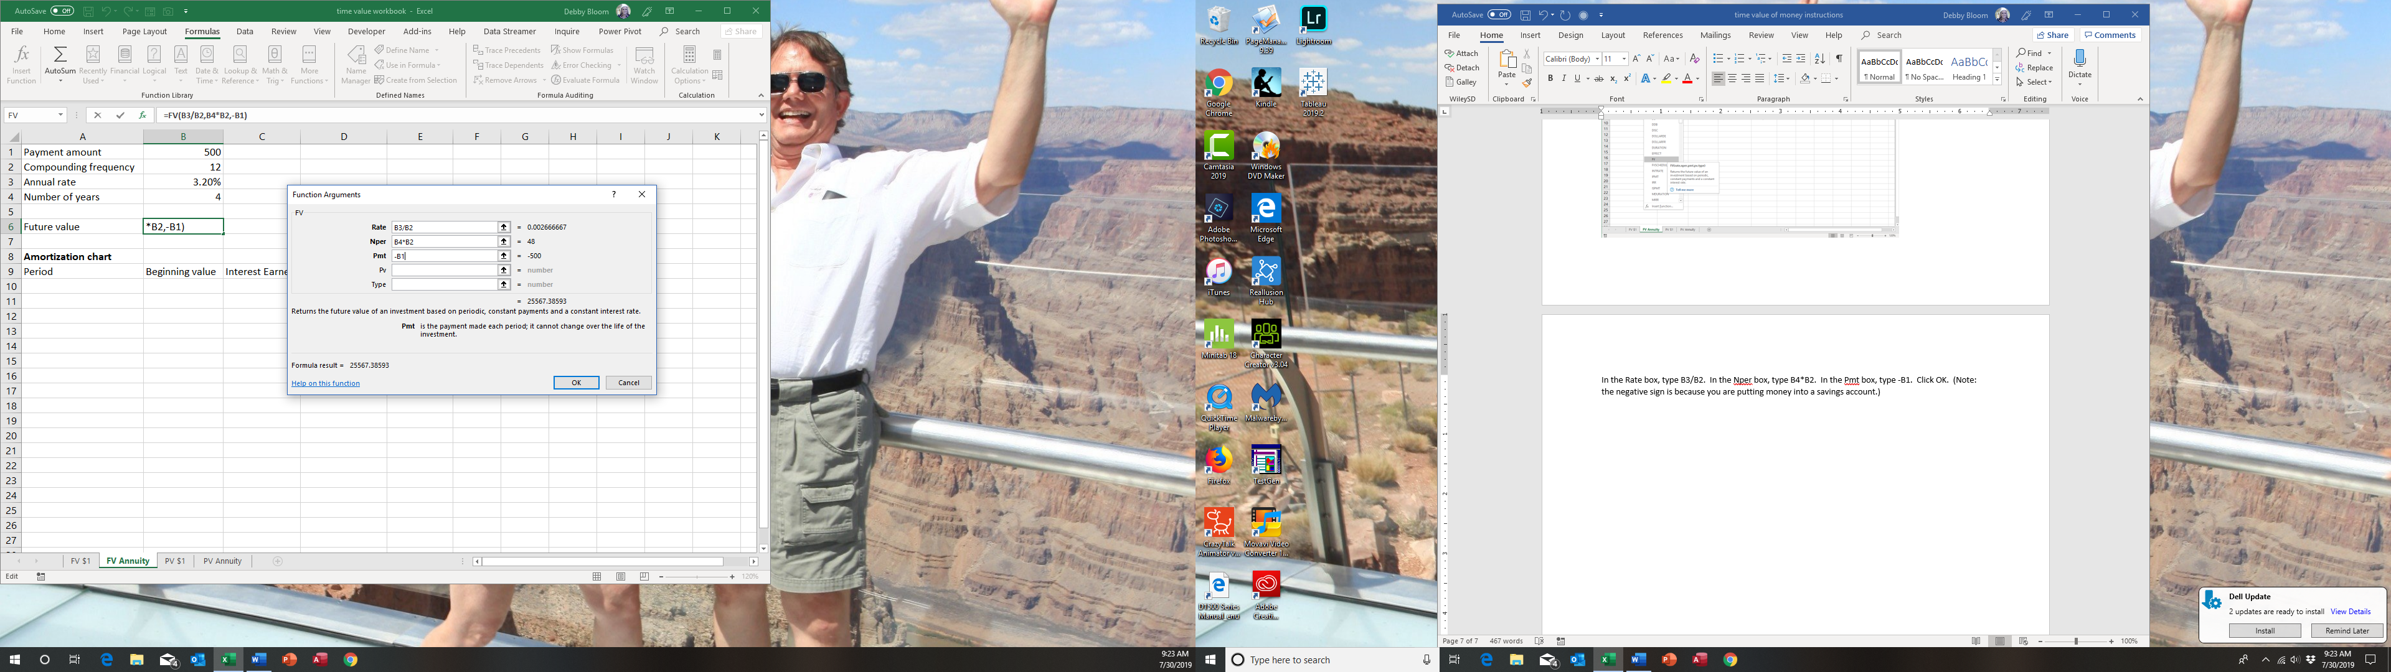
Type the number 0 in cell A10. Type the number 1 in cell A11. Select cells A10 and A11. Drag the fill handle down column A until you reach the number 48.
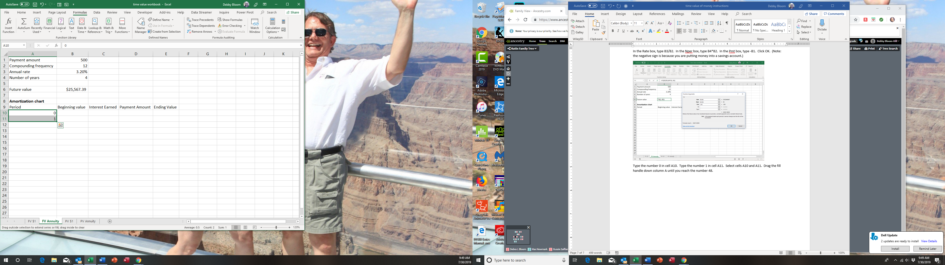
The fill handle

Type the number 0 in cell E10. In cell B11, type the formula =E10.
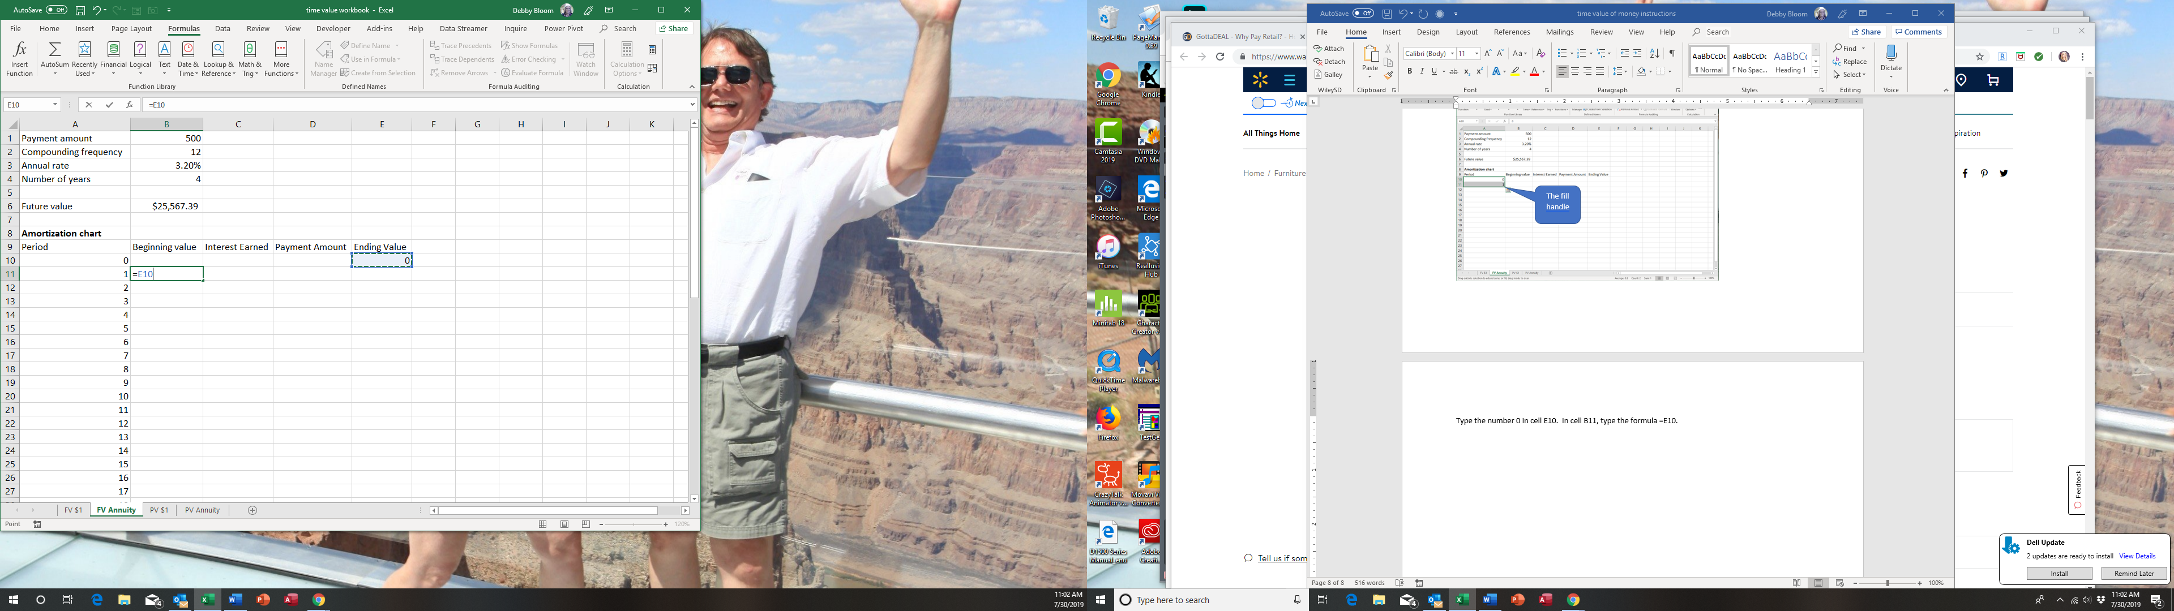
In cell C11, type the formula =B11*$B$3/$B$2 (use the F4 key on the keyboard to insert the absolute cell reference, or just type the dollar signs).
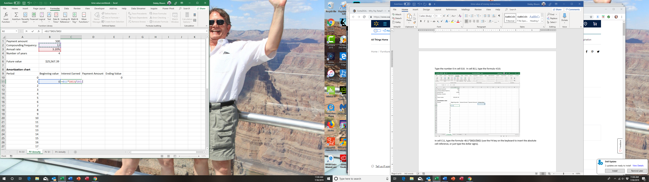

In cell D11, enter the formula =$B$1. Hit enter
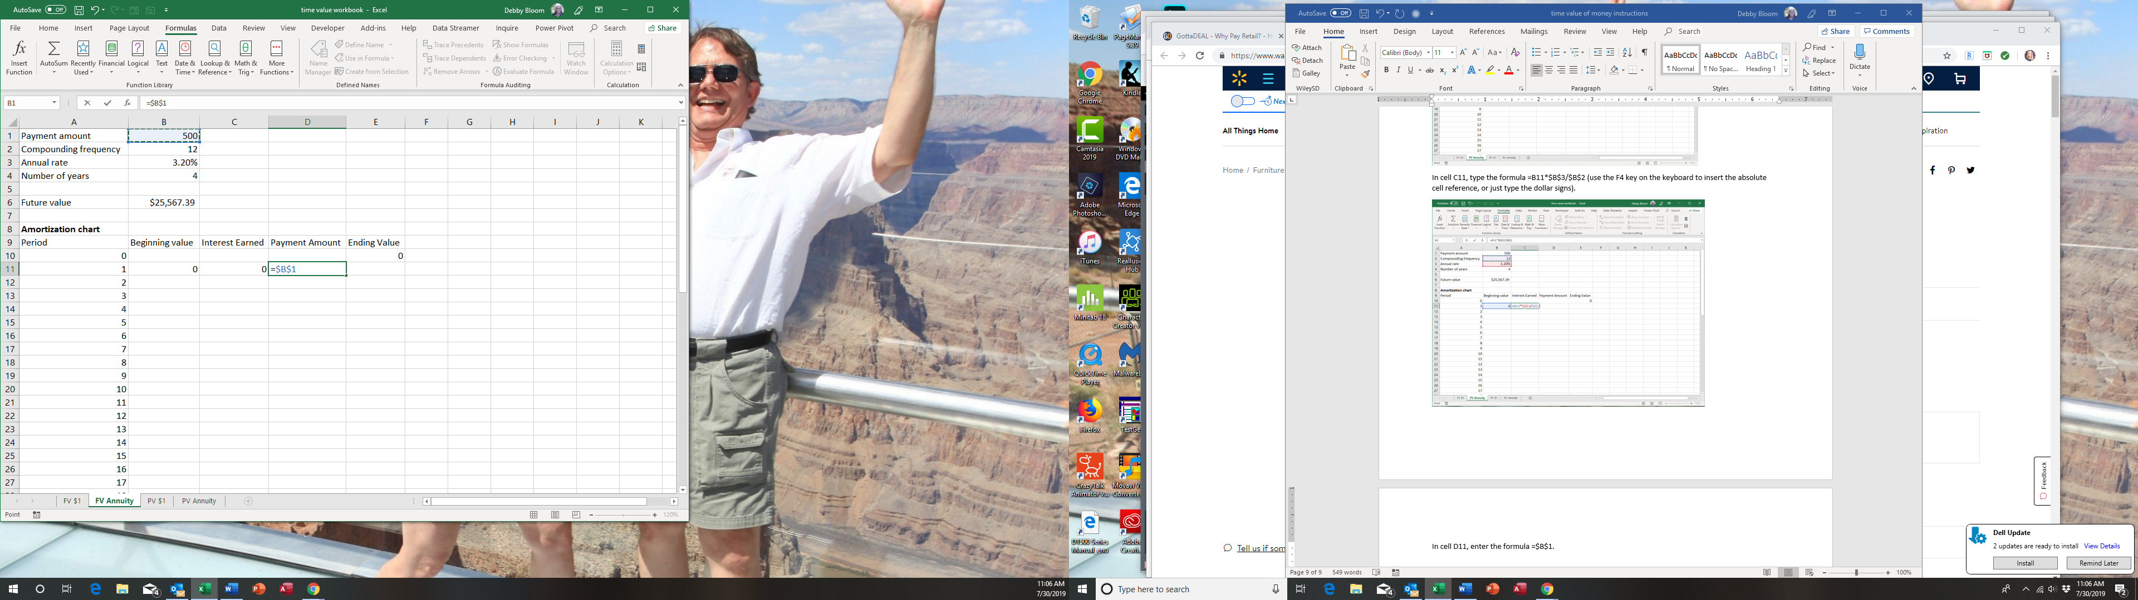
In cell E11, type the formula =B11+C11+D11 (you could use a sum function as well, just make sure to not include the period number). Hit enter.
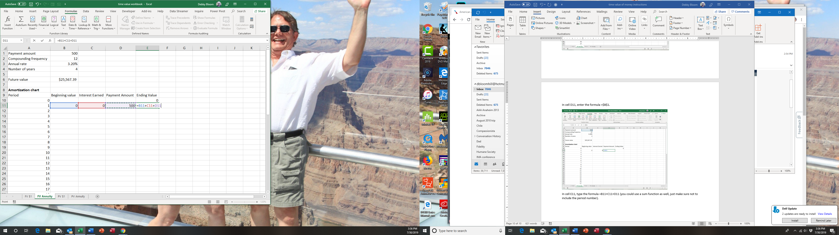
Select the range B11:E11. Double click the fill handle to copy the formulas down to period 48.
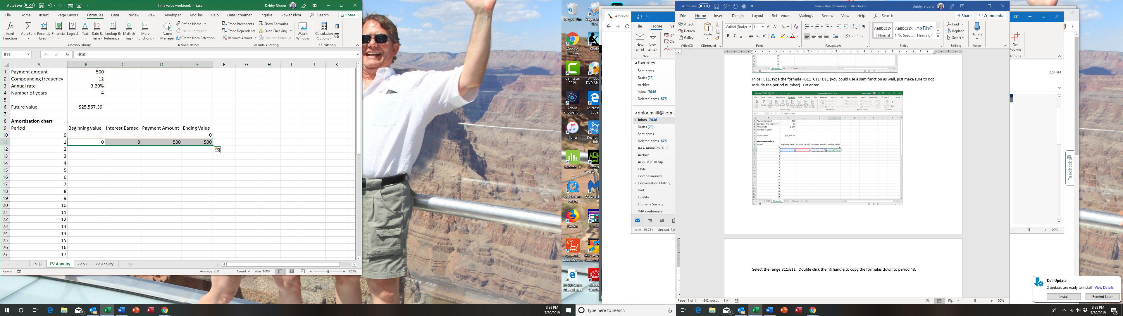
The result. The value in cell E58 should match the value in cell B6.
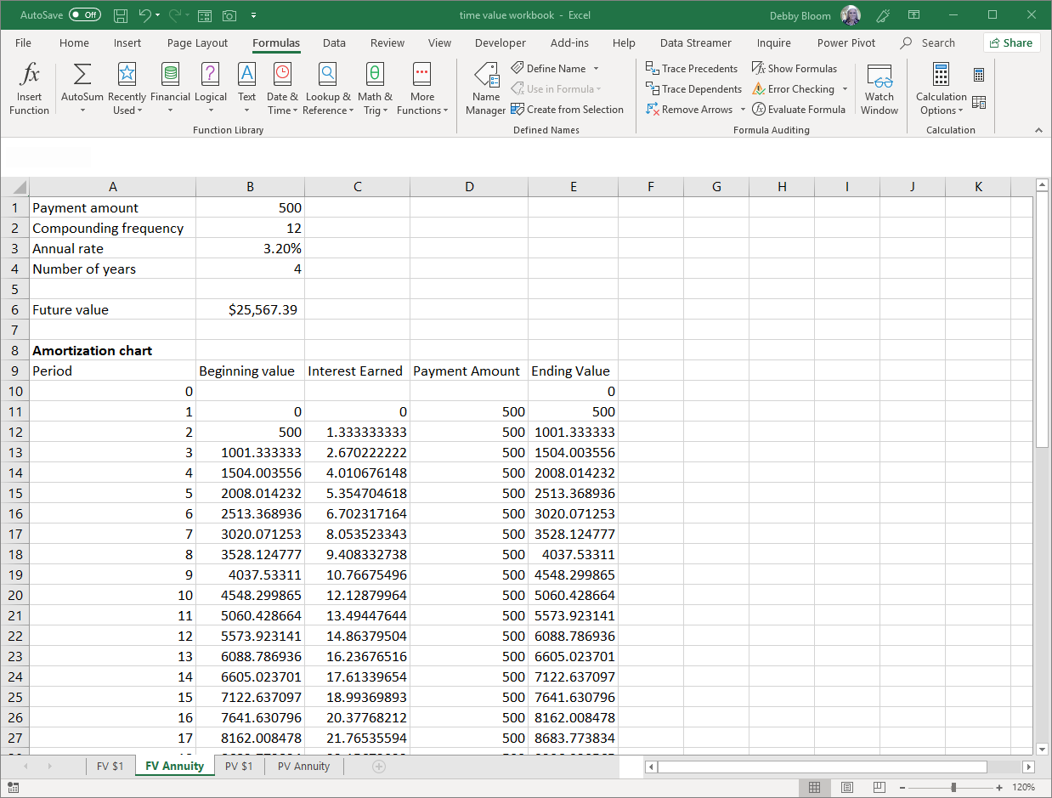
With this worksheet, you can change the payment amount, compounding frequency, annual rate and/or the number of years and the future value formula and the amortization chart will work (you may need to add or delete rows in the amortization chart depending on the number of years chosen).
Problem 3: Present Value of $1
Where you will receive a known amount at a future date and want to know how much that known amount is worth today.
Note: amortization charts are usually not very helpful for this type of problem
Example: your friend is starting a business and is offering to sell you a zero-coupon bond, which will pay $15,000 in exactly 10 years. You desire at 13.5% rate of return, compounded semi-annually. How much are you willing to pay for the bond today?
Click the PV $1 worksheet tab.
Click cell B6. Click the Formulas tab. In the Function Library group, click Financial, then PV.
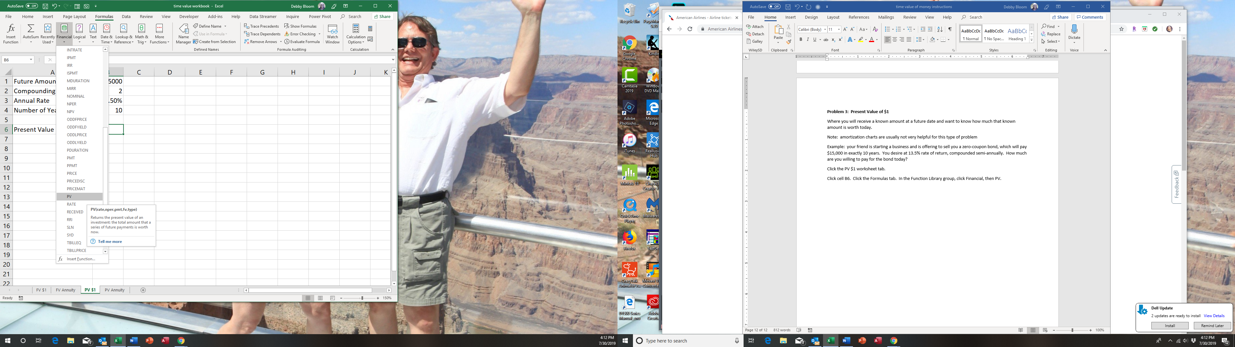

In the Rate box, type B3/B2. In the Nper box, type B4*B2. Skip the Pmt box (that would be used if we were receiving $15,000 every six months), and in the Fv box, type -B1 (the negative sign is necessary to make the answer a positive number). Click OK.
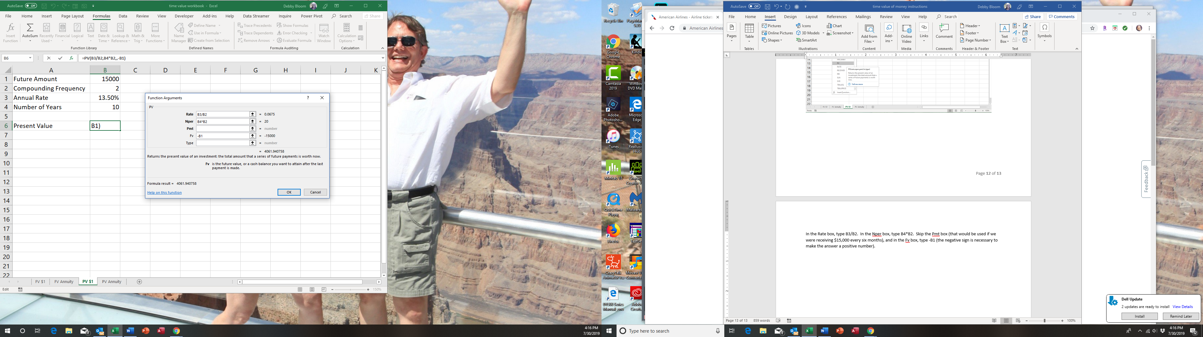
The result.
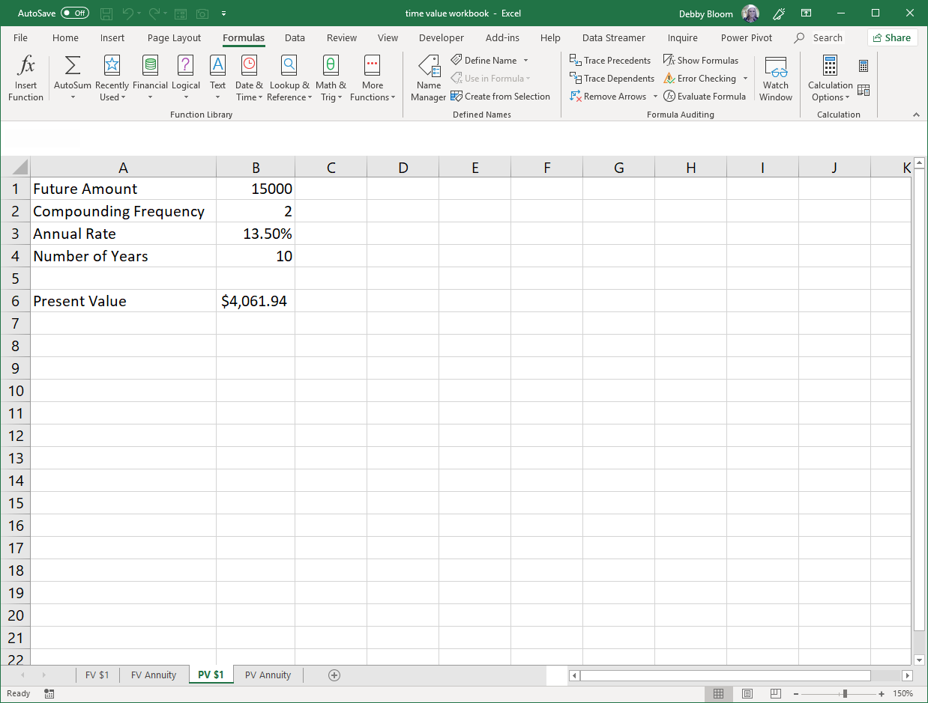
Problem 4: Present Value of an Annuity
When you borrow (or invest) an amount today and pay it back (receive it) in equal installments periodically over the next several years.
In this example, we will use an IF statement to make our amortization chart work for any length of time.
Example: You can afford a monthly car payment of $350. The dealer quotes you an annual rate of 4.5% and you would like to finance over 6 years. How expensive a car can you afford?
Click the PV Annuity worksheet tab.
Click cell B6. Click the Formulas tab. In the Function Library group, click Financial, then PV.
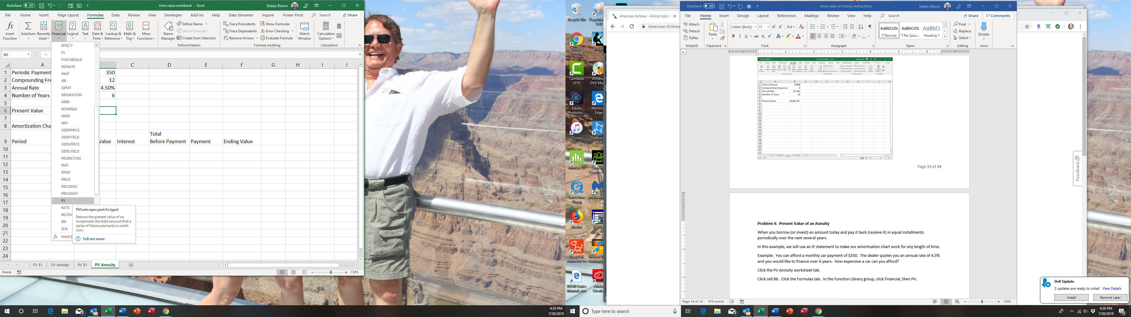

In the Rate box, type B3/B2. In the Nper box, type B4*B2. In the Pmt box, type -B1 (the negative sign is necessary to make the answer a positive number). Click OK.
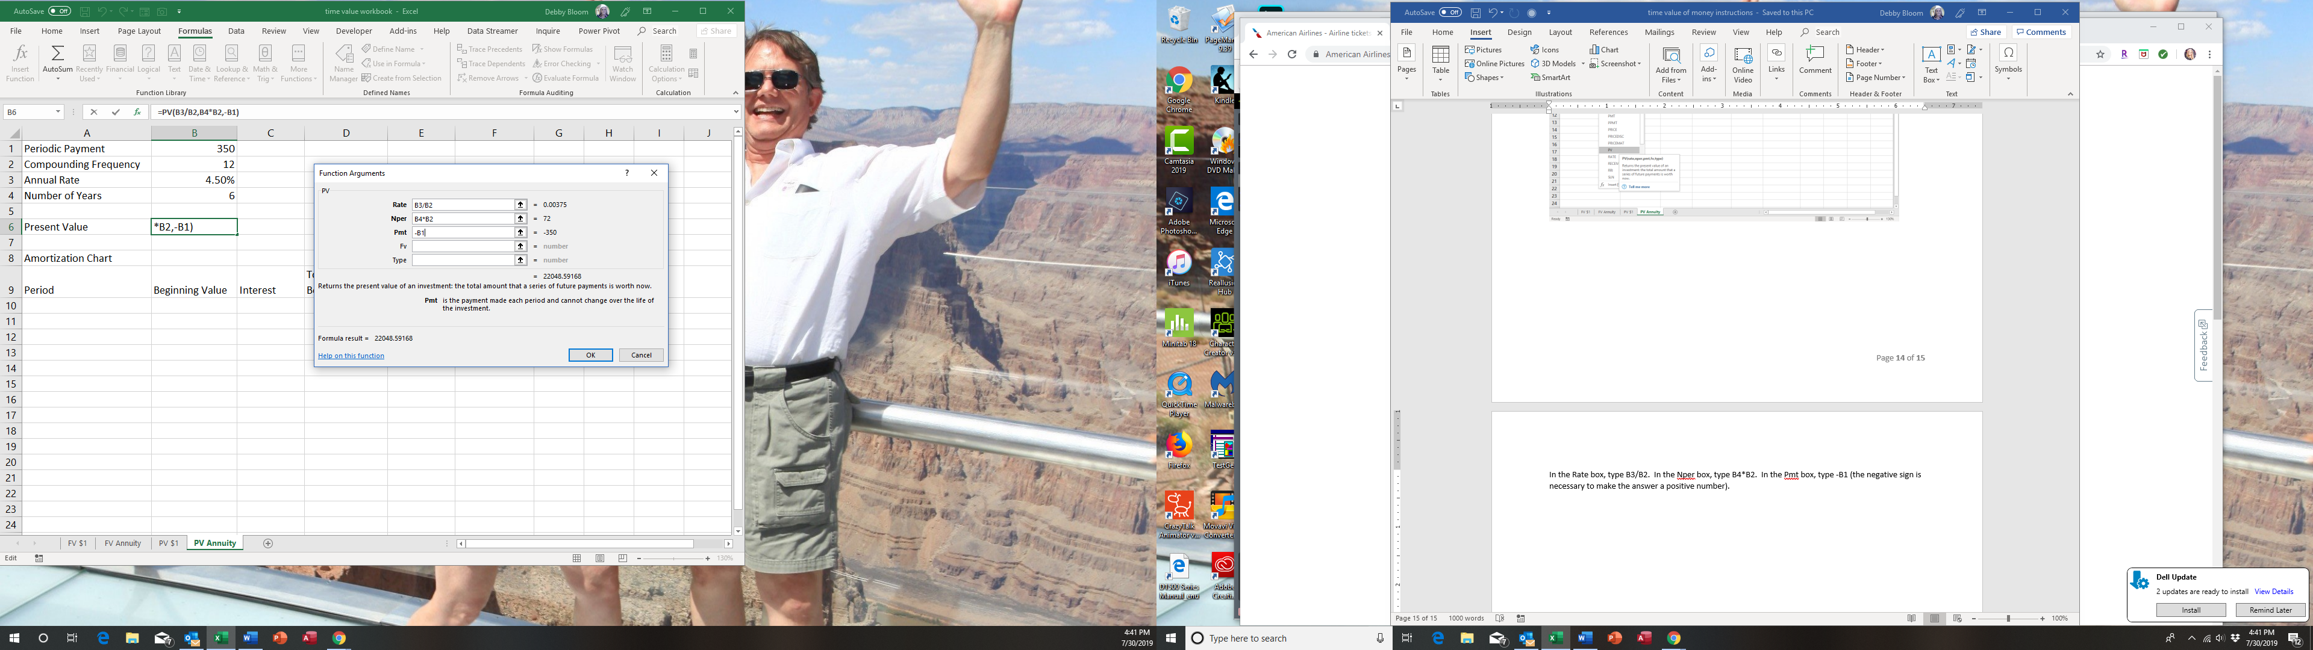
Click cell A10. Type the number 0 and hit enter. Click cell A10 again, click the Home tab, and in the Editing group, click Fill, then Series.
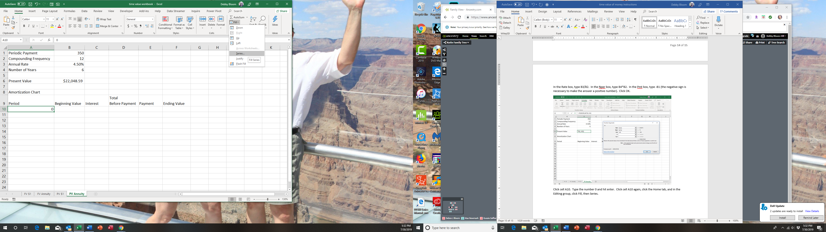
Make sure to click the radio button for Series in Columns (otherwise the numbers will be filled across row 10). Type should be linear and stop value 400. Click OK.
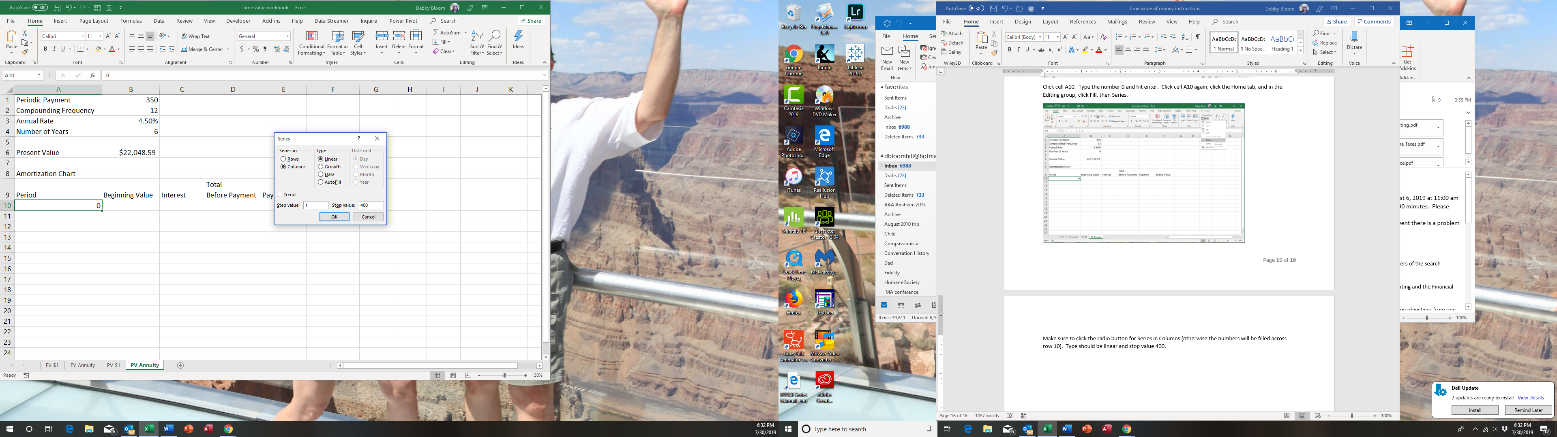
Click cell F10 and type the formula =B6. Hit enter.
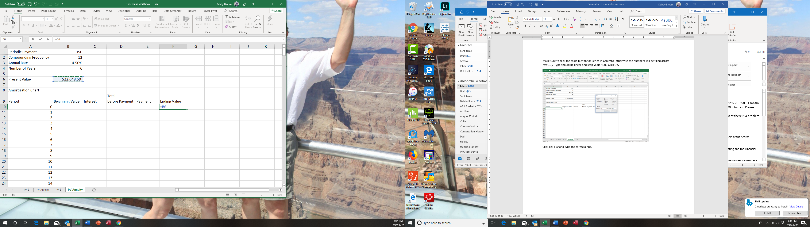

Click cell B11 and type the formula =F10. Hit enter.
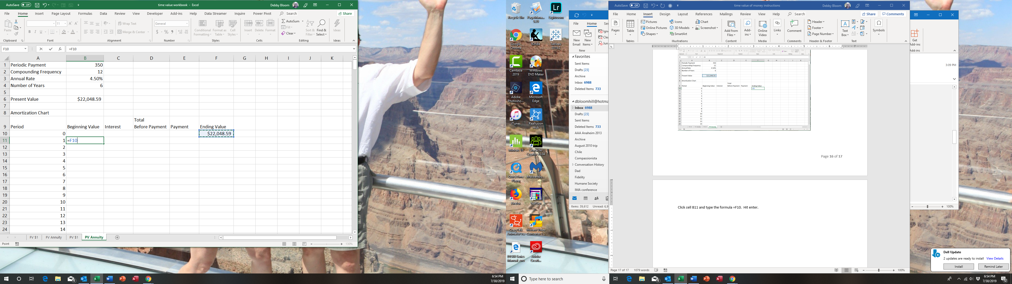
Click cell C11 and type the formula =B11*$B$3/$B$2. Use the F4 key or type the dollar signs. The formula will not work without the absolute cell references (dollar signs).
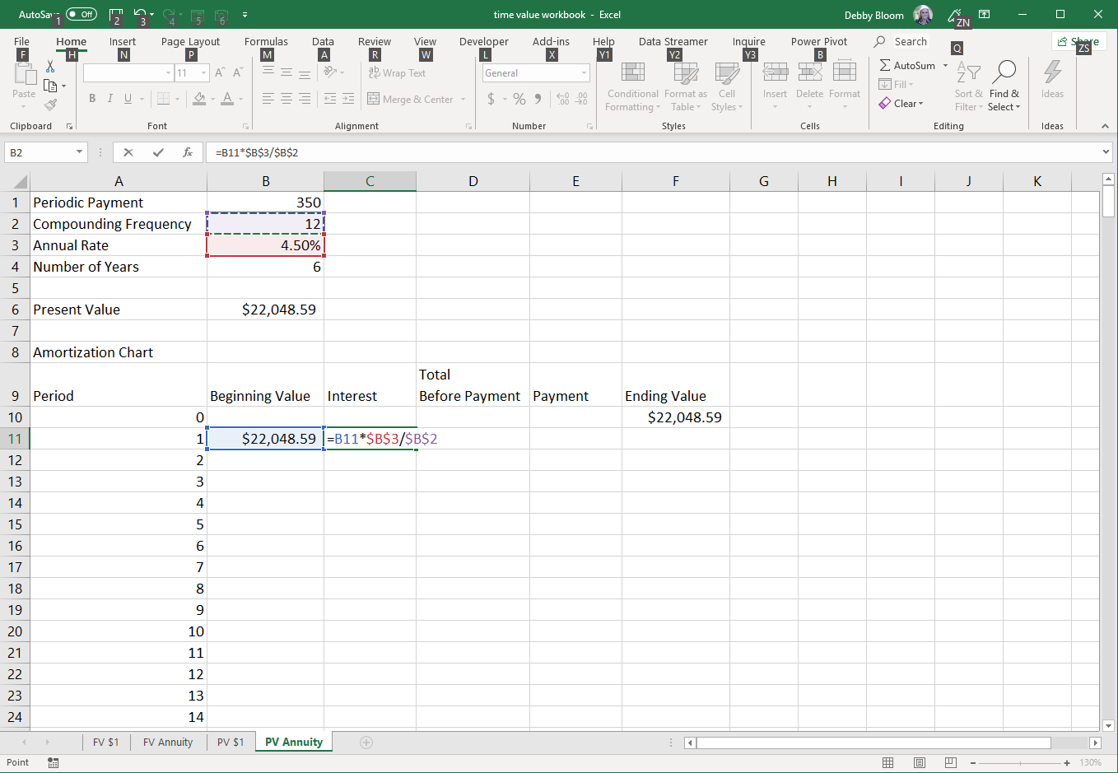

Click cell D11 and type the formula =B11+C11 (this calculation makes the IF statement in the next step a little easier).
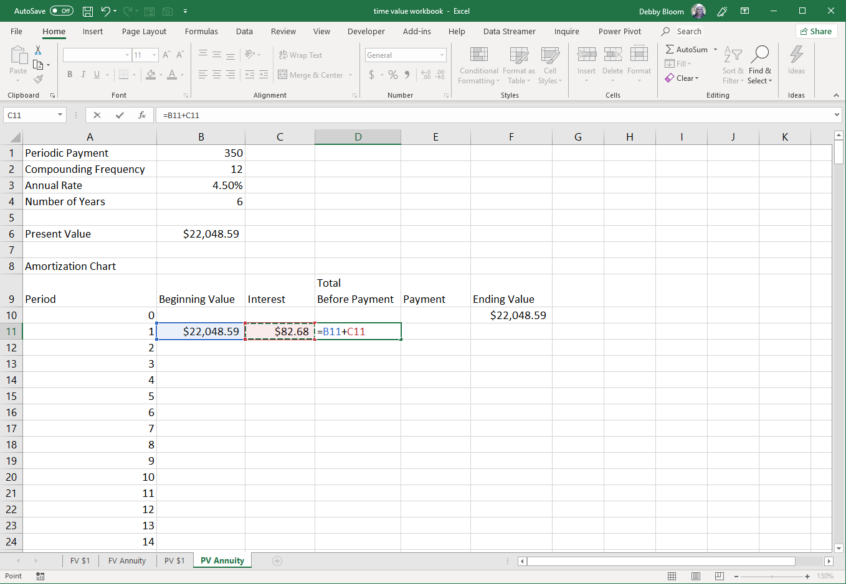
Click cell C11. Click the Formulas tab. In the Function Library group, click Logical, then IF.
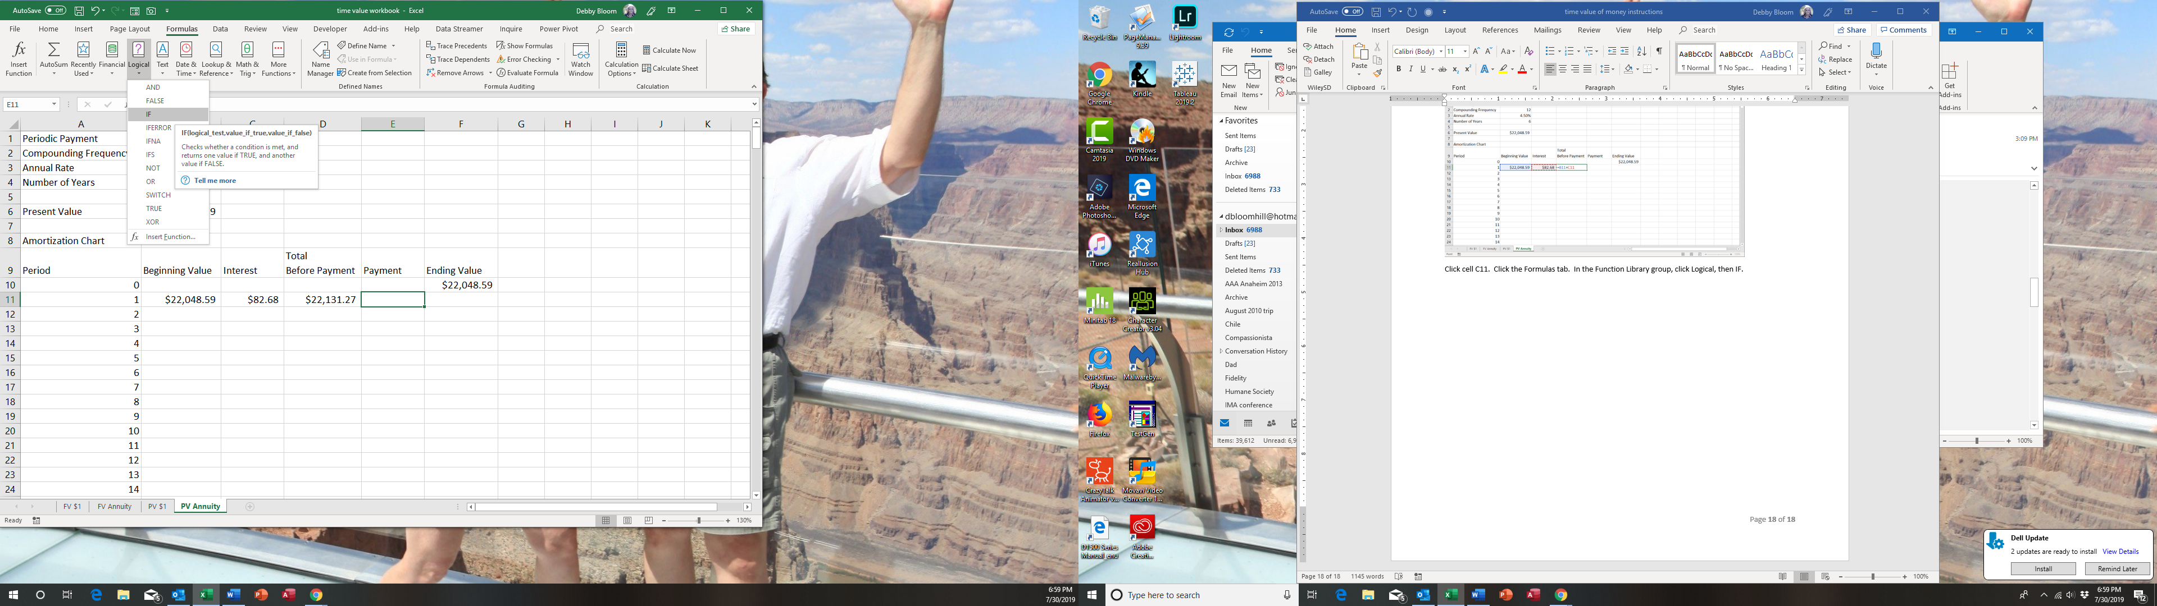

In the Logical test box, type D11>=$B$1. In the Value if true box, type $B$1. In the Value if false box, click cell D11. (We are telling Excel to stop the amortization once the total before the payment is less than the payment.) Click OK.
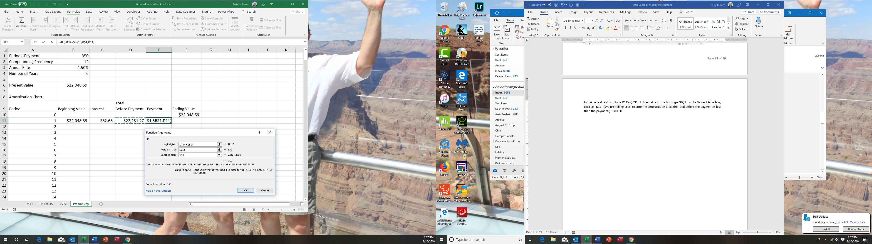
Click cell F11. Type the formula =D11-E11. Hit enter.
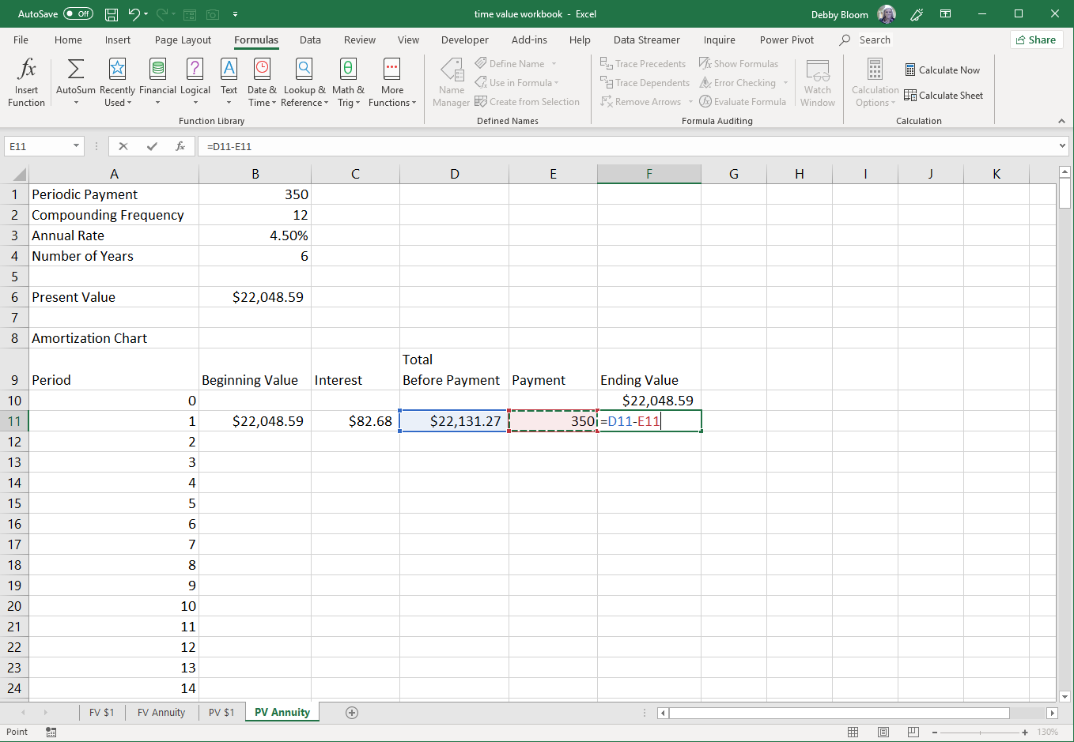
Select the range B11:F11. Double click the fill handle to copy the formulas down the columns.
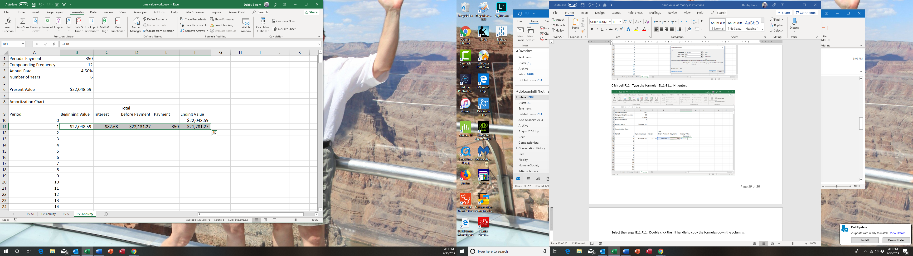
The result
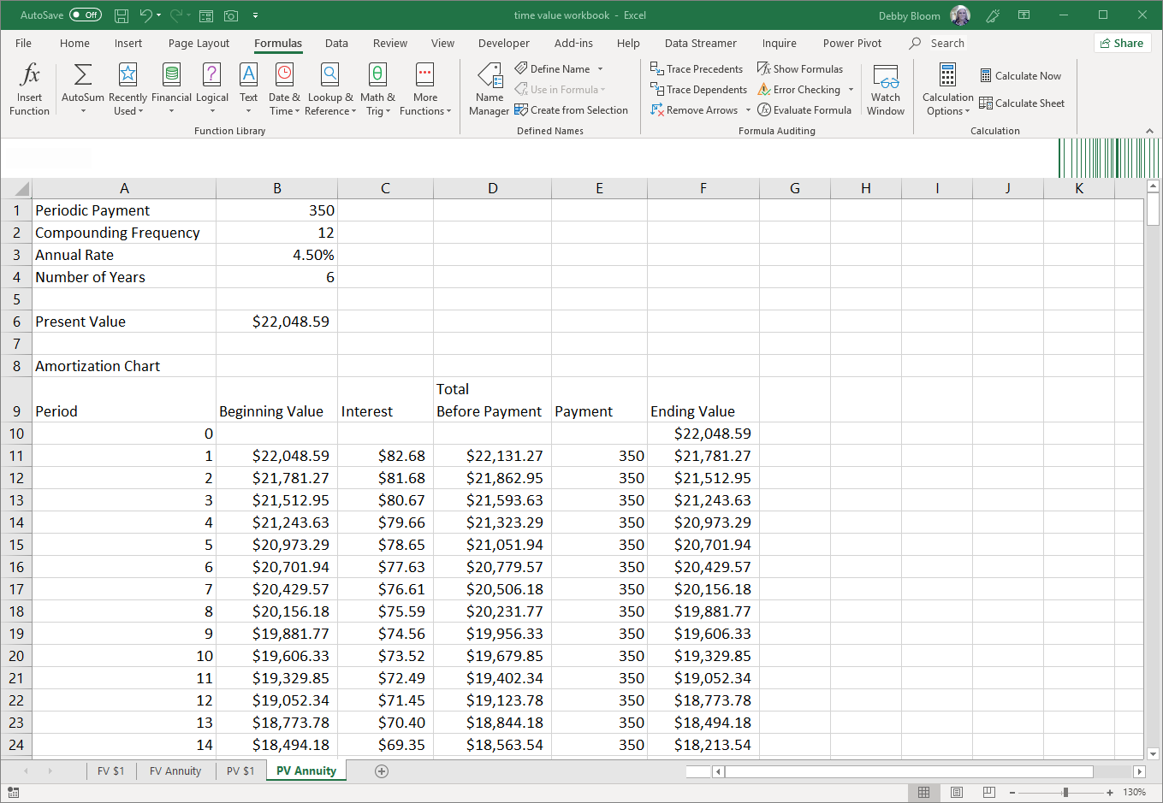

This worksheet will be correct even if values in cells B1 to B4 are changed. Not only that, but the amortization chart will stop and produce only zeroes after the loan term. If you desire longer terms, just extend the period number further down column A.

